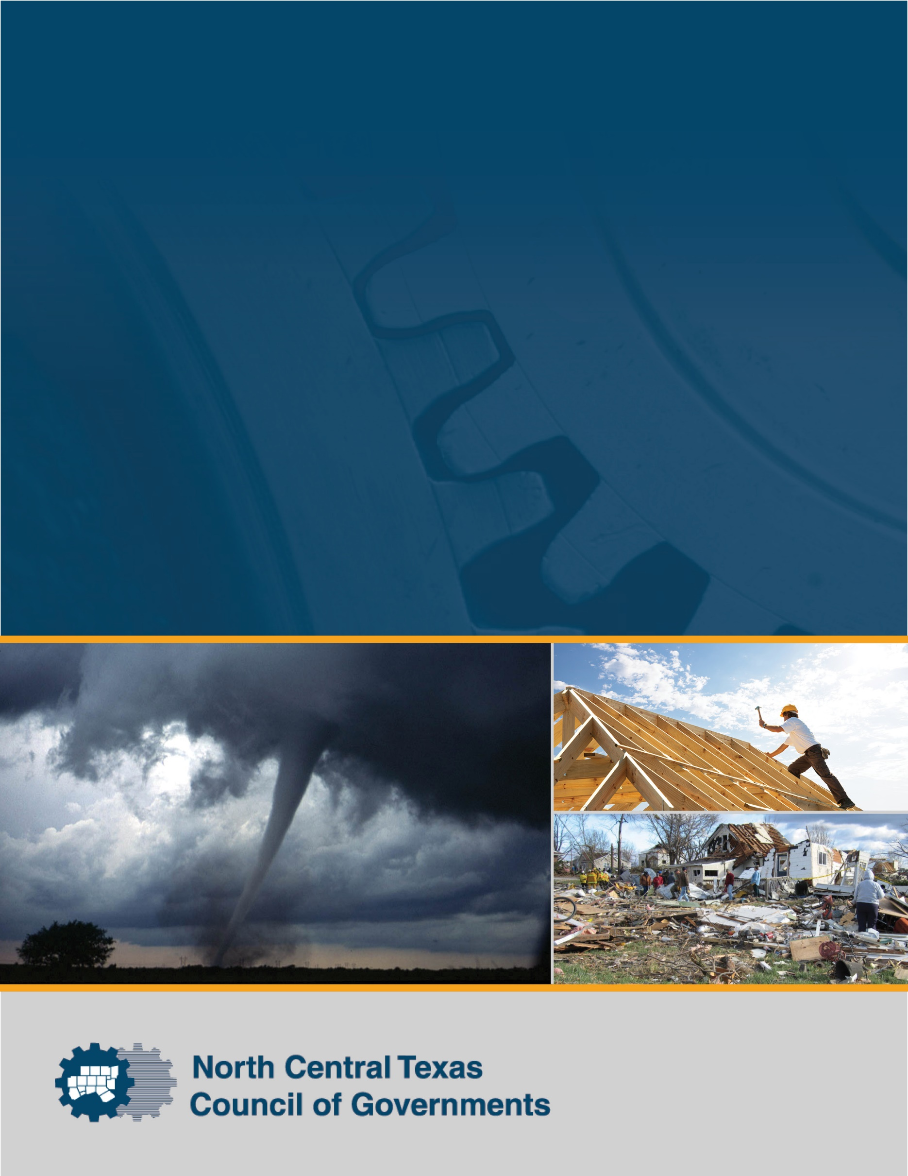
North Central Texas
Council of Governments
Recovery Tabletop Exercise

Situation Manual

January 15, 2020

Preface
The North Central Texas Council of Governments (NCTCOG) Recovery Tabletop Exercise was developed as part of the NCTCOG Recovery Planning Project. The Project includes development of a Recovery Framework for the region and a companion toolkit. This Situation Manual, as well as the accompanying Exercise Evaluation Guide and PowerPoint presentation, was produced with guidance set forth in the Federal Emergency Management Agency’s Homeland Security Exercise and Evaluation Program. The exercise documentation is included in the toolkit and available to North Central Texas jurisdictions for future use.

The Recovery Framework is in draft form at the time of this exercise. The purpose of the exercise is to gather information related to how jurisdictions in the North Central Texas region currently approach recovery and identify areas for improvement that the Framework and toolkit can address. The exercise aims to confirm that the Framework provides applicable, constructive, and operational guidance to assist with recovery. Information observed during the course of the exercise will be synthesized into the Recovery Framework, as appropriate, before the Framework is finalized.

Handling Instructions
The title of this document is the North Central Texas Council of Governments Recovery Tabletop Situation Manual. The information in this document is unclassified and may be used by the North Central Texas Council of Governments and its regional partners for training purposes. For more information, please consult the following point of contact:

Candice Forsyth
Emergency Preparedness Specialist
North Central Texas Council of Governments
(817) 608-2311
CForsyth@nctcog.org

This page intentionally left blank.

Table of Contents
Introduction 1
Background 1
Exercise Purpose 1
Exercise Scope 1
Core Capabilities 1
Exercise Objectives 2
Participants 2
Exercise Structure 3
Exercise Guidelines 3
Assumptions and Artificialities 3
Exercise Schedule 4
Module 1: Response to Recovery Transition and Immediate Recovery Actions 5
Friday, January 10, 2020 5
Wednesday, January 15, 2020 +5 Days 6
Discussion 6
Module 2: Short-term Recovery 9
February 10, 2020 +1 Month 9
Discussion 9
Module 3: Long-term Recovery 12
June 10, 2020 +6 Months 12
Discussion 12
Closing Discussion 14
Appendix A: Recovery Areas and Critical Functions A-1
Appendix B: Core Capabilities B-1

Summit Speakers

This page intentionally left blank.

Introduction

Background
North Central Texas has experienced a number of natural and human-caused disasters and is well-versed in the importance of recovery planning. To this end, the North Central Texas Council of Governments (NCTCOG) is developing a pre-disaster Recovery Framework to provide guidance and tools for local jurisdictions to take proactive steps toward resiliency and put mechanisms in place to facilitate disaster recovery. The Framework guides local jurisdictions in developing their own jurisdiction-specific plans by presenting an over-arching process for collaborating with government, nongovernment, and private-sector organizations. The Framework outlines six recovery areas and critical functions in each area (see Appendix A.

Exercise Purpose
The purpose of this tabletop exercise (TTX) is to validate the NCTCOG Recovery Framework by assessing the capabilities of North Central Texas jurisdictions and regional stakeholders to recover from a tornado outbreak affecting the region.

Exercise Scope
This TTX focuses on regional recovery from a tornado outbreak, specifically emphasizing roles, responsibilities, and expected actions by North Central Texas jurisdictions and stakeholder agencies.

The exercise will be conducted on January 15, 2020, from 12:15 p.m. to 4:15 p.m. Each segment of exercise play will continue until the Exercise Director determines that exercise objectives have been accomplished.

Core Capabilities
National Planning Scenarios and the establishment of the National Preparedness Priorities have steered the focus of homeland security toward a capabilities-based planning approach. Capabilities-based planning focuses on planning under uncertainty, since the next emergency cannot be forecast with complete accuracy. Therefore, capabilities-based planning takes an all-hazards approach to planning and preparation to build upon existing capabilities of organizations that can be applied to a wide variety of event scenarios. Jurisdictions and organizations use capabilities-based planning to identify a baseline assessment of their homeland security efforts by comparing current capabilities against the Core Capabilities list. This approach identifies gaps in current capabilities and focuses efforts on identifying and developing priority capabilities and tasks for the jurisdiction or organization. See Appendix A for more information related to capabilities-based planning.

The Exercise Planning Team identified the core capabilities listed below as key for conducting this exercise. These capabilities and their associated critical tasks provided the foundation for the development of the exercise objectives and scenario:
- Planning. Conduct a systematic process engaging the whole community as appropriate in the development of executable strategic, operational, and/or tactical-level approaches to meet defined objectives.
- Public Information and Warning. Deliver coordinated, prompt, reliable, and actionable information to the whole community through the use of clear, consistent, accessible, and culturally and linguistically appropriate methods to effectively relay information regarding any threat or hazard, as well as actions being taken and assistance being made available, as appropriate.
- Operational Coordination. Establish and maintain a unified and coordinated operational structure and process that appropriately integrates all critical stakeholders and supports the execution of core capabilities.
- Economic Recovery. Return economic and business activities to a healthy state and develop new business and employment opportunities that result in an economically viable community.
- Health and Social Services. Restore and improve health and social services capabilities and networks to promote the resilience, independence, health (including behavioral health), and well-being of the whole community.
- Housing. Implement housing solutions that effectively support the needs of the whole community and contribute to its sustainability and resilience.
- Infrastructure Systems. Stabilize critical infrastructure functions, minimize health and safety threats, and efficiently restore and revitalize systems and services to support a viable, resilient community.
- Natural and Cultural Resources. Protect natural and cultural resources and historic properties through appropriate planning, mitigation, response, and recovery actions to preserve, conserve, rehabilitate, and restore them consistent with post-disaster community priorities and best practices and in compliance with applicable environmental and historic preservation laws and executive orders.

Exercise Objectives
The objectives developed for the TTX identify opportunities or issues and assist in achieving an improved level of commitment and understanding of plans, policies, and procedures that would be activated based on a situation such as that represented. The exercise focuses on the following design objectives selected by the Exercise Planning Team:
- Objective 1. Gather information to validate the North Central Texas Recovery Framework, specifically its approach to coordination, organization, and collaboration that can be implemented by all jurisdictions to better prepare for and recover from disasters.
- Objective 2. Review critical functions for recovery related to economic recovery, health and social services, housing, infrastructure, land use planning and development, and natural and cultural resources.
- Objective 3. Explore the role of local government, the private sector, and nonprofit organizations in supporting community recovery.

Participants

Players
Players respond to the situation presented in the TTX based on their level of authority and knowledge of procedures, current plans and policies, and insights derived from experience or training.

Observers
Observers are encouraged to gather ideas and points for further consideration generated during the moderated discussion and may participate in the hotwash at the end of the TTX; however, they generally do not participate in the moderated discussion period.

Facilitators
Facilitators provide situation updates and moderate discussions. They also provide additional information or resolve questions as required. Key planning team members may assist with facilitation as subject matter experts during the TTX.

Evaluators
Evaluators observe and record player discussions, document future areas for discussion by participating organizations, and capture points of view expressed during the discussions. After the exercise, their information will be used to determine whether the expected performance outcomes were achieved and identify strengths and opportunities for improvement in the development of the after-action report. Evaluators will also be a part of exercise improvement planning efforts.

Exercise Structure
This will be a facilitated TTX. Players will participate in three modules, as outlined below.
- Module 1: Transition from Response to Recovery and Immediate Recovery Actions
- Module 2: Short-term Recovery
- Module 3: Long-term Recovery

Each module begins with an update that describes and summarizes key events occurring within that time period. Following the updates, participants will discuss among their jurisdiction’s table and will then participate in a moderated brief-back session for the large group before the next module is introduced.

Exercise Guidelines
- The exercise takes place in an open, low-stress, no-fault environment.
- Varying viewpoints, even disagreements, are expected. Participants should be tolerant of varying viewpoints, including those with which they disagree.
- Respond based on your knowledge of the plans and insights derived from experience and training.
- Discuss existing policies, memorandums of understanding, operational agreements, and capabilities.
- There is no single accepted solution; decisions are not precedent-setting and may not reflect your organization’s final position on a given issue. This is an opportunity to discuss and introduce multiple options and possible solutions.
- Issue identification is not as valuable as suggestions and recommended actions that could improve response, preparedness, mitigation, prevention, and recovery efforts; problem-solving efforts should be the focus.

Assumptions and Artificialities
In any exercise, a number of assumptions and artificialities may be necessary to complete play in the time allotted. During this exercise, the following apply:
- The scenario is plausible, and events occur as they are presented.
- Each agency’s plans and policies will be used in the response to the scenarios presented, without outside assistance.
- There is no hidden agenda, nor are there trick questions.
- Unless specifically identified, public and private entities are operating on a normal schedule and at normal staffing levels.

Exercise Schedule

January 15, 2020
Time | Activity
12:15 p.m. | Introductions, Overview, and Module 1: Response to Recovery Transition and Immediate Recovery Actions
1:40 p.m. | Module 2: Short-term Recovery
2:50 p.m. | Module 3: Long-term Recovery
4:00 p.m. | Hot Wash
4:15 p.m. | Adjourn

Module 1: Response to Recovery Transition and Immediate Recovery Actions

Friday, January 10, 2020

12:30 a.m. (0 Hours)

In the early morning hours of Friday, January 10, 2020, a rare tornado outbreak occurs across the North Central Texas region. Although January tornadoes are unusual, they are not unheard of in the area. Earlier in the day, the Storm Prediction Center warned of the possibility of a severe weather outbreak, and, from 12:00 a.m. to 2:00 a.m., numerous counties in the region received tornado warnings. Forecasters estimate 12 tornadoes touched down throughout the region, several of them most likely EF-3 or higher, although that will not be confirmed for several more hours when the National Weather Service can survey the damage. Additionally, the entire region is inundated with heavy rains for hours. Since the peak of the severe weather took place overnight, mass casualties and fatalities occurred. Responders have worked through the night, performing searches and rescues.

7:00 a.m. (+6.5 hours)
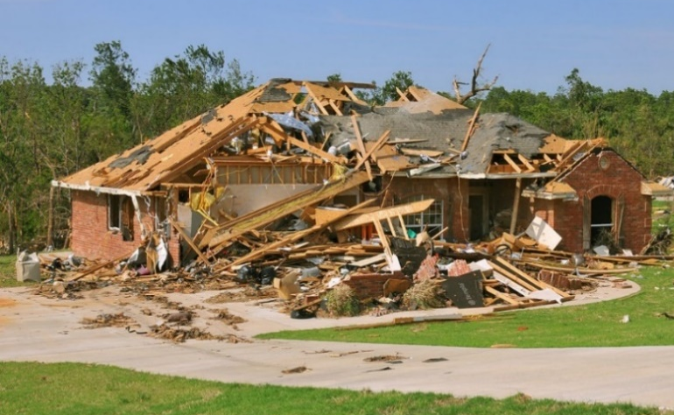
As day breaks, the extent of the damage becomes clear. Based on initial aerial surveys, officials estimate 10 percent to 15 percent of the housing in every county in the North Central Texas region is damaged. Significant damage has occurred to infrastructure throughout the region. Currently, 40 percent of the region does not have electricity, and 25 percent of households are without water. Heavy debris litters I-20 and I-35, other major highways, and smaller roadways. Several historical sites, including the Stockyards at Fort Worth, and Highland Park Village in Dallas have sustained heavy damage. Hospitals and schools throughout the region are damaged. Tree damage throughout the region is extensive, and localized flooding continues due to heavy rain coupled with power failures.

5:30 p.m. (+17 hours)
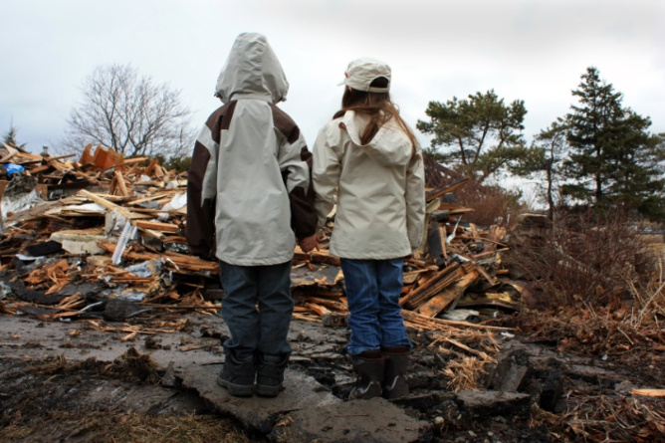
Officials indicate that all critical care patients have been rescued and transported. Hospitals are overwhelmed with EMS–transported victims and citizens transporting the injured in their personal vehicles. 911 centers continue to be inundated with phone calls from victims’ families and friends looking for information. Hundreds of people show up at hospitals desperately searching for their loved ones.
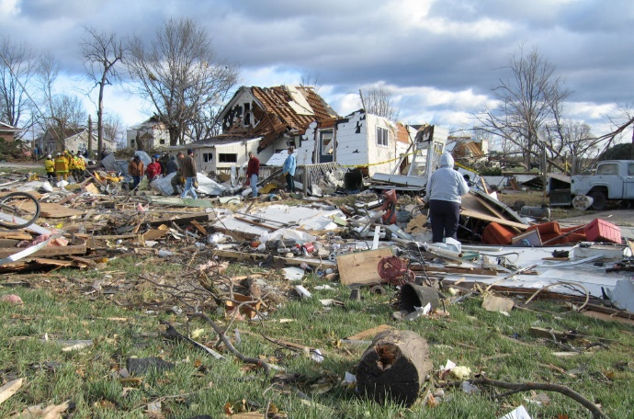

Wednesday, January 15, 2020 (+5 Days)
Five days have passed since the tornado outbreak, and life-saving measures including searches and rescues, and other EMS operations have been completed. Power has been restored to the majority of residents, although 10 percent of habitable structures still do not have power. Local officials have been working to conduct initial damage assessments in preparation for the arrival of state and federal agencies.

Discussion
Based on the information provided, participate in discussion concerning issues raised in Module 1. Identify critical issues, decisions, and/or questions that should be addressed at this time. Questions for consideration include the following:
- What are the high-priority recovery objectives at 5 days post-disaster?

- What steps must be taken to address damage to homes and infrastructure? What challenges exist for tasks such as damage assessment, debris management, and permitting and inspections? What organizations may be involved in these tasks?

- How are mobility and critical services, including utilities and transportation, restored?

- What are the critical needs of disaster survivors? What are the considerations for sheltering and/or temporary housing, mass feeding, donations management, and volunteer management at this stage? What organizations may be involved in managing and providing relief services to survivors?

- What information must be provided to the public, and how is information about recovery resources coordinated and disseminated to the public? (Note that many are still without power and access to the Internet).

- What conditions precipitate the transition from response to recovery operations, and how does the Emergency Operations Center begin to transition to a recovery organization while maintaining continuity?

- What support is provided to local businesses to allow them to resume operations quickly? What organizations may provide this assistance?

- What assistance is provided to local residents so that they can return to work and children can return to school? What organizations may provide this assistance?

- What are some potential environmental concerns during the immediate recovery phase? What organizations may be involved in addressing these concerns?

- How will affected jurisdictions mediate issues when competing for the same limited resources? How may regional resources be allocated and appropriately shared?

- How would cost documentation and expense tracking be managed to ensure reimbursement eligibility? How would in-kind donations and volunteer coordination be tracked and managed?

Module 2: Short-term Recovery

February 10, 2020 (+1 Month)

Since receiving a Presidential declaration, local governments have been working closely with state and federal partners. In the weeks following the incident, a long list of recovery issues has become apparent. Homeowners have been clearing out homes and, every day, more and more trash piles up at curbs. Many homes are being repaired and renovated, and dumpsters line the streets. Contractors are in short supply, hotels are fully booked, and many residents are still looking for interim housing. Multiple conflicting sources of information on insurance, homeowner assistance programs, and low-interest loans circulate on social media and within the community. Businesses are attempting to return to normal, but issues with supply chains and infrastructure disruptions are causing difficulties and slow recovery efforts. Due to structural damages, many of the region’s largest employers have suspended operations. Shortages persist for critical items such as gas and cleaning supplies in some areas. Several spontaneous, unverified disaster-related websites appear, soliciting donations and offering assistance to businesses and residents. Dozens of schools are significantly damaged and have begun the process of transitioning students to alternate locations.

Discussion
Based on the information provided, participate in discussion concerning issues raised in Module 2. Identify critical issues, decisions, and/or questions that should be addressed at this time. Questions for consideration include the following:
- What are the high-priority objectives in the first 8 weeks post-disaster?

- What short-term recovery challenges exist in the six recovery areas (economic, health and social services, housing, infrastructure, land use planning and development, and natural and cultural resources)? What organizations are equipped to address these challenges?

- What are the roles and activities of nongovernmental (private and nonprofit) organizations at this stage? How are their efforts coordinated with local government?
________________________________________________________________________________________________________________________________________________________________________________________________________________________________________________________________________________________________________________________________________________________________________________________________________________________________
- How do local jurisdictions collaborate, cooperate, and coordinate with regional governments, the state, and federal agencies during the short-term recovery phase?
________________________________________________________________________________________________________________________________________________________________________________________________________________________________________________________________________________________________________________________________________________________________________________________________________________________________
- What recovery organizational structure is in place at this time? Who is leading the recovery effort, and what other roles would be filled?
________________________________________________________________________________________________________________________________________________________________________________________________________________________________________________________________________________________________________________________________________________________________________________________________________________________________
- What short-term housing solutions are implemented and/or considered? Which organizations are involved in addressing housing issues?
________________________________________________________________________________________________________________________________________________________________________________________________________________________________________________________________________________________________________________________________________________________________________________________________________________________________

- How are repairs to historical sites and buildings managed?
________________________________________________________________________________________________________________________________________________________________________________________________________________________________________________________________________________________________________________________________________________________________________________________________________________________________
- How are community members engaged in community rebuilding efforts? What organizations help to garner public outreach for volunteer opportunities?
________________________________________________________________________________________________________________________________________________________________________________________________________________________________________________________________________________________________________________________________________________________________________________________________________________________________
- How do local residents and businesses remain informed of available recovery resources?
________________________________________________________________________________________________________________________________________________________________________________________________________________________________________________________________________________________________________________________________________________________________________________________________________________________________

Module 3: Long-term Recovery

June 10, 2020 (+6 Months)
In the 6 months since the tornado outbreak, recovery efforts have progressed. Most damaged infrastructure has been repaired or is in the process of repairs. Residents are in the process of working through their homeowner insurance claims, and many who experienced significant damage still fall short of paying for necessary repairs. Some residents have permanently moved out of the area to find work. Due to high demand and low supply, rental rates have skyrocketed, and there is an increase in people experiencing homelessness. Many small businesses and restaurants have permanently closed. Frustrated residents have taken to social media to criticize local officials for “not doing enough” to support residents.



Discussion
Based on the information provided, participate in discussion concerning issues raised in Module 3. Identify critical issues, decisions, and/or questions that should be addressed at this time. Questions for consideration include the following:

- What are the high-priority objectives moving forward during long-term recovery?

- What are some recovery activities and challenges for the six recovery areas (economic, health and social services, housing, infrastructure, land use planning and development, and natural and cultural resources)?

- Who leads the recovery efforts 6 months post-disaster? What other organizational roles and/or functions are active?

- What are some of the long-term housing recovery challenges? Which recovery partners are involved in implementing long-term housing solutions?

- What agencies at the state and federal levels are involved at this point? What assistance and resources do they have to offer?

- Which potential public-private partnerships are engaged in encouraging reinvestment in the local economy and enhancing economic resiliency?

- What outreach and communication strategies are being used to maintain morale during the long-term recovery phase?

Closing Discussion
- Hotwash. Conduct an immediate after-action discussion focusing on TTX objectives, decision making, and information coordination. This discussion will include closing comments from key agency representatives.
- Identify next steps. Clearly identify follow-up actions to the exercise, including development of the after-action report/improvement plan, edits for the North Central Texas Recovery Framework, and impacts on other existing plans, policies, and procedures (if applicable).
- Feedback. Complete and return participant feedback forms to exercise support staff.

Recovery Areas and Critical Functions

Recovery Area | Mission | Critical Functions
Economic | Restore and retain businesses and employment and generate economic development opportunities for the community | - Business Restoration, Retention, and Recruitment  - Employment and Workforce Support  - Business Recovery Centers
Health and Social Services | Restore health systems and provide social services to improve the well-being of individuals and families affected by the disaster | - Donations and Volunteers  - Individual and Family Services  - Public Health and Medical Services  - Schools and Academic Institutions
Housing | Develop strategies for realistic, accessible, and affordable temporary and long-term housing options for those displaced from their homes | - Housing Availability and Needs Assessment  - Short-term Housing  - Long-term Housing
Infrastructure | Repair and restore infrastructure and essential services and improve resiliency of infrastructure systems to future disasters | - Damage Assessment  - Debris Management  - Utility Restoration  - Transportation Restoration  - Public Facility Repair
Land Use Planning and Development | Oversee repairs, rebuilding, and reconstruction of homes, businesses, and community assets and engage the community in developing long-term recovery strategies that improve community resilience | - Damage Assessment  - Inspections and Permitting  - Community Engagement and Long-term Planning  - Historic Preservation  - Hazard Mitigation
Natural and Cultural Resources | Restore natural areas and cultural assets to their pre-disaster condition and improve resiliency to future disasters | - Environmental Remediation and Restoration  - Community Arts and Recreation

This page intentionally left blank.

Core Capabilities

Capabilities-based Planning
Capabilities-based planning is defined as planning, under uncertainty, to build capabilities suitable for a wide range of threats and hazards while working within an economic framework that necessitates prioritization and choice. Because it can never be determined with 100-percent accuracy what threat or hazard will occur, it is important to build capabilities that can be applied to a wide variety of incidents. As such, capabilities-based planning is all-hazards planning that identifies a baseline assessment of preparedness and security efforts. An assessment of this kind is necessary to begin any long-term exercise strategy. This determines where current capabilities stand against the core capabilities and identifies gaps in capabilities. The approach focuses efforts on identifying and developing the capabilities from the core capabilities to perform the critical tasks at the protection and response operations level.

Presidential Policy Directive 8: National Preparedness (PPD-8)
National preparedness is aimed at strengthening the security and resilience of the Nation by preparing for the full range of 21st-century risks that threaten national security, including weapons of mass destruction, cyber-attacks, terrorism, pandemics, transnational threats, and catastrophic natural disasters.

National preparedness is a shared responsibility. As such, PPD-8 is designed to facilitate an integrated, all-of-nation/whole community, capabilities-based approach to preparedness. Involving federal partners; state, local, and tribal leaders; the private sector; nongovernmental organizations; faith-based and community organizations; and most importantly the general public is vital to keeping people and communities safe and preventing the loss of life and property when disasters strike.

Implementation of PPD-8 requires extensive outreach, collaboration, and input from stakeholders at all levels of government, the private and nonprofit sectors, and the public.

The Federal Emergency Management Agency will coordinate closely with its partners throughout the homeland security and emergency management community, the private and nonprofit sectors, and the public to implement requirements included in PPD-8.

PPD-8 sets a strategic vision for national preparedness using a comprehensive approach to preparedness. These include the following:
- National Preparedness Goal
- National Preparedness System
- Campaign to Build and Sustain Preparedness
- National Preparedness Report

National Preparedness Goal
PPD-8 calls for development and maintenance of the National Preparedness Goal, defining the core capabilities necessary to prepare for the specific types of incidents posing the greatest risk to the security of the Nation. The Goal establishes concrete, measurable, prioritized objectives to mitigate specific threats and vulnerabilities—including regional variations of risk—and emphasizes actions intended to achieve an integrated, layered, accessible, and all-of-nation/whole community preparedness approach while optimizing use of available resources.

Core Capabilities
Core capabilities are essential for the execution of each of five mission areas: Prevention, Protection, Mitigation, Response, and Recovery. To assess both capacity and our gaps, each core capability includes capability targets for which measures will be developed. The core capabilities and capability targets are not exclusive to any single level of government or organization but rather require the combined efforts of the whole community.

The core capabilities represent an evolution from the target capabilities list. The transition to core capabilities expands the focus to include mitigation and allows greater focus on prevention and protection activities based on experience since the release of PPD-8. The capability targets associated with these core capabilities are ambitious. These are not targets for any single jurisdiction or agency; achieving these targets will require a national effort involving the whole community. Each mission area relies on the whole community to ensure success. This includes children, individuals with disabilities and others with access and functional needs, diverse communities, and people with limited English proficiency.

Core capabilities and targets, like the risks we face, are not static. They will be vetted and refined, taking into consideration the risk and resource requirements, during the planning process established through PPD-8.

Summit Speakers


Elizabeth A. Zimmerman, Former FEMA Associate Administrator for Response and Recovery and Director of Disaster Operations
As FEMA Associate Administrator, Ms. Zimmerman administered all aspects of FEMA’s response and recovery efforts. During her tenure, she oversaw more than 930 disasters, emergencies, and fire declarations, delivering over $6.5 billion in aid to 1.7 million individuals and families and more than $27 billion in federal disaster assistance to state, local, tribal, and non-profit groups. Ms. Zimmerman was appointed as the Department of Homeland Security’s representative to the American Red Cross Cabinet Council and to committee leadership positions within the National Emergency Management Association (NEMA). She directed one of the most significant changes to FEMA’s statutory authorities in the agency’s history through the development, coordination, and implementation of the Sandy Recovery Improvement Act (SRIA) which re-engineered FEMA’s Individual Assistance (IA) and Public Assistance (PA) programs to streamline the delivery of IA and PA support and improve payment processes. Prior to her work at FEMA, Ms. Zimmerman held positions as the Assistant Director of Recovery and as the Disaster Recovery Manager at the State of Arizona’s Division of Emergency Management and served for 10 years with the Utah Division of Emergency Management.

Preston Cook, Retired Director of Emergency Management for Hillsborough County, Florida

Preston Cook has over 30 years of experience in emergency management and public safety. He recently retired as Director of the Hillsborough County, Florida Office of Emergency Management, where he served since 2011. He has led emergency operations during many large-scale events and disasters, including various tropical systems such as Hurricane Irma in 2017 and the 2016 Pulse Nightclub Shooting in Orlando. He served previously as Executive Director of the Orange County, Florida, Office of Emergency Management and supported numerous disasters including the deadly tornadoes and devastating wildfires of 1998 as well as Hurricanes Charlie, Frances, and Gene. He also served as the Florida State Emergency Response Team (SERT) Chief managing the Florida Emergency Operations Center during the Deepwater Horizon Oil Spill in 2010.

Stephen C. Costello, Chief Recovery Officer, City of Houston

Mr. Costello is an engineer with a background in flood control and drainage. His first job in Texas was with the U.S. Army Corps of Engineers in Galveston. He co-founded Costello, Inc., a Houston civil engineering and surveying firm, in 1991 and served as president of the local and state chapters of the American Council of Engineering Companies. In 2014, he was named “Engineer of the Year” by the Texas Society of Professional Engineers.
Mr. Costello served as an at-large member of the Houston City Council from 2010 to 2015. In May of 2016, he was appointed by the Mayor as the city’s Chief Resilience Officer. His primary task was to focus on the flooding and drainage issues facing the city, thus his title of “Flood Czar.” He now serves as Chief Recovery Officer, coordinating the city’s recovery efforts from Hurricane Harvey.
Mr. Costello is currently an active board member of Family Houston, a 114-year-old nonprofit providing case management and counseling services to families in need. He has also served on the boards of the Memorial Park Conservancy, SER Jobs for Progress, and Marathon Kids.


Kathy Clark, Associate Director of Emergency Disaster Services, The Salvation Army Texas Division
Ms. Clark is committed to facilitating effective partnerships with local, State and Tribal emergency managers, the private sector, and non-profit partners to help Texans recover from disasters. In her role as the Associate Director for the Salvation Army – Texas Division, Ms. Clark is responsible for maintaining the relationship between The Salvation Army and Texas emergency management officials, including representing The Salvation Army at the Texas State Operations Center when activated. Additionally, Ms. Clark also holds the position of President for Texas Voluntary Organizations Active in Disaster (VOAD). Prior to moving to Texas in 2015, Ms. Clark served within the Emergency Disaster Services Department for The Salvation Army – Florida Division. Ms. Clark has staffed numerous catastrophic disasters for The Salvation Army, including the 2011 Alabama & Mississippi Tornadoes, Hurricane Harvey, and Hurricane Michael, where she served as Incident Commander. Additionally, Ms. Clark has served as the National Salvation Army Liaison to FEMA at the National Response Coordination Center (NRCC) in Washington, D.C., where she worked alongside other state and national VOAD members coordinating response and recovery from Hurricane Irene.

Christa López, Director of Recovery, Community Development, and Revitalization, Texas General Land Office

Ms. López has extensive professional experience as a state and federal planner working in the realm of crisis and emergency response. As the Deputy Director for Operations and Chief of Staff for Community Development and Revitalization with the Texas General Land Office, she leads the first state-led and FEMA funded Direct Housing Mission and coordinates staffing and operational programs for the Community Development Block Grant-Disaster Recovery (CDBG-DR). Prior to joining the Texas General Land Office, Ms. López was the Section Administrator for Human Services at the Texas Division of Emergency Management. In that role, Ms. López served as Human Services Branch Director in the State Operations Center and as the Individual Assistance Branch Director for federally declared disasters. For 19 years, Ms. López worked as a university administrator at the University of Texas at Austin, Colorado State University, and at Shippensburg University. Ms. López has responded to disasters related to hurricanes, explosions, tornadoes, floods, and the Space Shuttle Columbia crash.


Andrea Lowe, Unit Chief, Texas Division of Emergency Management
As the Unit Chief for Disaster Finance, Recovery and Mitigation with the Texas Division of Emergency Management (TDEM), Ms. Lowe’s area of responsibility is TDEM Region One which spans 42 counties and includes 397 cities. Over the course of the last five years, Ms. Lowe has held positions as a Program Support Technician and Public Assistance Grant Coordinator with TDEM.

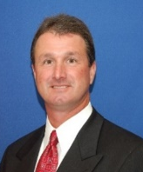
Kevin Jaynes, Regional Environmental Officer, FEMA Region 6
Mr. Jaynes has 29 years of experience conducting environmental site assessments, remedial oversight, health and safety training, hazardous materials, and federally-supported emergency responses. Since June 2010, he has served as FEMA’s Regional Environmental Officer responsible for managing and ensuring that all FEMA program activities in the region and at disasters receive the appropriate level of environmental and historic preservation (EHP) review as required by the National Environmental Protection Act (NEPA), National Historic Preservation Act (NHPA), associated regulations, and Executive Orders. He supervises the region’s EHP program teams in the Denton Regional Office, the Louisiana Integration and Recovery Offices, and the Texas Recovery Offices for Hurricane Harvey, which are responsible for review and comments on environmental assessments; the development of disaster and non-disaster program environmental compliance guidance; and negotiating, developing and implementing federal, tribal, state, and local interagency agreements and protocols for effective EHP compliance. From 1990 to 2008, Mr. Jaynes was employed under multiple federal contracts supporting the U.S. Environmental Protection Agency Region 6 emergency response and hazardous waste site investigations, where he participated in over 100 hazmat emergency responses and coordinated over 200 other responses and evaluations at superfund and chemical release incidents.

Francisco Sánchez, Deputy Emergency Management Coordinator, Harris County Office of Homeland Security & Emergency Management

Francisco Sánchez is the Deputy Emergency Management Coordinator for the Harris County Office of Homeland Security & Emergency Management (HCOHSEM). Mr. Sánchez joined HCOHSEMA in 2004 as the lead public information officer (PIO) during the local responses to both Hurricanes Katrina and Rita in 2005. He led the region’s Joint Information Center (JIC) operations during Hurricane Ike and the highly active 2008 hurricane season. Mr. Sánchez helped lead the region’s response to Hurricane Harvey, the second most destructive natural disaster in our nation’s history. Mr. Sánchez is an advocate of integrating emergency public information and JIC concepts into local emergency response efforts. He is a member of the highly regarded San Jacinto Type-III All Hazards Incident Management Team, one of only 18 such teams sanctioned by the state for deployment as ordered by the Texas governor. As a member of the Houston Area Urban Area Security Initiative (UASI) Regional Collaboration Committee, he works to build consensus on a variety of measures critical to local preparedness and response capabilities. In 2019, Sánchez was elected as President of the Emergency Management Association of Texas.

Misti Townsend, Regional Recovery Program Manager – Emergency Disaster Services, The Salvation Army Texas Division

Ms. Townsend has served the public for 15 years of continuous social service work and volunteering through counseling, teaching, training, research and nonprofit work. She discovered the area where passion and purpose intersect during her participation as a spontaneous volunteer for the December 2015 North Texas tornadoes. Working for the Texas Department of Emergency Management (TDEM), she was able to garner valuable experience acting as an advisor to cities and counties around the state in their creation and formation of Long-term Recovery Groups (LTRGs), coordination of resources, collaboration with large voluntary agencies, navigation of hardships, and efforts to meet the needs of affected populations. In 2017, her TDEM hat was traded for a Salvation Army shield when she became the Regional Recovery Program Manager for The Salvation Army Texas Division. In this role, Ms. Townsend leads the charge from the opposite side of the community-level recovery landscape by plugging in resources and financial assistance to survivors through LTRG networks across the state. She additionally serves as the Recovery Chair for the Texas Voluntary Agency Active in Disaster (TXVOAD).

Rocky Vaz, Director, City of Dallas Office of Emergency Management

Rocky Vaz is the Director of the Office of Emergency Management (OEM) for the City of Dallas. Under his leadership, the City of Dallas has achieved full accreditation through the Emergency Management Accreditation Program (EMAP), the second largest city in the nation to receive this accreditation. Mr. Vaz oversaw the expansion of Dallas Alert, the city’s emergency notification system, and a city-wide community preparedness initiative to educate Dallas residents about the hazards they may face and empower them to be prepared. During his tenure, Mr. Vaz has successfully coordinated the city’s response to several large-scale events and disasters including the 2014 Ebola event, 2015 flooding, 2016 police shooting in Downtown Dallas, 2016 mega shelter operations for Hurricane Harvey evacuees, 2016 natural gas explosion and evacuations, and the 2019 EF3 tornado. Mr. Vaz serves on various local, regional, state, and federal committees on emergency preparedness, disaster recovery, and homeland security. Mr. Vaz also chairs the Dallas / Fort Worth / Arlington (DFWA) UASI Executive Committee. Mr. Vaz is a founding member of the National Homeland Security Association (NHSA) for which he served in various capacities including as President of the NHSA Board for three years. He continues to serve on the Executive Board as the Past President.

This page intentionally left blank.

https://www.dhs.gov/presidential-policy-directive-8-national-preparedness (accessed online November 1, 2019)

