
Name of Jurisdiction

ICS/ICS-LIKE EOC
PLANNING
HANDBOOK
December 2020

Approval and Implementation
The (Name of Jurisdiction) Incident Command System (ICS)/ICS-like EOC Planning Handbook is designed to provide operational guidance for the (Name of Jurisdiction) Emergency Operations Center (EOC) by defining the overarching approach to (Name of Jurisdiction)’s EOC operations and position-specific guidance for the EOC Planning Coordination Section Chief, Units, and Positions. General and position-specific guidance includes general tasks, activation, operations, shift change, and demobilization checklists. Checklists will be used during operation and will continue to be refined based on subject matter expertise and lessons learned during real-world events. Handling instructions for this document are defined on page vii.
The (Name of Jurisdiction) ICS/ICS-like EOC Handbooks (Command, Operations, Planning, Logistics, and Finance/Admin) supersede all previous EOC handbooks and manuals for (Name of Jurisdiction) and implements the handbooks as the primary operational guidance for the (Name of Jurisdiction) EOC. In turn, this handbook does not supersede or replace the (Name of Jurisdiction) Emergency Operations Plan (EOP) and its annexes or other procedures already in place in (Name of Jurisdiction). Instead, it supplements those procedures with a temporary ICS/ICS-like management structure, which provides for the immediate management of response operations and the early transition to recovery operations.
This ICS/ICS-like EOC Planning Handbook is approved and implemented on (insert day) of (month), (year).

(Signature)
_____________________________________________________
(Name)

_____________________________________________________
(Senior Official Title), (Name of Jurisdiction)
Additional signature lines should be added to accommodate additional signatories.

This page intentionally left blank.

Record of Changes
Change # | Change Date | Change Type | Entered By

This page intentionally left blank.

Record of Distribution
Date | Office/Department | Representative | Signature

This page intentionally left blank.

Handling Instructions
The (Name of Jurisdiction) ICS/ICS-like EOC Planning Handbook is designated For Official Use Only (FOUO) and is the property of (Name of Jurisdiction) (Name of Organization). Only (Name of Organization) representatives may distribute the handbook to individuals with a need to know. Distribution by other individuals without prior authorization is prohibited. The handbook is unclassified but contains sensitive information that may be exempt from public release under the Freedom of Information Act (5 U.S.C. 552) and the Texas Public Information Act (Texas Government Code Chapter 552).
The handbook and its associated sections are to be controlled, handled, distributed, and disposed of in line with the U.S. Department of Homeland Security policy regarding FOUO designated materials. Copies of this handbook, digital and hard copy, should be stored in secure locations due to the operational content for emergency response, including materials focused on safety and security. The handbook should not be distributed to the public, media, or personnel without a valid need to know.
All questions regarding the handling of this document should be directed to (Name of Jurisdiction) (Name of Organization) (Name of Emergency Management Position).
This page intentionally left blank.

Table of Contents
Introductory Materials
Approval and Implementation i
Record of Changes iii
Record of Distribution v
Handling Instructions vii
EOC Operations 1
I. Introduction and Purpose 2
Introduction 2
Purpose 2
II. Emergency Response, ICS Fundamentals, and Community Lifelines Integration 3
Emergency Response Systems, Laws, and Authorities 3
ICS Overview 4
Unified Command 4
Unified Coordination 4
Disaster District Committees 5
ICS Organizational Elements – Roles and Responsibilities 6
Planning P 9
ICS/EOC Interface 10
FEMA Community Lifeline Integration into Situational Awareness 11
III. EOC Concept of Operations 12
Overview: Emergency Response Organization, Assignments, and Responsibilities 12
Activation Levels 13
Activation Triggers 14
ICS/ICS-like EOC Organization Chart 15
ICS/ICS-like EOC Layout 16
EOC Organization: Emergency Response Positions, Units, and Responsibilities 18
IV. EOC General Responsibilities Checklist 32
V. EOC Activation Checklist 35
VI. EOC Demobilization Checklist 37
Planning Coordination Section Chief and Units Roles, Responsibilities, and Checklists 39
I. Planning Coordination Section Chief 40
Roles and Responsibilities 40
Position Checklists (Activation, Operations, Demobilization) 41
II. Demobilization Unit 45
Roles and Responsibilities 45
Position Checklists (Activation, Operations, Demobilization) 45
III. Situation Unit 47
Roles and Responsibilities 47
Position Checklists (Activation, Operations, Demobilization) 47
IV. Advance Planning Unit 50
Roles and Responsibilities 50
Position Checklists (Activation, Operations, Demobilization) 50
V. Documentation Unit 52
Roles and Responsibilities 52
Position Checklists (Activation, Operations, Demobilization) 52
VI. Resource Tracking Unit 54
Roles and Responsibilities 54
Unit Checklists (Activation, Operations, Demobilization) 54
VII. Technical Specialists 56
Roles and Responsibilities 56
Position Checklists (Activation, Operations, Demobilization) 56
Handbook Maintenance, Revision, and References 59
I. Maintenance and Revision 60
II. References 61
Appendices 63
Appendix A: Damage Assessment Process A-1
Appendix B: Demobilization Plan Process B-1
Baseline Resource Demobilization Processes B-2
Appendix C: Glossary of ICS Terms C-1
Appendix D: Abbreviations D-1

EOC Operations
The goal of the Incident Command System (ICS)/ICS-like EOC Planning Handbook is to define key information and guidance regarding the operation of the (Name of Jurisdiction) Emergency Operations Center (EOC). The handbook accomplishes this goal by providing an overall organizational approach and general procedures for the management of information, activities, and operations in the EOC during an emergency or disaster. The handbook is focused on defining EOC operations to function based on a worst-case scenario and defines how critical functions and roles of the (Name of Jurisdiction) are managed during a response.
The (Name of Jurisdiction) EOC is operated using an ICS/ICS-like approach. Built on the organizational structure as defined in the National Incident Management System (NIMS), the (Name of Jurisdiction) EOC operates in line with emergency operations of other local, regional, state, and federal emergency management organizations. The ICS/ICS-like approach provides a flexible system, allowing for parts or the entire EOC to be activated to meet operational objectives.
The EOC Operations section begins with an introduction and a definition of the purpose of this handbook. It explores emergency response, ICS fundamentals, and community lifelines integration and documents the EOC Concept of Operations. This is followed by the EOC General Responsibilities Checklist, the EOC Activation Checklist, and the EOC Demobilization Checklist.

Introduction and Purpose

Introduction
Disasters and emergencies can happen suddenly, which can affect normal staffing levels, causing (Name of Jurisdiction) public safety departments to become overwhelmed. The (Name of Jurisdiction) Office of Emergency Management (OEM) has established this EOC handbook, which provides a guideline for the management of the immediate actions and operations required to respond to an emergency or disaster situation. The priorities of (Name of Jurisdiction) during a disaster are life safety, incident stabilization, protection of property and the environment, and the re-establishment of social norms. The overall objective is to respond to emergency conditions and manage the process of restoring the (Name of Jurisdiction) back to pre-disaster conditions.

Purpose
This handbook provides a management structure, key responsibilities, emergency assignments, and general procedures to follow during an emergency. OEM has established this handbook to address the priorities listed above. This handbook does not supersede or replace the (Name of Jurisdiction) Emergency Operations Plan and its annexes or other procedures that are already in place in (Name of Jurisdiction). It supplements those procedures with a temporary ICS/ICS-like management structure, which provides for the immediate management of response operations and the early transition to recovery operations. The emergency operations plan and annexes will always take precedent whenever procedural conflicts occur.

Emergency Response, ICS Fundamentals, and Community Lifelines Integration
This section outlines emergency response, ICS fundamentals, and community lifelines integration based on the specific use by (Name of Jurisdiction).

Emergency Response Systems, Laws, and Authorities
This section addresses the (Name of Jurisdiction) emergency responsibilities and is consistent with the following plan, system, laws, and authorities.

(Name of Jurisdiction) Emergency Operations Plan
Emergency management response authority, policies, responsibilities, and assignments are established in the (Name of Jurisdiction) Emergency Operations Plan (EOP). This plan allows the chief elected official or designee emergency authority to take actions and make emergency expenditures of funds in response to emergency conditions.
This plan is consistent with all plans and procedures and does not supersede or replace current procedures for safety, hazardous materials response, or other procedures that are already in place.

System, Laws, and Authorities
The (Name of Jurisdiction) emergency management response system and this handbook are in accordance with the following laws, codes, and executive orders:
(Name of Jurisdiction)
- Ordinance #(Number), Emergency Management
- Ordinance #(Number), Adoption of the National Incident Management System (NIMS)
State of Texas
- Government Code 418, Emergency Management
- Government Code 421, Homeland Security
- Government Code 433, State of Emergency
- Texas Administrative Code Title 37, Public Safety and Corrections
- Executive Order RP-32, Emergency Management and Homeland Security
- Executive Order RP-40, National Incident Management System (NIMS)
Federal Government
- The Federal Emergency Management Agency (FEMA) is the federal-level authority for emergency management. A presidential declaration activates the Federal Emergency Response Plan and allows the state to access federal resources for emergency response.
- The Robert Stafford Act (Public Law 93-288, amended) provides the federal authority and program for federal congressional appropriation of public funds for disaster assistance. The Stafford Act also includes a provision for hazard mitigation projects.
- Homeland Security Presidential Directive 5 (HSPD-5) - Management of Domestic Incidents (National Incident Management System), which was issued on February 28, 2003, enhances the ability of the United States to manage domestic incidents by establishing a single, comprehensive national incident management system.
This EOC handbook is designed for response operations. The North Central Texas Council of Governments (NCTCOG) Recovery Framework and associated toolkit (https://www.nctcog.org/ep/resources/local-disaster-recovery-framework-and-toolkit) are designed to assist with local recovery planning.

ICS Overview
As defined in the National Incident Management System (2017), ICS is a standardized approach for addressing command, control, and coordination of on-scene incident management. ICS is also used in many EOCs for incident management. ICS establishes a hierarchy and a flexible, expandable organizational structure to meet the demands of an incident.
The system allows for the integration of personnel from multiple organizations with varying levels of experience across disciplines to establish a coordinated incident management approach applicable to all hazards. ICS is used by government organizations (local, state, and federal), nongovernmental organizations (NGOs), and private sector entities.
Beyond simply addressing personnel for incident management, the ICS organizational structure provides an integrated approach for communications, equipment, facilities, personnel, and procedures.

Unified Command
The overall management of an incident can be the responsibility of a single Incident Commander (IC) or a Unified Command (UC). To improve unity of effort, Unified Command can be established to integrate multiple jurisdictions or agencies that are all engaged in managing an incident. The approach allows all jurisdictions and/or organizations with authority or functional responsibilities to jointly manage an incident, working collaboratively to establish strategies, incident objectives, and a single Incident Action Plan (IAP). Once Unified Command is established, each organization and/or jurisdiction retains its own authorities and responsibilities. Communication is an essential element for the operation of an effective Unified Command.
The composition of a Unified Command is based on the demands, the location, and the type of incident. Unified Command, like a single Incident Commander, is responsible for establishing an Incident Command Post (ICP), designating Section Chiefs, establishing a single resource ordering system, approving the IAP, establishing strategic guidance and prioritized incident objectives, capturing lessons learned and best practices, and establishing a joint decision-making process.

Unified Coordination
Unified coordination describes incident management activities conducted by primary, state, tribal, territorial, insular area, and federal entities at the incident level. Unified coordination is established using an ICS structure. Though organized using an ICS structure, unified coordination does not manage on-scene response operation; instead, unified coordination focuses on support operations that may or may not extend beyond the boundaries of the incident.
The Unified Coordination Group (UCG) is composed of senior leader representatives from state, tribal, territorial, insular area, and federal government interests and in some cases, may include local governments, private sector organizations, and NGOs. Each representative in a UCG is required to have a significant jurisdictional responsibility or authority, and like Unified Command, the composition of the UCG varies by incident based on the location, scope, and nature of the disaster. The UCG sits at the top of a unified coordination organization chart. Unified coordination serves as the primary field-based entity for federal response.

Local Elected Officials
Mayors and county judges serve as emergency management directors with specific responsibilities and authorities as defined in the Texas Government Code (Section 418):
- The presiding officer of the governing body of a political subdivision (municipality or county) may declare a local state of disaster. After seven days, the declaration must be ended or renewed by the governing body.
- The county judge or mayor of a municipality has the authority to order an evacuation of part or all of the population of a stricken or threatened area to preserve life or to address other disaster mitigation, response, or recovery.
- The county judge or mayor can control ingress and regress of a disaster area inside his/her jurisdiction.
- The county judge’s authority supersedes the authority of the mayor when a conflict of decisions takes place in connection to evacuation orders and/or control of entry/exit from a disaster area.
This information is subject to change based on legal decisions associated with ongoing litigation, a change in the Texas Government Code, or other legal findings.

Mutual Aid
Under Texas Government Code (Section 418), local governments may provide mutual aid to other local governments using existing mutual agreements or through the Texas Statewide Mutual Aid System (SMA). The SMA allows local government entities to request mutual aid response capabilities without an established, written mutual aid agreement for 12 hours at no cost. Mutual aid requests are considered authorized under the SMA, unless an outside agreement is in place between the coordinating local governments. This information is subject to change.

Disaster District Committees
Disaster districts in the State of Texas serve as the initial source of state-level emergency preparedness and response assistance to local governments. The State of Texas established a minimum of one disaster district committee (DDC) in each of the Texas Council of Government regions. Each DDC is composed of local representatives from the state agencies to engage in homeland security preparedness and response activities. Several regions have multiple DDCs, including the NCTCOG region, which has two (4A and 4B). The public safety director of the Texas Department of Public Safety appoints a commanding officer from the Texas Highway Patrol to chair each DDC.

ICS Organizational Elements – Roles and Responsibilities
The following section defines key organizational elements, including organizational structures and facility types, commonly used in an ICS organizational structure. Some terms apply to EOC and field operations, which is noted.

Section
The ICS organizational element having responsibility for a major functional area of incident management (e.g., Operations, Planning, Logistics, and Finance/Admin). The organizational level is used in field incident command and EOC organizational structures. Sections can contain additional organizational structures (e.g., branches, units), but the use of lower-level organizational features is based on the needs of the incident.
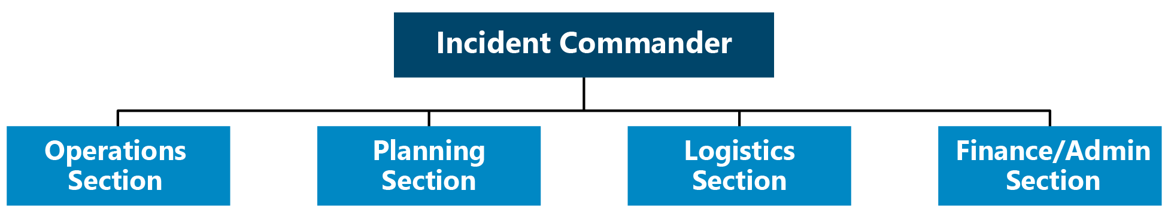
Figure 1: Incident Commander and Four Traditional Sections of an ICS Organizational Structure

Branch
A branch serves as a specific organizational level in an ICS organizational structure. A branch has functional or geographic responsibilities for major elements of an incident operations. The organizational level is used in field incident command and EOC organizational structures. Branches are used in the Operations and Logistics Sections. In the Operations Section, branches are located below a Section Chief and above any divisions or groups (see definitions below). In the Logistics Section, branches are used between the section and units.
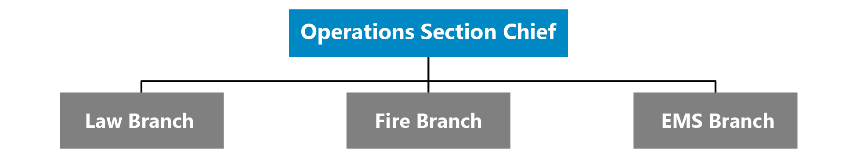
Figure 2: Example of Functional Branches of an ICS Organizational Structure

Division
A division is the organizational level having responsibility for operations within a defined geographic area. Divisions are established when the number of resources exceeds the manageable span of control of the Section Chief. Divisions are typically associated with field operations.
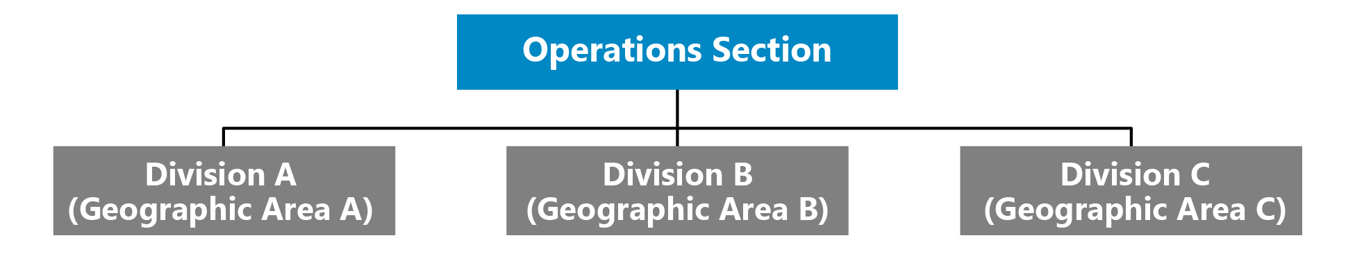
Figure 3: Example of Divisions in an ICS Organizational Structure

Group
Within an incident management structure groups are subdivisions of operations based on functional areas. Differing from divisions, the subdivision is based on a functional area not a geographic area. Each group contains the resources to perform a specific function. Groups are typically associated with field operations.
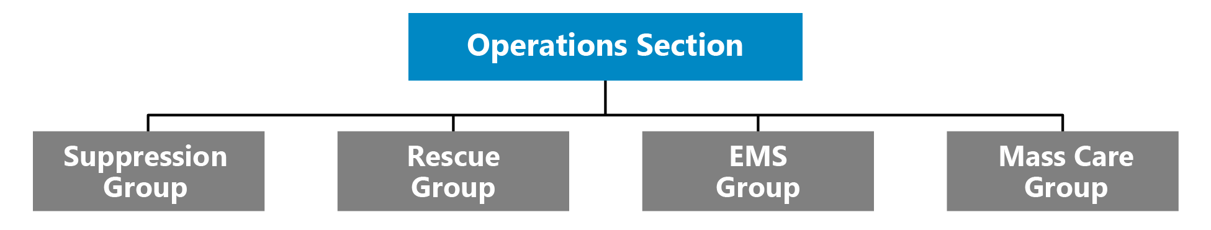
Figure 4: Example of Functional Groups in an ICS Organizational Structure

Unit
Within an ICS organizational structure, units are located within the Planning, Logistics, and Finance/ Administration Sections. Units have functional responsibility for a specific activity (e.g., Cost Unit, Transportation Unit, Communications Unit, etc.).
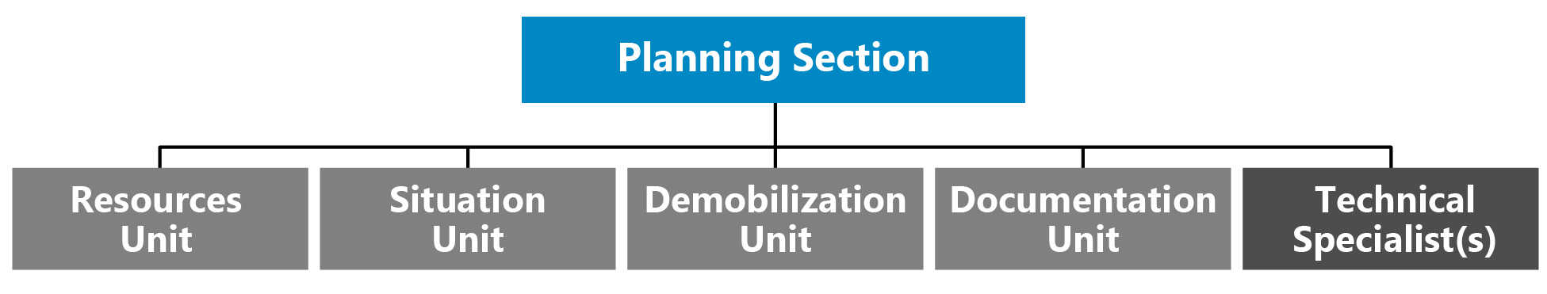
Figure 5: Example of Units and Technical Specialists in an ICS Organizational Structure

Technical Specialists
ICS functions in a wide variety of incidents that need technical specialists. Technical specialists have special expertise and skills, and they are activated only when needed. No specific qualifications are prescribed, as technical specialists normally perform the same duties during an incident that they perform in their everyday jobs, and they are typically certified in their fields or professions.
Technical specialists may serve anywhere within the organization depending on factors such as complexity, span of control, lines of communication, and subject matter expertise. They are most often assigned to the specific area (section, branch, division, group, or unit) where their services are needed. Technical specialists assigned to the Command Staff are called command advisors. In some situations, they are assigned to a separate unit within the Planning Section, much like a talent pool, and assigned out to various jobs on a temporary basis.
Generally, if the expertise is needed for only a short time and involves only one individual, that individual is assigned to the Situation Unit. If the expertise is needed on a long-term basis and necessitates several persons, a separate Technical Unit is established in the Planning Section.
Access and functional needs advisor | Agricultural specialist
Behavioral health specialist | Community representative
Decontamination specialist | Environmental impact specialist
Epidemiologist | Flood control specialist
Geographic Information Systems (GIS) specialist | Health physicist
Industrial hygienist | Intelligence specialist
Legal advisor | Meteorologist
Pharmacist | Science and technology advisor
Toxicologist | Veterinarian

Task Force
A task force is a combination of resources that are different, which may be different kinds and/or types, that are brought together to meet a specific mission or operational need. Task Forces can be used in connection with field operations and/or an EOC. A Community Feeding Task Force, for example, may be composed of representatives from a variety of county agencies and NGOs, each with different organizational focuses but with the shared mission of supporting the distribution of food in the community during a disaster.

Strike Team/Resource Team
Differing from a task force, a strike team (also known as a resource team) is composed of resources of the same kind and type with a focus on a specific mission or operational need. Strike teams, such as an Explosive Ordnance Disposal (EOD) Team, focusing on a specific mission, have an established minimum staffing requirement, common communications, and a leader.

Single Resources
Differing from task forces and strike teams, single resources are individuals, a specific piece of equipment, including supporting supplies and personnel, or a team (or crew) with an identified supervisor. Single resources are commonly used throughout an incident.

Staging Area
The staging area is a physical location that is temporarily used to station resources (personnel, supplies, and equipment) prior to operational assignment.

Planning P
The Planning P is an operational planning cycle approach for establishing strategic and operational objectives, developing on-scene IAPs and/or EOC emergency action plans (EAPs) and IAPs, operating/updating the existing plan, and maintaining situational awareness and information sharing processes. The “leg” portion of the Planning P process is only enacted during the initial response phase. Subsequent operational periods follow the circular portion of the process. The EOC Director, General Staff, Command Staff, and other EOC staff members participate in the process through effective engagement in development of the EOC IAP or EAP and communication of essential elements of information for development of situation reports (SITREPs) and spot reports. The Planning Section Chief is ultimately responsible for ensuring implementation of the operational planning cycle.

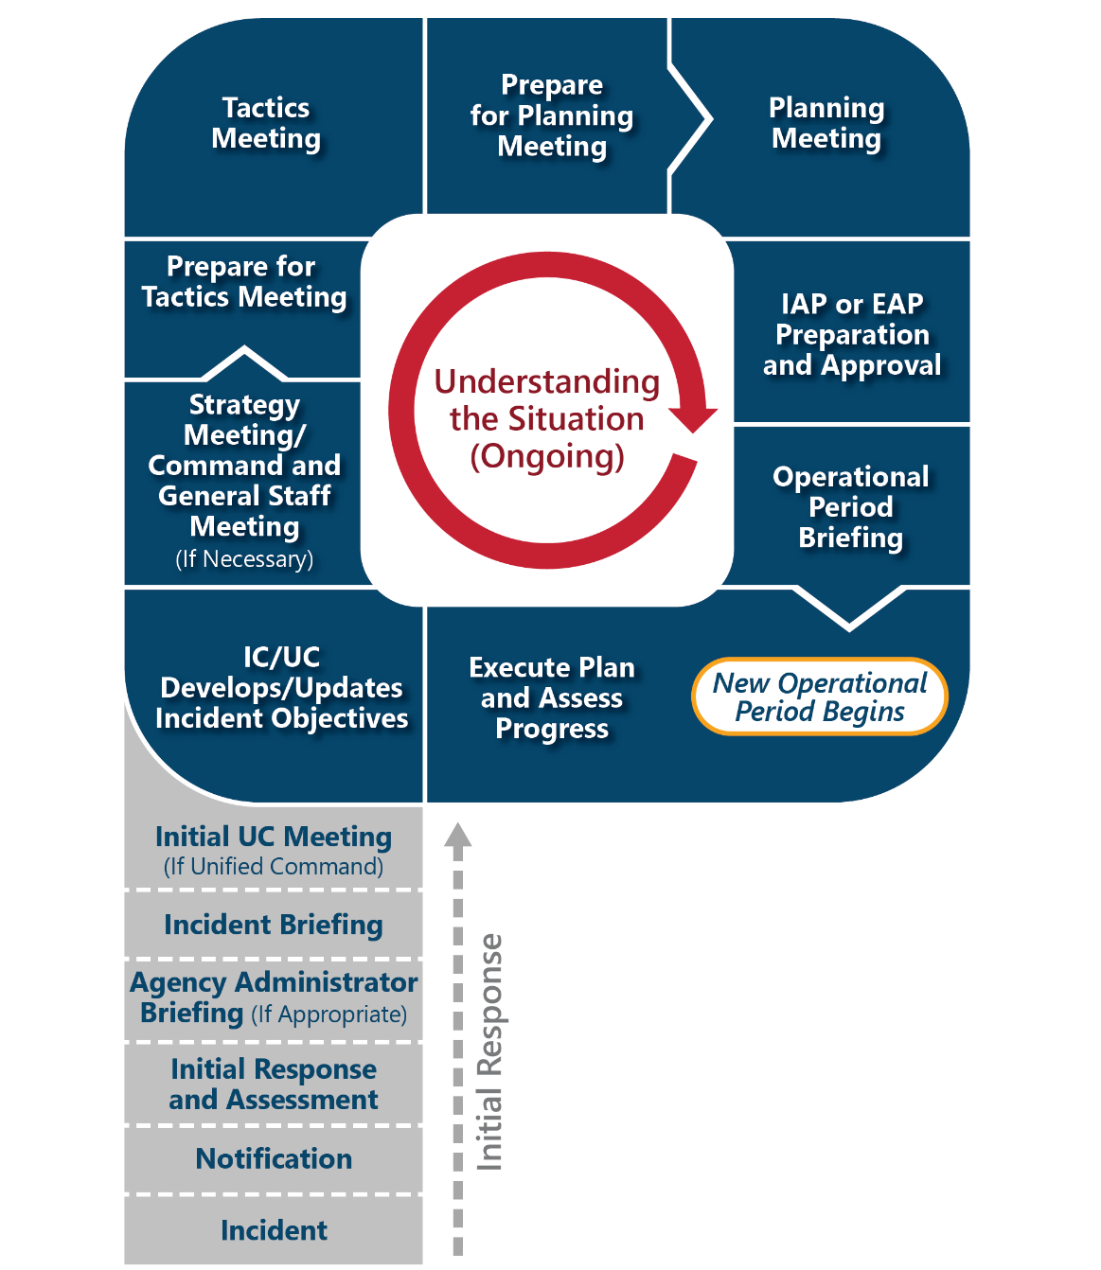
Figure 6: The Planning P

ICS/EOC Interface
When field and EOC operations are both established, these operations must be interfaced to establish and maintain a unified response. An effective interface establishes clear lines of communication, clearly defines roles and responsibilities, and establishes appropriate connection points between incident command and the EOC organizations based on activated sections, units, and positions.
The EOC can be leveraged to oversee specific operational elements and to provide coordination support to field operations. When supporting on-scene incident command, the EOC provides operational and strategic coordination; information collection, analysis, and dissemination; and logistical support (e.g., resource acquisition and tracking). Establishing direct lines of communication is essential for a coordinated approach and aligning operational objectives. EOC staff, as directed by the EOC Director and Section Chiefs, establishes coordination with appropriate field counterparts. Identifying the appropriate counterparts is aided by the (Name of Jurisdiction) EOC’s use of an ICS/ICS-like organizational structure, which reflects the ICS established for field operations. Additionally, through adherence to NIMS, both organizations use a unified doctrine composed of common terminology and operational protocols.
The operational period of field and EOC operations can be synchronized, though not always perfectly aligned, based on each organization’s operational planning cycles.

EOC/Field Synchronization
The synchronization of planning processes between the EOC and incident command in the field is an essential process for ensuring the objectives outlined by both entities are aligned. When an incident necessitates moving into a multi-operational cycle based on magnitude, scope, or longevity of an incident, incident command will develop an on-scene IAP. When the EOC is activated, the EOC will develop an EOC (IAP or EAP). The IAP developed in the field focuses directly on field response operations, and the EOC (IAP or EAP) focuses on providing coordination and support to field operations and other objectives not directly associated with the scene such as mass care. In turn, there are circumstances when an incident does not involve a field operation overseen by an incident or area command (e.g., COVID-19). In these cases, the EOC’s (IAP or EAP) will serve as the overarching plan for establishing strategic and operational objectives.
When there is establishment of field and EOC operations, synchronization is achieved by ensuring appropriate incident command and EOC personnel are involved in shared meetings that fit within the operational tempo of both organizations, allowing for development of plans that are aligned and operating simultaneously to meet overarching incident objectives. If the EOC’s (IAP or EAP) is out of sync with the field operations’ IAP, a mismatch can occur between the two organizations’ objectives and the prioritization of objectives. The synchronization of operational planning cycles is most commonly established between On-scene Incident Commander and the EOC Director and coordinated with the planning sections.
Synchronization in terms of aligning objectives may not mean attempting to perfectly align the operational tempo and operational planning cycles of field and EOC operations. For example, the development of field operations’ objectives may need to precede the development of an EOC’s operational objectives to ensure the EOC’s focus aligns with the needs of field operations based on newly established objectives. If both planning cycles are operating on the same operational tempo with perfectly aligned meetings, it can result in plans that are not aligned because they are attempting to follow exactly the same development timeline. Also, if leadership from either organization is attending (even virtually) meetings of the other entity, they cannot attend corresponding meetings in their own planning cycle. Additionally, when there are multiple incident command structures in the field, alignment with the EOC requires additional consideration.

FEMA Community Lifeline Integration into Situational Awareness
Focused on response, the Federal Emergency Management Agency (FEMA) established community lifelines as a way to organize operational focus on seven essential categories required for incident stabilization and protection of life. The seven categories are safety and security; food, water, shelter; health and medical; energy (power and fuel); communications; transportation; and hazardous materials.

Figure 7: FEMA Community Lifelines
FEMA defines lifelines as fundamental services that when stabilized, allow all other aspects of a society to function. Each lifeline is composed of supporting components and subcomponents. For example, the energy lifeline has two components: power grid and fuel. In turn, power grid has three subcomponents: generation systems, transmission systems, and distribution systems.
During an emergency response, evaluation of community lifelines, focusing on incident impacts, allows for an assessment of the overarching impacts on a community. By focusing on community lifelines, incident impact information is used to build clear situational awareness focused on stabilization and restoration of key services and elements of the community, keeping response and support staff and decision-makers informed.
The Planning P drives the cyclical process of assessing the current situation based on community lifelines and determining stabilization targets for each community lifeline. With a focus on building and maintaining situational awareness, the EOC produces SITREPs as part of the Planning P cycle. In turn, the Planning P can drive the development of SITREPs through the EOC (IAP or EAP) development process. When using community lifelines, EOC (IAPs or EAPs) are developed through analysis of impacts to all seven community lifelines, the establishment of stabilization targets for all impacted community lifelines, and defining response activities that result in meeting stabilization targets.

EOC Concept of Operations
This handbook provides the organized management system for (Name of Jurisdiction) to follow during emergencies. It is designed as a flexible system in which the entire plan or parts of the plan may be activated, as appropriate to the situation. It is based on a worst-case scenario and provides for the critical functions and roles of the (Name of Jurisdiction) during a response. It is considered a management tool, because it provides an overall organization and general procedures for the management of information, activities, and operations during an emergency.
The handbook is also based on the Incident Command System (ICS), the management structure adopted throughout the United States and internationally. (Name of Jurisdiction) utilizes a five-section structure and each of the five sections contains sub-elements and/or positions for the critical operations needed for the (Name of Jurisdiction) to operate effectively during an emergency. An organizational chart of the sections and positions can be found on page (Page #).

Overview: Emergency Response Organization, Assignments, and Responsibilities
Emergency response management requires the establishment of an organization comprised of the most important or critical functions of the (Name of Jurisdiction). This organization is called to duty during times of emergency, when normal operations are not sufficient to meet the immediate or overwhelming needs that occur. These critical functions are necessary to provide immediate emergency response for:
- Life safety and protection of property and assets
- Restoration of lifelines
- Resumption and continuation of (Name of Jurisdiction) government operations
- Restoration of government operations to normal
- Recovery of expenses and losses through the federal disaster assistance programs under the Stafford Act (PL 94-288 amended)
Consistent with the NIMS ICS/ICS-like organization and similar to the current emergency management standard within the State of Texas, the (Name of Jurisdiction) EOC handbook follows a five-section structure as the basis for organizing emergency planning and response. The five sections are (1) Command, (2) Operations Coordination, (3) Planning Coordination, (4) Logistics Coordination, and (5) Finance/Admin Coordination. The (Name of Jurisdiction) emergency response organization is based on these sections, as shown on the “ICS/ICS-like EOC Organization Chart” located on page (Page #). A description of the roles and responsibilities of EOC positions are shown within the “(Name of Jurisdiction) Emergency Response Positions, Units, and Responsibilities” table located on pages 18–31.

Activation Levels
If different than those defined in the table below, jurisdiction-specific activation levels should be used.
(Name of Jurisdiction) Office of Emergency Management EOC Activation Levels
Activation Level | Level Description | Response / Notification | EOC Staff Actions | EOC Facility
Level 4 | - Normal, day-to-day | - EOC Support | - EOC Support | - Steady State
Level 3 | - Monitoring the situation. There is potential for an emergency, but no immediate threat to life or property  - Public warning may be needed | - OEM on stand-by or monitoring situation  - OEM Director notified  - Local department heads and other officials notified of conditions  - Amateur Radio Operations may be activated  - OEM Director and local officials receive periodic updates | - Notified of condition | - Standby/Open
Level 2 | - Escalation from non-routine emergencies  - Multi- departmental response | - OEM staff respond to EOC  - OEM Director notified  - Activate appropriate department heads and other officials and have them respond to the EOC  - Notify additional department heads and other officials of conditions and place on stand-by  - Notify (Other Jurisdiction(s)) OEM | - EOC partially activated, depending on circumstances | - Open
Level 1 | - Assistance from other jurisdictions or mutual aid may be needed  - Local area disaster or multi-site incident | - OEM staff respond to EOC  - OEM Director notified  - Activate all appropriate department heads and other officials needed for full activation and have them respond to the EOC  - Notify (Other Jurisdiction(s)) OEM | - EOC fully staffed | - Open

Activation Triggers
Activation triggers describe changes in the EOC’s operational posture based on coordination demands of a threat or actual incident. Please note, Level 4 is defined as routine or normal operational posture; therefore, no trigger is defined. Jurisdiction-specific activation triggers should be used to further refine the provided activation trigger information.
- Level 3 Activation Trigger: When a potential threat or incident grows beyond the capability or capacity of Level 4 operations or is expected to do so, the Emergency Management Coordinator, or designee, makes the decision to increase monitoring, notify EOC staff, and send out periodic updates in response to potential threats or an active incident. At this point, the EOC maybe on standby or open.
- Level 2 Activation Trigger: When a potential threat or incident grows beyond the capability or capacity of Level 3 operations or is expected to do so, the transition to a partial activation of the EOC will take place. The partial activation staffing level will be tailored to meet the anticipated needs. The Emergency Management Coordinator, or designee, may move directly to activation Level 2 if deemed warranted by the potential threat or active incident.
- Level 1 Activation Trigger: When a potential threat or incident grows beyond the capability or capacity of Level 2 operations or is expected to do so, the transition to Level 1 (full activation) will take place. The Emergency Management Coordinator, or designee, may move directly to full activation if deemed warranted by the potential threat or active incident.

ICS/ICS-like EOC Organization Chart
The ICS/ICS-like EOC Organization Chart is a sample that depicts a full Level 1 Activation. Not all positions and units will be needed each time the EOC is activated. Activate the EOC positions and units deemed necessary to effectively respond to the situation then expand or contract as needed.

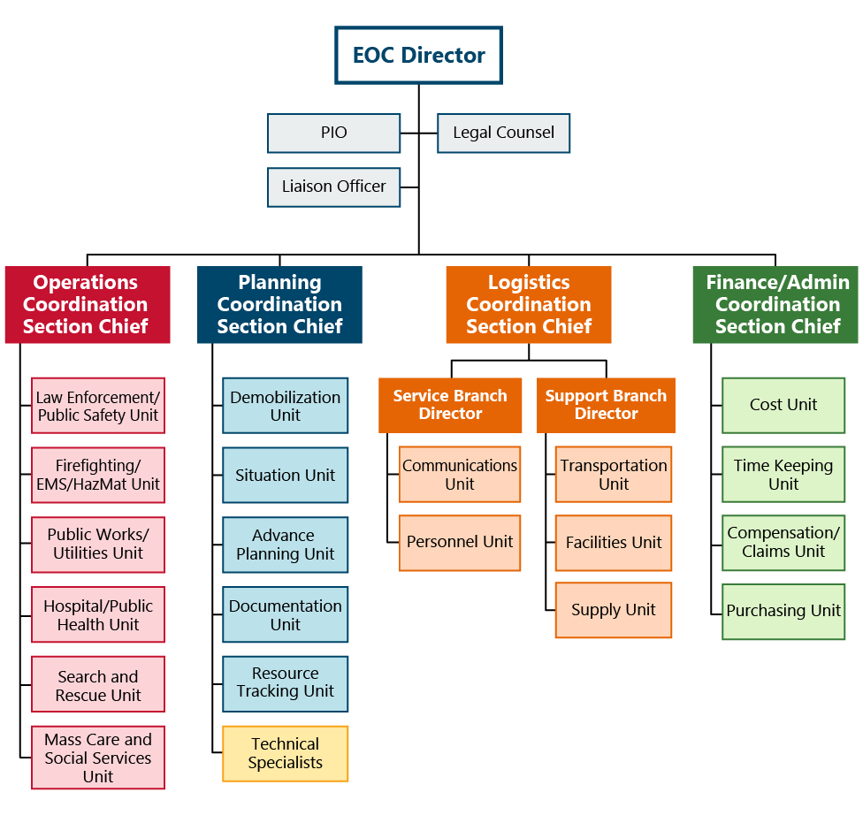

Figure 8: ICS/ICS-like EOC Organization Chart

ICS/ICS-like EOC Layout
Two ICS/ICS-like EOC floorplan layouts are provided as examples. A customized graphic should be developed based on the jurisdiction’s EOC layout to replace the examples.
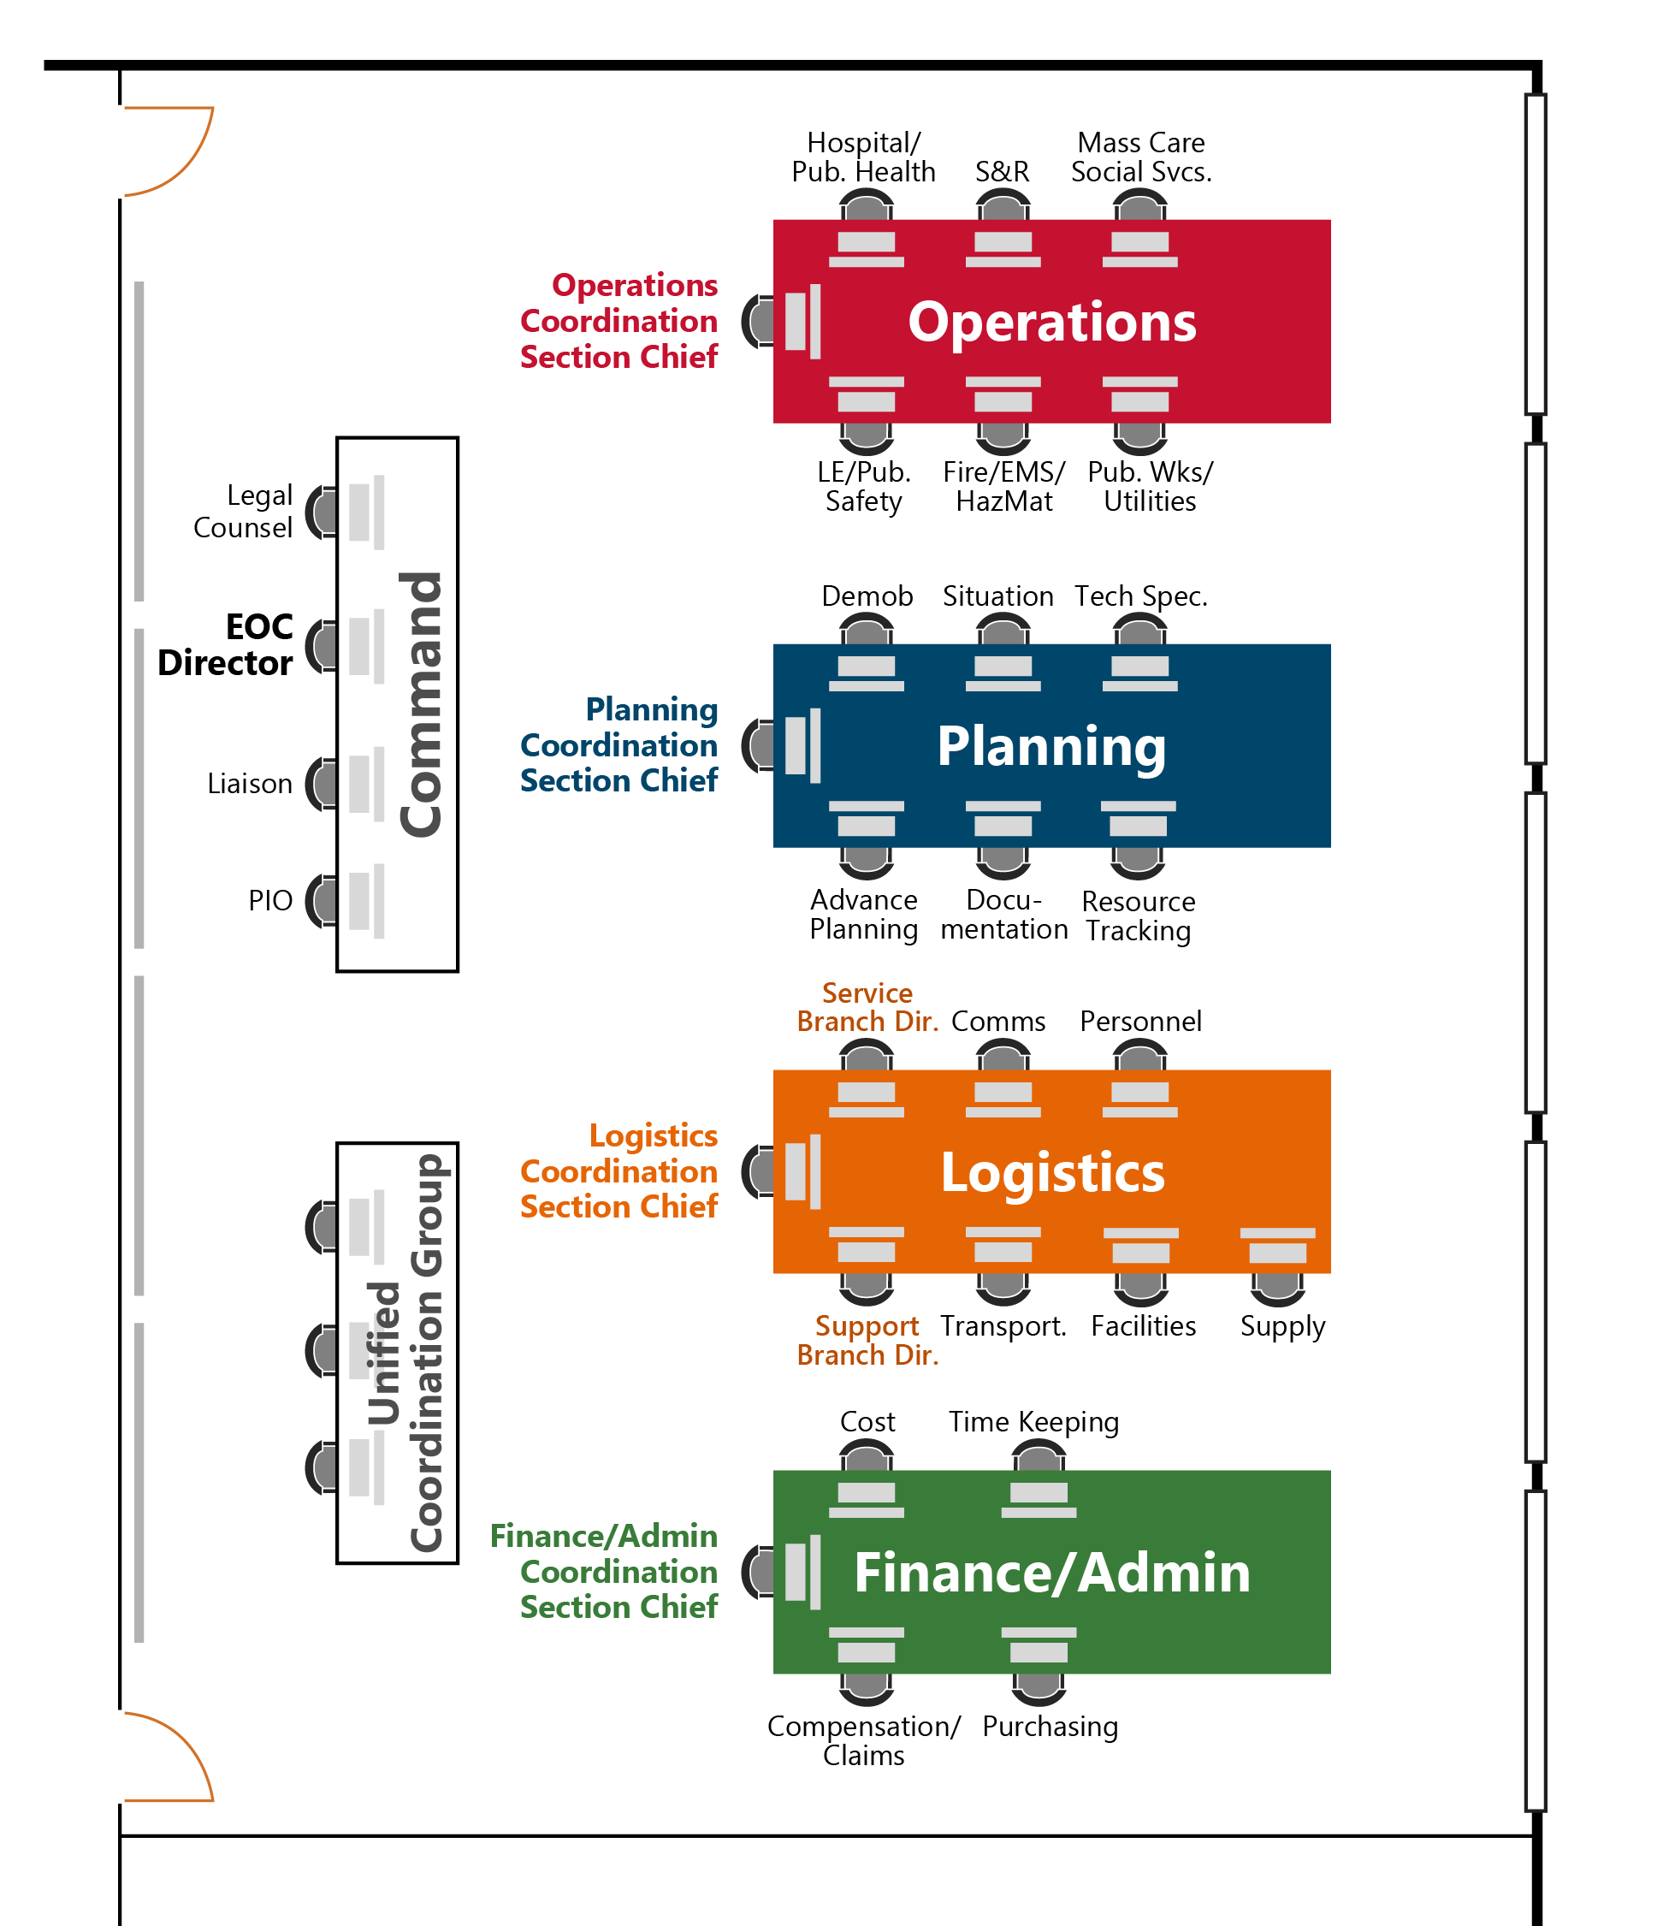
Figure 9: EOC Floorplan Example 1

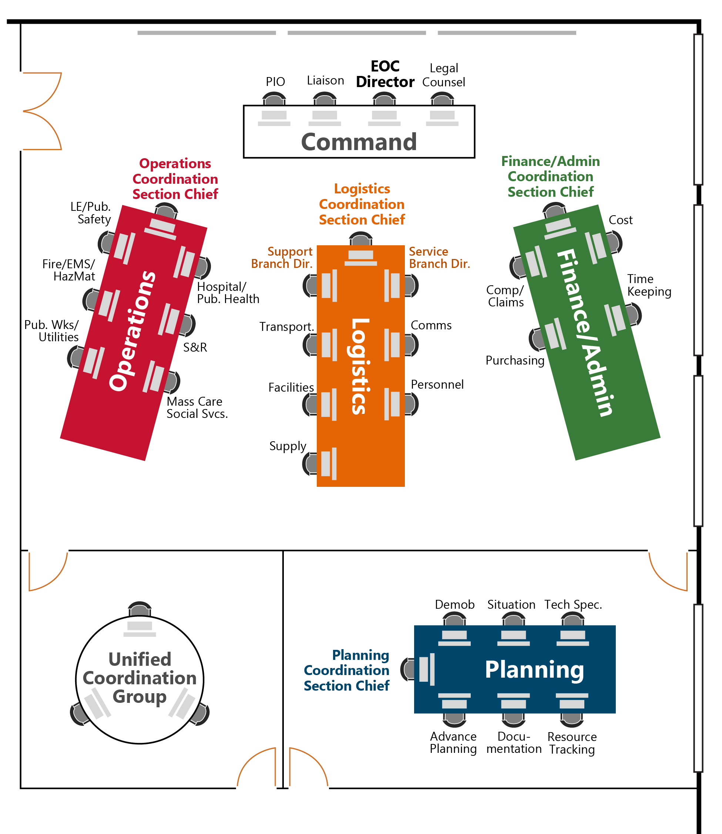
Figure 10: EOC Floorplan Example 2

EOC Organization: Emergency Response Positions, Units, and Responsibilities
Command Section
Position/Unit | Responsibilities
EOC Director | The EOC Director manages and provides direction for the emergency response and recovery.  Specific areas of management include the following:  - Establish direction and control of the overall emergency response and recovery.  - Determine needs and activate the EOC Command Staff and sections as needed.  - Coordinate with the Public Information Officer regarding public information, press releases, and media relations.  - Coordinate with the Liaison Officer about activities and coordination with surrounding jurisdictions and state, federal, and private partners.  - Coordinate with Legal Counsel regarding emergency actions, liability, legal procedures, and possible legal eventualities.  - Provide (Name of Jurisdiction) senior elected and appointed officials information about the emergency or disaster and response activities and the need for a local disaster declaration.  - Manage fiscal authorization for expenditures.
Public Information Officer (PIO) | - Serve as the (Name of Jurisdiction) central coordination point for all media releases.  - Ensure the public within the affected area receives complete, accurate, and consistent information about life safety procedures, public health advisories, relief and assistance programs, and other vital information.  - Coordinate media releases with PIOs at incidents or representing other affected emergency response agencies as required.  - Develop the format for press conferences, in conjunction with EOC Director.  - Determine the need for additional PIOs to support the incident.
Liaison Officer | - Oversee all liaison activities, including coordinating with outside agency representatives assigned to the EOC and handling requests from other EOCs for (Name of Jurisdiction) representatives.  - Establish and maintain a central location for incoming agency representatives, providing workspace and support as needed.  - Ensure position-specific guidelines, policy directives, SITREPS, the appropriate EOC (IAP or EAP) are provided to agency representatives upon check-in.  - In coordination with the EOC Director, provide orientations for VIPs and other visitors to the EOC or incident scene with approval of the incident commander.
Legal Counsel | - Assess (Name of Jurisdiction) legal risks and liabilities resulting from the emergency or from operations.  - Provide professional counsel to the EOC Director regarding emergency actions, liabilities, legal procedures, and possible legal eventualities.  - Represent the (Name of Jurisdiction) in matters involving local, state, and federal regulatory agencies.

Operations Coordination Section
Position/Unit | Responsibilities
Operations Coordination Section  Chief | - Supervise the Operations Coordination Section.  - Ensure the Operations Coordination Section staff provides on-scene personnel the resources and support necessary to achieve incident objectives, identify unmet needs, and address leadership priorities.  - Ensure the operational objectives and assignments identified in the EOC (IAP or EAP) are carried out effectively.  - Establish the appropriate level of unit organizations within the Operations Coordination Section, continuously monitoring the effectiveness, and modifying accordingly.  - Maintain a communications link between On-scene Incident Commander and the EOC for the purpose of coordinating the overall response, resource requests, and event status information.  - Ensure the Planning Coordination Section is provided with Status Reports and Incident Reports.  - Conduct periodic operational briefings for the EOC Director as required or requested.
Law Enforcement/ Public Safety Unit | - Coordinate (Name of Jurisdiction) law enforcement and public safety operations.  - Maintain the status of unassigned law enforcement and public safety resources.  - Develop and maintain status reports for major incidents requiring or potentially requiring mutual aid, state, and/or federal support.  - Request and coordinate mutual aid resources, as necessary.  - Coordinate the mobilization and transportation of additional resources through the Logistics Coordination Section.  - Ensure the appropriate actions are taken to address the operational objectives and assignments in the EOC (IAP or EAP) assigned to the unit.
Firefighting/ EMS/HazMat Unit | - Coordinate (Name of Jurisdiction) firefighting, emergency medical service (EMS), and hazardous materials (HazMat) operations.  - Maintain the status of unassigned firefighting, emergency medical service, and hazardous materials resources.  - Develop and maintain status reports for major incidents requiring or potentially requiring mutual aid, state, and/or federal support.  - Request and coordinate mutual aid resources, as necessary.  - Coordinate the mobilization and transportation of additional resources through the Logistics Coordination Section.  - Ensure the appropriate actions are taken to address the operational objectives and assignments in the EOC (IAP or EAP) assigned to the unit.
Public Works/ Utilities Unit | - Survey and restore (Name of Jurisdiction) utility systems that have been disrupted.  - Develop and maintain status reports.  - Coordinate with additional utility service providers on their status and restoration of disrupted services.  - Survey public and private facilities, assessing the damage to such facilities and coordinating the repair of damage to public facilities.  - Survey and repair local infrastructure systems including streets and roads within the jurisdictional area.  - Coordinate the mobilization and transportation of additional resources through the Logistics Coordination Section.  - Coordinate clearance of debris in order to open roads for access.  - Ensure that the appropriate actions are taken to address the operational objectives and assignments in the EOC (IAP or EAP) assigned to the unit.
Hospital/Public Health Unit | - Coordinate (Name of Jurisdiction) hospital and public health operations.  - Maintain the status of available hospital and public health resources.  - Develop and maintain status reports including patient tracking, available beds, and fatalities.  - Identify additional needs that may be met through mutual aid, state, and/or federal support.  - Request and coordinate mutual aid.  - Coordinate the mobilization and transportation of additional resources through the Logistics Coordination Section.  - Ensure the appropriate actions are taken to address the operational objectives and assignments in the EOC (IAP or EAP) assigned to the unit.
Search and  Rescue Unit | - Coordinate (Name of Jurisdiction) search and rescue operations.  - Maintain the status of unassigned search and rescue resources.  - Develop and maintain status reports for major incidents requiring or potentially requiring mutual aid, state, and/or federal support.  - Request and coordinate mutual aid resources, as necessary.  - Coordinate the mobilization and transportation of additional resources through the Logistics Coordination Section.  - Ensure the appropriate actions are taken to address the operational objectives and assignments in the EOC (IAP or EAP) assigned to the unit.
Mass Care and Social Services Unit | - Coordinate (Name of Jurisdiction) mass care and social services.  - Develop and maintain status reports including available shelters, shelter status, capacity, shelter populations, available shelter space, and unmet needs.  - Identify how unmet needs could be addressed through mutual aid, volunteer organizations, private sector, state, and/or federal support.  - Request and coordinate mutual aid.  - Coordinate the mobilization and transportation of additional resources through the Logistics Coordination Section.  - Ensure the appropriate actions are taken to address the operational objectives and assignments in the EOC (IAP or EAP) assigned to the unit.

Planning Coordination Section
Position/Unit | Responsibilities
Planning Coordination Section  Chief | - Ensure the responsibilities of the Planning Coordination Section are addressed as required, including the following:  - Collect, analyze, and display situation information.  - Prepare SITREPs.  - In coordination with the EOC Director, the Command Staff, and the General Staff, establish the operational periods, meetings schedules, and staffing plan.  - Prepare and distribute the EOC (IAP or EAP), and facilitate the planning meeting.  - Conduct advance planning activities and report.  - Provide technical support services to EOC sections and branches.  - Ensure resources are tracked and resource tracking boards are developed and maintained.  - Develop the EOC Demobilization Plan, if necessary.  - Coordinate the collection, analysis, and sharing of incident-related intelligence and investigative information.  - Document and maintain files on all EOC activities.  - Establish the appropriate level of organization for the Planning Coordination Section.  - Determine the need to establish a separate intelligence unit to serve as a conduit for secure information sharing with law enforcement entities based on requirements for additional security clearances.  - Supervise and exercise overall responsibility for the coordination of unit activities within the section.  - Inform EOC Director of significant issues affecting the Planning Coordination Section.  - In coordination with other Section Chiefs, ensure status reports are completed and used as the basis for situation analysis reports and the EOC (IAP or EAP).
Demobilization Unit | - Develop a Demobilization Plan for the EOC based on a review of all pertinent planning documents, and status reports.  - Work closely with Command and General Staff to ensure a smooth and orderly release of resources.  - Coordinate with the Facilities Unit.
Situation Unit | - Oversee the collection, organization, and analysis of situation information related to the emergency.  - Oversee damage assessment.  - Coordinate the collection, analysis, and sharing of incident-related intelligence and investigative information (unless a separate intelligence unit is established by Planning Coordination Section Chief).  - Ensure information collected from all sources is validated prior to posting on status boards.  - Ensure SITREPs are developed for dissemination to EOC staff and to other agencies/organizations as required.  - Ensure an EOC (IAP or EAP) is developed for each operational period.  - Ensure all maps, status boards, and other displays contain current and accurate information.  - Prepare to deliver a situational briefing throughout the ICS planning process and at other times as directed.
Advance Planning Unit | - Development of an Advance Plan consisting of potential response and recovery related issues likely to occur beyond the next operational period, generally within 36 to 72 hours.  - Review all available status reports, EOC (IAPs or EAPs), and other significant documents.  - Determine potential future impacts of the emergency, particularly issues which might modify the overall strategic EOC objectives.  - Provide periodic briefings for EOC Director and General Staff addressing Advance Planning issues.
Documentation Unit | - Collect, organize, and file all completed emergency related forms, to include all EOC Activity Logs (ICS 214), SITREPs, (IAPs or EAPs), and any other related information, just prior to the end of each operational period.  - Ensure any documentation submitted to the Documentation Unit is accurate and complete. Have reporting parties correct any errors or omissions before final submission.  - Provide document reproduction services to EOC staff.  - Distribute the EOC SITREPs, (IAPs or EAPs), and other documents, as required.  - Maintain a permanent electronic archive of all SITREPs and (IAPs or EAPs) associated with the emergency.  - Assist the OEM Director in the preparation and distribution of the After-Action Report.
Resource  Tracking Unit | - Coordinate with other units, including those in the Logistics Coordination Section and field operations (e.g., staging area manager) to capture and centralize necessary resource, location, and status information.  - Develop and maintain resource tracking boards that include status, location, and other important information.
Technical Specialists | - Provide technical observations and recommendations to EOC staff in specialized areas as required.  - Advise on legal limitations on use of particular resources.  - Work with inter-agency coordination groups as necessary providing expertise.

Logistics Coordination Section
Position/Unit | Responsibilities
Logistics Coordination Section  Chief | - Ensure the responsibilities of the Logistics Coordination Section are addressed as required, including the following:  - Provide telecommunication services and information technology.  - Locate or acquire equipment, supplies, personnel, facilities, and transportation to meet field and EOC operational needs.  - Track resources from deployment through demobilization and return (unless consumable).  - Arrange for food, lodging, and other support services as required both for the EOC and field site requirements.  - Establish the appropriate level of unit staffing within the Logistics Coordination Section, continuously monitoring the effectiveness of the organization and modifying as required.  - Ensure Logistics Coordination Section objectives, as stated in EOC (IAPs or EAPs), are accomplished within the operational period or within the estimated time frame.  - Coordinate closely with the Operations Coordination Section Chief to establish priorities for resource allocation within the operational area.  - Keep the EOC Director informed of all significant issues relating to the Logistics Coordination Section.  - Ensure critical resources are allocated according to policy, priorities, and direction established by the EOC (IAP or EAP).  - Supervise the Logistics Coordination Section.
Service Branch Director | - Ensure the responsibilities of the Service Branch are addressed as required, including the following:  - Provide telecommunication services and information technology.  - Secure and provide personnel resources as requested in support of the EOC and field operations.  - Ensure Logistics Coordination Section objectives focused on the Service Branch, as stated in EOC (IAPs or EAPs), are accomplished within the operational period or within the estimated time frame.  - Keep the Logistics Coordination Section informed of all significant issues relating to the Service Branch.  - Supervise and support the Service Branch (Communications Unit and Personnel Unit).  - Assign tasks to appropriate Service Branch units based on assignments from the Logistics Coordination Section Chief and branch-related objectives defined in the EOC (IAPs or EAPs).
Communications Unit | - Ensure radio, telephone, and computer resources and services are provided to EOC staff as required.  - Oversee the installation and/or maintenance of communications resources in the EOC. Establish communications links with the field operations.  - Determine specific computer requirements for all EOC positions.  - Implement Records and Information Management System (RIMS) if available, for internal information management to include message and e-mail systems.  - Develop and distribute an Incident Radio Communications Plan (ICS 205) that identifies all systems in use and lists specific frequencies allotted for the emergency.
Personnel Unit | - Secure and provide personnel resources as requested in support of the EOC and field operations.  - Identify, recruit, and register volunteers as required.  - Develop an EOC organization chart to reflect EOC activation.  - Coordinate all staff time with the Finance/Admin Coordination Section for cost tracking.
Support Branch Director | - Ensure the responsibilities of the Support Branch are addressed as required, including the following:  - Locate or acquire equipment, supplies, facilities, and transportation to meet field and EOC operational needs.  - Track resources from deployment through demobilization and return (unless consumable).  - Arrange for food, lodging, and other support services as required both for the EOC and field site requirements.  - Ensure Logistics Coordination Section objectives focused on the Support Branch, as stated in EOC (IAPs or EAPs), are accomplished within the operational period or within the estimated time frame.  - Keep the Logistics Coordination Section informed of all significant issues relating to the Support Branch.  - Supervise and support the Support Branch (Transportation Unit, Facilities Unit, and Supply Unit).  - Assign tasks to appropriate Support Branch units based on assignments from the Logistics Coordination Section Chief and branch-related objectives defined in the EOC (IAPs or EAPs).
Transportation Unit | - In coordination with other units, as necessary, and the Situation Unit, develop a transportation plan to support EOC operations.  - Arrange for the acquisition or use of required transportation resources.
Facilities Unit | - Ensure adequate essential facilities are provided for the response effort, including securing access to the facilities and providing staff, furniture, supplies, and materials necessary to configure the facilities to accomplish the mission.  - Ensure acquired buildings, building floors, and or workspaces are returned to original state when no longer needed.
Supply Unit | - Oversee allocation of equipment and supplies not normally provided through mutual aid channels.  - Coordinate procurement actions with the Finance/Admin Coordination Section to ensure all applicable procurement process requirements are met and to facilitate purchasing of resources and services to meeting incident demands.  - Coordinate delivery of equipment and supplies as required.  - Maintain all documentation for FEMA reimbursement.  - Procure food and lodging to meet EOC staff requirements.  - Oversee processing and fulfillment of resource request for all off-incident ordering.

Finance/Admin Coordination Section

Position/Unit | Responsibilities
Finance/Admin Coordination Section Chief | - Ensure all financial records are maintained throughout the event or disaster.  - Ensure all on-duty time is recorded and collected for all personnel.  - Ensure all on-duty time sheets are collected from EOC-assigned personnel and departments are collecting this information from field-level supervisors or incident commanders and staff.  - Ensure continuity of the payroll process for all employees responding to the event or disaster.  - Determine purchase order limits for the Logistics Coordination Section’s Supply Unit.  - In consultation with EOC Director, determine spending limits, if any.  - Ensure workers’ compensation claims resulting from the response are processed in a reasonable time, given the nature of the situation.  - Ensure all travel and expense claims are processed in a reasonable time, given the nature of the situation.  - Provide administrative support to all EOC sections as required, in coordination with the Logistics Coordination Section’s Personnel Unit.  - Activate units within the Finance/Admin Coordination Section as required; monitor section activities continuously and modify the organization as needed.  - Ensure all recovery documentation and disaster financial assistance paperwork is accurately maintained and submitted.  - Ensure all recovery documentation is accurately maintained during the response and submitted on the appropriate forms to FEMA and/or the Texas Division of Emergency Management (TDEM).  - Supervise the Finance/Admin Coordination Section.  - Keep EOC Director informed of all significant issues relating to the Finance/Admin Coordination Section.
Cost Unit | - Collect cost information, perform cost-effectiveness analyses, and provide cost estimates and cost savings recommendations.  - Manage the accounting, auditing, and documentation of all emergency expenditures including labor, benefits, purchases, and contracts.  - Set up and manage the emergency accounting system.  - Compile damage cost estimates and arrange for sources of emergency funding. Maintain a central FEMA documentation file.  - Provide auditing of all expenditures to verify budget accounts, invoices and documentation.  - Receive invoices and process authorizations for payment.  - Ensure personnel and equipment that receive payment are properly identified.  - Work with the Time Keeping Unit and Supply Unit to collect all cost data.  - Report documented response costs and projected response costs.  - Maintain accurate information on the cost of all assigned resources.  - Identify and distribute appropriate cost documentation forms.  - Monitor direct costs and anticipated costs and track obligations against various ceilings daily.  - Add up obligations from all sources (e.g., contractor, government, vendors, etc.) against each funds ceiling.
Time Keeping Unit | - Track, record, and report all on-duty time for personnel working during the emergency.  - Ensure personnel time records, travel expense claims, and other related forms are prepared and submitted to (Budget and Payroll Office Name).  - Determine the personnel and equipment time-reporting requirements for each agency and/or organization involved with the response effort.  - Ensure that all responders know of the time and method for submitting the daily time sheets.  - Maintain a separate log to track overtime expenditures.  - Work with the Cost Unit to agree on when the Cost Unit would like to receive the daily totals of personnel and equipment time reports and in what format.  - Provide accurate time accounting to any agency representatives.  - Track personnel equipment hours against anticipated burn-rate; update burn-rate if necessary.  - Provide completed time records to agencies that are demobilizing from the incident.
Compensation/ Claims Unit | - Assume responsibility for all FEMA documentation from initial preparation to filing for disaster relief claims.  - Oversee investigations of injuries and property/equipment damage claims arising out of the emergency.  - Complete all forms required by worker's compensation program.  - Maintain a file of injuries and illnesses associated with the emergency including results of investigations.  - Analyze financial value, insurance coverage, and any impacts on future premiums.  - Investigate all claims involving property associated with or involving the incident.  - Investigate all incident vehicle accidents.  - Coordinate closely with the EOC Director, Section Chief, EOC Safety Officer if one is activated, and others as needed when working on injury compensations.  - Develop and advertise the incident claim process.  - Maintain thorough documentation for all claims (e.g., witness statements, photos, etc.).  - Report on the status of claims processing.
Purchasing Unit | - Coordinate with Supply Unit on all matters involving the need to exceed established purchase order limits.  - Negotiate all contracts.  - Establish local sources for equipment, supplies, and services, and notify the Logistics Coordination Section Chief and Supply Unit.  - Manage and account for all procurement orders.  - Manage and account for all payments.  - Document all contracts, procurement orders, and payments.  - Report on the status of all contracts.  - Administer all financial matters pertaining to vendor contracts.  - Coordinate vendor contracts not previously addressed by existing approved vendor lists.

EOC General Responsibilities Checklist
The EOC General Responsibilities Checklist is used by all EOC staff during the activation and demobilization phases. If EOC checklists are completed using an incident management software, jurisdictions can upload this checklist for each EOC position.
EOC General Responsibilities Checklist – For All Positions
Item | Completed Time | Action | Follow-up Needed/ Notes
Activation Phase
1. |  | Check in upon arrival at EOC and sign in on the EOC sign-in sheet.
2. |  | Check in with the Liaison Officer if you are a representative from an outside agency.
3. |  | Report to EOC Director, Section Chief, or other assigned supervisor to obtain current situation status and specific job responsibilities and assignments.
4. |  | Set up workstation and review position-specific activation and operations checklists.
5. |  | Maintain Activity Log (ICS 214) that chronologically describes the actions you take during your shift.
6. |  | Determine resource needs, such as a computer, phone, fax, stationery, plan copies, and other reference documents. Request resources to meet unfilled needs.
7. |  | Participate in any facility and safety orientations as required.
8. |  | Identify and establish communications with field operations points of contact.
Shift Change
9. |  | Ensure incoming staff replacement signs into the EOC on the EOC Sign-in Sheet.
10. |  | Complete shift change briefing with incoming position staff to cover the following topics:  - Situation overview and outlook  - Incident priorities  - Position/Section accomplishments during the last operational period  - Operational objectives for the next operational period as contained in the EOC (IAP or EAP)  - Open/ongoing tasks  - Relevant agencies contact information  - Corrective actions/adjustments to processes  Any identified system issues (e.g., communications failure).
11. |  | Provide incoming staff replacement with most recent SITREP and new operational period EOC (IAP or EAP).
12. |  | Submit Activity Log (ICS 214) and completed checklists to Documentation Unit.
13. |  | Provide incoming personnel with outgoing personnel’s contact phone number(s).
14. |  | Sign out of computer systems that use unique username and password. Do not sign out of generic accounts that will be used by incoming personnel.
15. |  | Sign out of the EOC on the EOC Sign-in Sheet prior to leaving the facility. Check out with supervisor.
Demobilization Phase
16. |  | Deactivate assigned position and complete the Demobilization Check-out form when authorized by the EOC Director or designee.
17. |  | Complete all required forms, reports, and other documentation. All forms and paperwork should be submitted through supervisor to the Planning Coordination Section prior to departure.
18. |  | Notify field operations points of contact of EOC demobilization and demobilization time.
19. |  | Clean up work area before leaving. Return any equipment or unused supplies.
20. |  | Provide supervisor with contact phone number(s).
21. |  | Sign out of all computer programs, log off the computer, and turn off the monitor. Do not shut down the computer.
22. |  | Record sign-out time on the EOC sign-in sheet.
23. |  | Be prepared to provide input to the EOC After-Action report.
24. |  | Upon request, participate in formal post-operational debriefs.
25. |  | Attend critical incident stress debriefings as needed.

EOC Activation Checklist
This Activation Checklist will be used to activate (Name of Jurisdiction) EOC. The individual(s) completing the actions should indicate the time, names, follow-up needed, and notes about the action. For planned events, some elements of this checklist can be completed in advance.
EOC Activation Checklist
Item | Completed Time | Action | Name/Follow-up Needed/Notes
1. |  | Based on activation triggers, at the direction of the OEM Director, or based on other protocols, activate the EOC at the appropriate activation level.
2. |  | Notify EOC staff and include report time and location (Name of Jurisdiction) leadership of the EOC activation and reason for activating.
3. |  | Notify (Name of Jurisdiction) leadership of the EOC activation and reason for activating.
4. |  | Notify Incident Command of EOC activation time and activation level.
5. |  | Notify other relevant stakeholders of the (Name of Other Jurisdiction(s)) EOC activation, including neighboring jurisdictions’ Offices of Emergency Management.
6. |  | Ensure Texas Division of Emergency Management is notified of EOC activation.
7. |  | Consider the need for additional facility security, and if necessary, request from (Name of Jurisdiction’s Law Enforcement).
8. |  | Set up the EOC’s physical location: Turn-on EOC systems (e.g., AV equipment, computer systems, communication systems).
9. |  | Provide just-in-time training for new EOC staff to complete tasks.
10. |  | Assess the need for additional specialist resources, such as subject matter experts. If required, request liaisons.
11. |  | Identify, review, and share any applicable existing agency or emergency operations plans that will serve as reference resources.
12. |  | Gather information to assess incident assignments and determine immediate needs and actions.
13. |  | Follow additional initial response steps in the Planning P, including the initial incident briefing.

EOC Demobilization Checklist
This Demobilization Checklist will be used to demobilize (Name of Jurisdiction) EOC. The individual(s) completing the actions should indicate the time, names, follow-up needed, and notes about the action.
EOC Demobilization Checklist
Item | Completed Time | Action | Name/Follow-up Needed/Notes
1. |  | Notify (Name of Jurisdiction) leadership of the EOC deactivation and reason for deactivating.
2. |  | Notify Texas Division of Emergency Management and other jurisdictions of EOC deactivation.
3. |  | Notify SITREP recipients of the EOC deactivation timeline.
4. |  | Notify Incident Command of EOC deactivation and deactivation time.
5. |  | Shut down the EOC’s physical location: Turn off EOC systems (e.g., AV equipment, computer systems, communication systems).
6. |  | Save all incident documentation to (Name of Jurisdiction Department Name shared drive) for long-term historical recordation.
7. |  | Return all logistical support materials (e.g., EOC Handbooks, paper, pens, pencils, etc.) to storage locations.
8. |  | Inventory office supplies and place order for new supplies for replenishment.
9. |  | Take additional steps to return EOC to steady state in preparation for next activation.

This page intentionally left blank.

Planning Coordination Section Chief and Units Roles, Responsibilities, and Checklists
The content in this section should be edited to match the jurisdiction’s specific operations, which may include removing or adding positions/units based on specific EOC organizational structure. Additionally, the associated checklist tasks can be swapped, eliminated, or consolidated based on specific EOC positions/units used by a jurisdiction.
The Planning Coordination Section Chief and Units Roles, Responsibilities, and Checklists section defines the roles and responsibilities of the Planning Coordination Section positions and units in the (Name of Jurisdiction) EOC. Additionally, the section provides activation, operations, and demobilization checklists for each position. The provided guidance and checklists serve as job aids, defining areas of responsibilities and required tasks for these position at each phase of EOC operations.
The Planning Coordination Section is responsible for the collection, analysis, dissemination, and use of information regarding potential or actual incidents. The section oversees the development of EOC (IAPs or EAPs) and SITREPs, which are essential tools for building situational awareness and establishing operational objectives for the next operational period. These products allow EOC staff, leadership, and partners to understand the current situation, help predict the probable course of incident events, and assist in information decision-making processes. The section also drives advanced planning considerations, development of the EOC’s demobilization plans, and documentation of actions taken during the EOC activation to create a historical record and support cost recovery efforts. It also provides technical specialists based on the demands of the specific incident.
The Planning Coordination Section Chief oversees the section, which is composed of the Demobilization Unit, Situation Unit, Advance Planning Unit, Documentation Unit, Resource Tracking Unit, and Technical Specialists based on the necessary approach to meet incident demands. Though not a standard unit, an Intelligence Unit can be established to serve as a conduit for secure information sharing with law enforcement entities based on requirements for additional security clearances.
During an EOC activation, only necessary branches and units are activated.

Planning Coordination Section Chief
The Planning Coordination Section Chief is responsible for the collection, analysis, dissemination, and use of information regarding potential or actual incidents. Information is needed to:
- Understand the current situation,
- Predict probable course of incident events, and
- Inform the decision-making process to prepare alternative strategies and control operations for the incident.
The Planning Coordination Section Chief facilitates planning activities and is responsible for preparation of the EOC (IAPs or EAPs) and SITREPs. The Planning Coordination Section Chief plays a significant role throughout the operational planning cycle. In coordination with the EOC Director, the Command Staff, and the General Staff, the Planning Coordination Section Chief is responsible for establishing the operational periods, meetings schedules, and staffing plan. The Planning Coordination Section Chief activates and supervises units within the Planning Coordination Section.

Roles and Responsibilities
- Ensure the responsibilities of the Planning Coordination Section are addressed as required, including the following:
  - Collect, analyze, and disseminate situation information,
  - Prepare SITREPs,
  - Facilitate planning activities. Prepare and distribute the EOC (IAP or EAP) and facilitate the planning meeting,
  - Conduct advance planning activities and report,
  - Provide technical support services to EOC sections and branches,
  - Develop the EOC Demobilization Plan, if necessary,
  - Coordinate the collection, analysis, and sharing of incident-related intelligence and investigative information, and
  - Document and maintain files on all EOC activities.
- Establish the appropriate level of organization for the Planning Coordination Section.
- Determine the need to establish a separate intelligence unit to serve as a conduit for secure information sharing with law enforcement entities based on requirements for additional security clearances.
- In coordination with the EOC Director, the Command Staff, and the General Staff, establish the operational periods, meetings schedules, and staffing plan.
- Inform EOC Director of significant issues affecting the Planning Coordination Section.
- In coordination with other Section Chiefs, ensure status reports are completed and used as the basis for situation analysis reports and the EOC (IAP or EAP).
- Supervise the Planning Coordination Section and exercise overall responsibility for the coordination of unit activities within the section.
- Ensure that Activity Logs (ICS 214) are maintained by Planning Coordination Section Staff.
Reports to: EOC Director
Member of: General Staff

Subordinate Units and Positions Roles and Responsibilities
The Planning Coordination Section Chief is responsible for the oversight of the Demobilization Unit, Situation Unit, Advance Planning Unit, Documentation Unit, Resource Tracking Unit, and Technical Specialists. All functions that are not assigned by the Section Chief remain the responsibility of the Section Chief.

Position Checklists (Activation, Operations, Demobilization)
Planning Coordination Section Chief Checklist
Item |  | Completed Time |  | Action | Follow-up Needed/ Notes
Activation Phase
1. |  |  |  | Complete the tasks outlined in the Activation Phase of the EOC General Responsibilities Checklist.
2. |  |  |  | Receive initial briefing from EOC Director that includes initial priorities for the EOC based on current status and information from On-scene Incident Commander, if assigned.
3. |  |  |  | Ensure the Planning Coordination Section is set up properly and that appropriate personnel, equipment, and supplies are in place.
4. |  |  |  | Based on the situation, activate Units within the Planning Coordination Section.  - Demobilization Unit  - Situation Unit  - Advance Planning Unit  - Documentation Unit  - Resource Tracking Unit  - Technical Specialists
5. |  |  |  | Based on the incident, determine the need to separate the coordination of collection, analysis, and sharing of incident-related intelligence and investigative information from the Situation Unit into a separate Intelligence Unit.
6. |  |  |  | Ensure that sufficient staff is available for EOC Operational Periods as required.
7. |  |  |  | Meet with Operations Coordination Section Chief and review any major incident reports.
8. |  |  |  | Review responsibilities within the Planning Coordination Section and develop plans for carrying out these responsibilities.
9. |  |  |  | Identify objectives to be accomplished during the initial operational period.
10. |  |  |  | Adopt a proactive attitude, thinking ahead and anticipating situations and problems before they occur.
11. |  |  |  | As appropriate, assist Planning Coordination Section staff in gaining field response points of contact to improve field/EOC operations interface.
Operational Phase
12. |  |  | Establish and maintain an Activity Log (ICS 214) and other necessary files.
13. |  |  | Ensure major incident reports and branch status reports are completed by the Operations Coordination Section and accessible by the Planning Coordination Section.
14. |  |  | Ensure an EOC SITREP is produced, approved, and distributed to EOC sections in timeframe defined by EOC Director.  Note: Commonly at least once prior to the end of the operational period but may be more frequent or less frequent based on operational tempo.
15. |  |  | Ensure all status boards and other displays are kept current and posted information is neat and legible.
16. |  |  | Ensure the PIO has immediate and unlimited access to all status reports and displays.
17. |  |  | Conduct periodic briefings with Planning Coordination Section staff and work on section objectives for forthcoming operational periods.
18. |  |  | Establish the operational periods, meetings schedules, and staffing plan, in coordination with the EOC Director, the Command Staff, and the General Staff.
19. |  |  | Complete ICS/ICS-like 230 and facilitate planning activities.
20. |  |  | For each operational period, ensure that the staffing plan includes the name, agency, and contact information for individuals filling EOC staff positions and that it is disseminated prior to shift change.
21. |  |  | Ensure the objectives of each section are completed and status posted in preparation for the next planning meeting.
22. |  |  | Ensure the EOC (IAP or EAP) is completed and distributed prior to the start of the next operational period.
23. |  |  | Complete the TDEM Disaster Summary Outline and notify EOC Director.
24. |  |  | Work closely with other Planning Coordination Section staff to ensure the Section’s objectives, as defined in the current EOC (IAP or EAP), are being addressed.
25. |  |  | Ensure the Planning Coordination Section develops and distributes a report that highlights potential events or conditions likely to occur beyond the forthcoming operational period, particularly those situations that may influence the overall priorities of the EOC.
26. |  |  | Ensure the Documentation Unit maintains files on all EOC activities.
27. |  |  | Ensure fiscal requirements are coordinated through the Finance/Admin Coordination Section.
28. |  |  | Complete the tasks outlined in the Shift Change section of the EOC General Responsibilities Checklist.
Demobilization Phase
29. |  |  | Ensure Demobilization Plan for the EOC is complete, approved, and distributed to all sections.
30. |  |  | Oversee preparation of the EOC After-Action Report (AAR).
31. |  |  | Determine demobilization status of Planning Coordination Section and advise EOC Director.
32. |  |  | Complete all logs and documentation and forward to Documentation Unit.
33. |  |  | Ensure any open actions are assigned to appropriate staff of other EOC sections.
34. |  |  | Ensure that all expenditures have been coordinated through the Finance/Admin Coordination Section.
35. |  |  | Provide input towards the EOC AAR.
36. |  |  | Complete tasks outlined in the Demobilization Phase of the EOC General Responsibilities Checklist.

Demobilization Unit
The Demobilization Unit is responsible for addressing the process of the EOC’s demobilization through the development of the Demobilization Plan. The plan establishes an approach and timetables for demobilizing units/positions to ensure necessary EOC support throughout the activation without continuing to staff the EOC beyond necessary levels. The plan may require multiple updates throughout the activation to match the changing elements of the incident and corresponding response.

Roles and Responsibilities
- Prepare the Demobilization Plan and assist in ensuring that an orderly, safe, and cost-effective movement of personnel and equipment is accomplished from the incident.
- Develop a Demobilization Plan for the EOC based on a review of all pertinent planning documents and status reports.
- Work closely with EOC Command and General Staff to ensure a smooth and orderly release of resources.
- Coordinate with the Facilities Unit regarding the demobilization of facilities.
Reports to: Planning Coordination Section Chief

Position Checklists (Activation, Operations, Demobilization)
Demobilization Unit Checklist
Item |  | Completed Time |  | Action | Follow-up Needed/ Notes
Activation Phase
1. |  |  |  | Complete tasks outlined in the Activation Phase of the EOC General Responsibilities Checklist.
Operational Phase
2. |  |  | Establish and maintain Activity Log (ICS 214) and other necessary files.
3. |  |  | Review EOC personnel roster to determine size and scope of any demobilization efforts.
4. |  |  | Meet individually with the general staff to determine the need for assistance in any demobilization planning.
5. |  |  | Advise the Planning Coordination Section Chief on the need for a formal written Demobilization Plan.
6. |  |  | If a Demobilization Plan is required, develop the plan using detailed specific responsibilities, release priorities, and procedures. See Appendix B: Demobilization Plan Process.
7. |  |  | In coordination with the Section Chiefs, establish which units/personnel should be demobilized first.
8. |  |  | Establish timetables for deactivating or downsizing units, including deactivation of specific EOC positions.
9. |  |  | Determine if any special needs exist for personnel demobilization (e.g., transportation).
10. |  |  | Develop a checkout procedure, if necessary, to ensure all deactivated personnel have closed out all open tasks or transferred open tasks to remaining EOC or normal operating positions.
11. |  |  | Submit any formalized Demobilization Plan to the Planning Coordination Section Chief for approval prior to implementation.
12. |  |  | Meet with any activated agency representatives and technical specialists to determine if assistance is required for demobilization from the EOC.
13. |  |  | Complete the Shift Change tasks outlined in the EOC General Responsibilities Checklist.
Demobilization Phase
14. |  |  | Complete tasks outlined in the Demobilization Phase of the EOC General Responsibilities Checklist.

Situation Unit
The Situation Unit is responsible for overseeing the collection, organization, and analysis of situation information related to the emergency. The unit builds situational awareness and a common operating picture through the development of SITREPS and ensures development of the EOC (IAP or EAP) each operational period.

Roles and Responsibilities
- Oversee the collection, organization, and analysis of situation information related to the emergency.
- Coordinate the collection, analysis, and sharing of incident-related intelligence and investigative information (unless a separate Intelligence Unit is established by Planning Coordination Section Chief).
- Ensure information collected from all sources is validated prior to posting on status boards.
- Ensure damage assessment is conducted according to established Damage Assessment Process.
- Ensure SITREPs are developed for dissemination to EOC staff and to other agencies and organizations as required.
- Ensure an EOC (IAP or EAP) is developed for each operational period.
- Ensure all maps, status boards, and other displays contain current and accurate information.
- Prepare to deliver a situational briefing throughout the ICS planning process and at other times as directed.
Reports to: Planning Coordination Section Chief

Position Checklists (Activation, Operations, Demobilization)
Situation Unit Checklist
Item |  | Completed Time |  | Action | Follow-up Needed/ Notes
Activation Phase
1. |  |  |  | Complete the tasks outlined in the Activation Phase of the EOC General Responsibilities Checklist.
2. |  |  |  | Contact activated incident command post(s) and establish a schedule for obtaining situation reports.
3. |  |  |  | Ensure adequate staffing to collect and analyze incoming information, maintain the development of SITREPs, and facilitate the EOP (IAP or EAP) planning process. Coordinate with Planning Coordination Section Chief to address any identified staffing needs.
Operational Phase
4. |  |  | Establish and maintain Activity Log (ICS 214) and other necessary files.
5. |  |  | Oversee the collection and analysis of all emergency-related information, including incident-related intelligence and investigative information (unless a separate Intelligence Unit is established by Planning Coordination Section Chief).
6. |  |  | Ensure damage assessment is conducted according to the procedures outlined in Appendix A: Damage Assessment Process.
7. |  |  | Oversee the preparation and distribution of the SITREP. Coordinate with the Documentation Unit for manual distribution and reproduction as required.
8. |  |  | Ensure each EOC section provides the Situation Unit with status reports on a regular basis.
9. |  |  | Meet with the Public Information Officer to determine the best method for ensuring access to current information.
10. |  |  | Prepare a situation summary for the EOC planning meeting.
11. |  |  | Ensure each EOC section provides section objectives at least 30 minutes prior to each EOC planning meeting.
12. |  |  | In preparation for the EOC planning meeting, ensure all EOC objectives are posted and the meeting room is set up with appropriate equipment and materials (e.g., easels, markers, situation reports, etc.).
13. |  |  | Following the EOC planning meeting, ensure the Documentation Unit publishes and distributes the EOC (IAP or EAP) prior to the beginning of the next operational period.
14. |  |  | Ensure adequate EOC staff are assigned to maintain all maps, status boards, and other displays.
15. |  |  | Complete the Shift Change tasks outlined in the EOC General Responsibilities Checklist.
Demobilization Phase
16. |  |  | Complete tasks outlined in the Demobilization Phase of the EOC General Responsibilities Checklist.

Advance Planning Unit
The Advance Planning Unit is responsible for consideration of advanced planning considerations, including potential future impacts of the incident and response- and recovery-related issues. The unit develops an Advance Plan to consider these impacts on strategic and operational EOC objectives.

Roles and Responsibilities
- Develop an Advance Plan consisting of potential response and recovery related issues likely to occur beyond the next operational period, generally within 36 to 72 hours.
- Review all available status reports, EOC (IAPs or EAPs), SITREPs, and other significant documents.
- Determine potential future impacts of the emergency, particularly issues which might modify the overall strategic EOC objectives.
- Provide periodic briefings for EOC Command and General Staff addressing advance planning issues.
Reports to: Planning Coordination Section Chief

Position Checklists (Activation, Operations, Demobilization)
Advance Planning Unit Checklist
Item |  | Completed Time |  | Action | Follow-up Needed/ Notes
Activation Phase
1. |  |  |  | Complete tasks outlined in the Activation Phase of the EOC General Responsibilities Checklist.
Operational Phase
2. |  |  | Establish and maintain Activity Log (ICS 214) and other necessary files.
3. |  |  | Review all SITREPs to consider updates to the Advance Plan.
4. |  |  | Support the Situation Unit’s development of SITREPs by providing insight based potential future impacts over the next 36 to 72 hours.
5. |  |  | Meet with EOC Command and General Staff to determine best estimates of the future direction and outcomes of the incident.
6. |  |  | Develop an Advance Plan identifying future policy related issues, social and economic impacts, significant response or recovery resource needs, and any other key issues likely to affect EOC operations within a 36 to 72-hour time frame.
7. |  |  | Submit the Advance Plan to the Planning Coordination Section Chief for review and approval prior to conducting briefings for EOC Command.
8. |  |  | Review operational objectives submitted by each section in the EOC (IAPs or EAPs) for the next operational period. In conjunction with the General Staff, recommend a transition strategy to EOC Command when EOC activity shifts predominately to recovery operations.
9. |  |  | Complete the Shift Change tasks outlined in the EOC General Responsibilities Checklist.
Demobilization Phase
10. |  |  | Complete tasks outlined in the Demobilization Phase of the EOC General Responsibilities Checklist.

Documentation Unit
The Documentation Unit is responsible for ensuring the proper recordation of all incident-related documents and forms, ensuring the accuracy of these documents. The unit also assists with the distribution of Planning Coordination Section products, as directed.

Roles and Responsibilities
- Collect, organize, and file all completed emergency-related forms, to include all EOC activity logs, SITREPs, EOC (IAPs or EAPs), and any other related information, just prior to the end of each operational period.
- Ensure any documentation submitted to the Documentation Unit is accurate and complete. Have reporting parties correct any errors or omissions before final submission.
- Provide document reproduction services to EOC staff.
- Distribute the EOC SITREPs, EOC (IAPs or EAPs), and other documents, as required.
- Maintain a permanent electronic archive of all SITREPs and EOC (IAPs or EAPs) associated with the incident to establish a historical record and assist with potential cost recovery efforts.
- Assist the OEM Director in the preparation and distribution of the After-Action Report.
Reports to: Planning Coordination Section Chief

Position Checklists (Activation, Operations, Demobilization)
Documentation Unit Checklist
Item |  | Completed Time |  | Action | Follow-up Needed/ Notes
Activation Phase
1. |  |  |  | Complete tasks outlined in the Activation Phase of the EOC General Responsibilities Checklist.
Operational Phase
2. |  |  | Establish and maintain Activity Log (ICS 214) and other necessary files.
3. |  |  | Meet with the Planning Coordination Section Chief to determine what EOC materials should be maintained as official records.
4. |  |  | Meet with the Advance Planning Unit to determine EOC materials and documents necessary to provide accurate records and documentation for recovery purposes.
5. |  |  | Initiate and maintain a roster of all activated EOC positions to ensure Activity Logs (ICS 214) are accounted for and submitted to the Documentation Unit at the end of each shift.
6. |  |  | Reproduce and distribute SITREPs and EOC (IAPs or EAPs) to all necessary personnel and approved partners.
7. |  |  | Maintain extra copies of reports and plans available for special distribution as required.
8. |  |  | Support requests for documentation from other EOC staff (e.g., Cost Unit).
9. |  |  | Set up and maintain document reproduction services for the EOC.
10. |  |  | Complete the Shift Change tasks outlined in the EOC General Responsibilities Checklist.
Demobilization Phase
11. |  |  | Complete tasks outlined in the Demobilization Phase of the EOC General Responsibilities Checklist.

Resource Tracking Unit
The Resource Tracking Unit is responsible for tracking resources used for emergency response from the time of deployment through demobilization. Resource tracking involves maintaining information regarding the location and status of all ordered, deployed, and assigned resources.

Roles and Responsibilities
- Coordinate with the other units in the Planning Coordination Section and field operations (e.g., staging area manager) to capture and centralize necessary resource/location status information.
- Develop and maintain resource status/location boards in the Planning Coordination Section.
Reports to: Planning Coordination Section Chief

Unit Checklists (Activation, Operations, Demobilization)
Resource Tracking Unit Checklist
Item |  | Completed Time |  | Action | Follow-up Needed/ Notes
Activation Phase
1. |  |  |  | Complete the tasks outlined in the Activation Phase of the EOC General Responsibilities Checklist.
Operational Phase
2. |  |  | Establish and maintain an Activity Log (ICS 214) and other necessary files.
3. |  |  | Ensure an accurate inventory of all incident resources is maintained, including locations, statuses, and projected demobilization date/time, if known.
4. |  |  | Assist the Transportation Unit’s effort to maintain accurate inventory of all support vehicles, including locations, statuses, and projected demobilization date/time, if known.
5. |  |  | Manage and inventory nontactical equipment.
6. |  |  | Establish communication channels to ensure resource tracking and effective status communication with resource requestors and On-scene Incident Command.
7. |  |  | Monitor and track resources from the time of deployment through return to station (for non-consumables). Track consumables until deployed to requesting party. All changes in status should be documented using a Resource Status Change form (ICS 210).  Note: If resources are deployed to a staging area, they become the responsibility of the Staging Area Manager and On-scene Incident Command until demobilized from the field operation.
8. |  |  | If a resource is dispatched and tracked via computer-aided dispatch programs, track resource status via specified computer consoles or online portal.
9. |  |  | Using established communication channels, document when non-consumable resources are resupplied and refit for service.
10. |  |  | Keep the Planning Coordination Section Chief informed of significant issues affecting the Resource Tracking Unit.
11. |  |  | Complete the Shift Change tasks outlined in the EOC General Responsibilities Checklist.
Demobilization Phase
12. |  |  | Relay the status of open orders (supplied by the Supply Unit) and resources still deployed to the Planning Coordination Section Chief and applicable agencies/ organizations.
13. |  |  | Complete tasks outlined in the Demobilization Phase of the EOC General Responsibilities Checklist.

Technical Specialists
Review and edit the Technical Specialists description, roles and responsibilities, and checklists to match jurisdiction-specific expectations and processes.
Technical Specialists are responsible for providing specialized, technical observations and recommendations based on specialized areas of expertise. Technical Specialists are only activated based on specific areas of expertise needed for emergency response operations based on the incident. These individuals commonly perform duties like those performed for their normal jobs and may be certified their fields.

Roles and Responsibilities
- Provide technical observations and recommendations to EOC staff in specialized areas as required.
- Advise on legal limitations on use of particular resources.
- Work with inter-agency coordination groups as necessary, providing expertise.
Reports to: Planning Coordination Section Chief

Position Checklists (Activation, Operations, Demobilization)
Technical Specialists Checklist
Item |  | Completed Time |  | Action | Follow-up Needed/ Notes
Activation Phase
1. |  |  |  | Complete the tasks outlined in the Activation Phase of the EOC General Responsibilities Checklist.
Operational Phase
2. |  |  | Establish and maintain Activity Log (ICS 214) and other necessary files.
3. |  |  | Provide technical services as required to requesting EOC staff.
4. |  |  | Contribute to EOC planning meetings and inter-agency coordination groups as requested.
5. |  |  | Ensure all recommendations are appropriately documented.
6. |  |  | Advise the Planning Coordination Section when duties are completed.
7. |  |  | Obtain release from Planning Coordination Section Chiefs prior to leaving the EOC.
8. |  |  | Complete the Shift Change tasks outlined in the EOC General Responsibilities Checklist.
Demobilization Phase
9. |  |  | Complete tasks outlined in the Demobilization Phase of the EOC General Responsibilities Checklist.

This page intentionally left blank.

Handbook Maintenance, Revision, and References
The Handbook Maintenance, Revision, and References section focuses on establishing a clear maintenance and revision process for the (Name of Jurisdiction) ICS/ICS-like EOC Planning Handbook and listing of relevant references used in the development of the handbook.

Maintenance and Revision
The Maintenance and Revision section establishes a standard method and timeline for reviewing and updating the ICS/ICS-like EOC Planning Handbook. The section only requires inserting applicable jurisdiction information, but it can be edited further based on established review processes of the jurisdiction.
The (Name of Jurisdiction) ICS/ICS-like EOC Planning Handbook is a living document based on priorities established by the (Name of Jurisdiction) (Department Name). The handbook is reviewed and revised (Time Frame) by (Position Title) to ensure all outlined operational guidance is accurate and up to date. The updated handbook is submitted to (Position Title) for final review and approval.
Additionally, the handbook may be updated on an ad hoc basis to incorporate lessons learned from exercises and real-world incidents.

References
(Name of Jurisdiction) Emergency Operations Plan
Community Lifelines Implementation Toolkit, Version 2.0, (2019) FEMA
FEMA Incident Stabilization Guide (Operational Draft), (2019) FEMA
G0191: ICS/EOC Interface Workshop Student Manual, (2013) FEMA
National Incident Management System, 3rd ed., (2017) FEMA
National Response Framework, (2019) FEMA
NIMS Emergency Operations Center Skillsets User Guide, (2018) FEMA
State of Texas Emergency Management Plan, Basic Plan, (2020) TDEM
Texas Emergency Management Executive Guide FY2019 edition, TDEM
Texas Government Code, Chapter 418, Emergency Management (amended), (1975)

This page intentionally left blank.

Appendices
Appendix A: Damage Assessment Process
Appendix B: Demobilization Plan Process
Appendix C: Glossary of ICS Terms
Appendix D: Abbreviations

This page intentionally left blank.

Damage Assessment Process
The following defines the Damage Assessment Process in (Name of Jurisdiction).
- Rapid Assessment: The method used to determine the immediate needs of the incident. The operational priorities for assessing the situation are as follows:
Life, safety, and health
Property protection
Environmental protection
Restoration of essential utilities
Restoration of essential program functions
Coordination among appropriate stakeholders
- Local Situation Report: Completed based on published operational planning cycle.
Number of deaths and injuries
Status of schools
Power outages and anticipated restoration
Telecommunication system outages
Closures of roads and bridges
Damage to or loss of water and wastewater treatment facilities
Number of homes and businesses destroyed or damage
Number of vehicles destroyed or damaged
Need for shelters
Evacuation orders
Emergency declaration
- Data Collection
Individual assistance assessment
Public assistance assessment
Site references
Pictures/sketches
Environmental considerations
Maps and Global Positioning System data
- Data Distribution: Used in situation reports and Incident Action Plans
- Summarized Data Provided to Decision Makers
- Complete Disaster Summary Outline

Demobilization Plan Process
The following process is used to develop an incident Demobilization Plan in the (Name of Jurisdiction) Emergency Operations Center (EOC).
- Review Plans and Establish Situational Awareness
- Review EOC Incident Action Plan and situation reports to establish working knowledge of incident scope, size, duration estimates, and resources.
- Review resource release priorities established by EOC Director, which form the cornerstone of the Demobilization Plan.
- Determine anticipated incident and response length/time frame.
- Coordinate with Resource Tracking Unit to determine resources currently located at the incident.
- Attend the Tactics Meeting to determine if there are excess resources based on tactical objectives/task.
- Request Demobilization Planning Meeting
- Schedule meeting via Planning Coordination Section Chief.
- Hold Demobilization Planning Meeting
- Gather functional requirements for demobilization from EOC Director, EOC Command Staff, and EOC General Staff considering the following areas:
  - Safety
  - Logistics
  - Finance
- Request copies of the Incident Check-in List (ICS 211) and Organization Assignment List (ICS/ICS-like 203) or Incident Organization Chart (ICS/ICS-like 207), if not already received.
- Establish Demobilization Method for Resources
- Develop resource demobilization process and document in Demobilization Plan.
- Develop process for emergency demobilization of a resource.
- Ensure Demobilization Plan accounts for financial considerations with respect to resources.
- Document Safety Measures
- Coordinate with the On-scene Safety Officer and others to ensure appropriate rest periods are maintained and enforced prior to release of a resource.
- Document safety measures in Demobilization Plan.
- Draft Demobilization Plan for Incident
- Ensure the approach for demobilization is appropriate for the incident and the Demobilization Unit is adequately staffed to handle the process and associated tasks.
- Include directories, maps, and instructions for incident-specific demobilization procedures, including the following information:
  - Return of credentials
  - Maps to the airport
  - Numbers for local taxi services
- Consider the different types of demobilization processes, systems, and procedures that may be used, including the following:
  - Paper systems using T-Cards, Demobilization Forms (e.g., ICS 221 Demobilization Check-out form) and check out recorders for simple, small scale incidents
  - Computer-based systems using electronic communication and/or electronic form filling to demobilize resources from multiple locations and/or agencies can be better used in larger incident
- Keep the Planning Coordination Section Chief informed throughout development to ensure the most up to date information, including Command Priorities, is included in draft plan.
- Submit Demobilization Plan for Review
Submit the plan and updated versions to the Planning Coordination Section Chief for review.
Submit the plan to EOC Director for review and approval, via Planning Coordination Section Chief.

Baseline Resource Demobilization Processes
The following information is provided to establish a baseline method for demobilization of resources for planned and unplanned demobilizations:

Planned Demobilization
- Review the Demobilization Plan.
- Construct a tentative release list.
- Construct a demobilization tracking table.
- Notify the resources to be demobilized.
- Complete Demobilization Check-out (ICS 221).
- Release the resources and notify home unit.

Unplanned Demobilization
- Section chief notifies Demobilization Unit.
- Demobilization Unit collects critical information related to the emergency demobilization.
- Demobilization Check-out (ICS 221) completed.
- Resource released and home unit notified.

Glossary of ICS Terms
Access and Functional Needs: Individual circumstances requiring assistance, accommodation, or modification for mobility, communication, transportation, safety, health maintenance, etc., due to any temporary or permanent situation that limits an individual’s ability to take action in an emergency.
Agency: A government element with a specific function offering a particular kind of assistance.
Agency Administrator/Executive: The official responsible for administering policy for an agency or jurisdiction.
Agency Representative: A person assigned by a primary, assisting, or cooperating local, state, tribal, territorial, or Federal Government agency, or nongovernmental or private organization, who has authority to make decisions affecting that agency’s or organization’s participation in incident management activities following appropriate consultation with that agency’s leadership.
Area Command: An organization that oversees the management of multiple incidents or oversees the management of a very large or evolving situation with multiple ICS organizations. See Unified Area Command.
Assigned Resource: A resource that has been checked in and assigned work tasks on an incident.
Assignment: A task given to a person or team to perform based on operational objectives defined in the IAP.
Assistant: A title for subordinates of principal Command Staff and EOC director’s staff positions. The title indicates a level of technical capability, qualification, and responsibility subordinate to the primary positions. Assistants may also be assigned to unit leaders.
Assisting Agency: An agency or organization providing personnel, services, or other resources to the agency with direct responsibility for incident management.
Authority Having Jurisdiction: An entity that has the authority and responsibility for developing, implementing, maintaining, and overseeing the qualification process within its organization or jurisdiction. This may be a state or Federal agency, training commission, NGO, private sector company, or a tribal or local agency such as a police, fire, or public works department. In some cases, the AHJ may provide support to multiple disciplines that collaborate as a part of a team (e.g., an IMT).
Available Resource: A resource assigned to an incident, checked in, and available for assignment.
Badging: The assignment of physical incident-specific credentials to establish legitimacy and permit access to incident sites. See Credentialing.
Base: See Incident Base.
Branch: The organizational level having functional or geographical responsibility for major aspects of incident operations. A branch falls between the Section Chief and the division or group in the Operations Coordination Section, and between the section and units in the Logistics Coordination Section. Branches are identified by Roman numerals or by functional area.
Camp: A geographical site within the general incident area (separate from the Incident Base) that is equipped and staffed to provide sleeping, food, water, and sanitary services to incident personnel.
Certification: The process of authoritatively attesting that individuals meet qualifications established for key incident management functions and are, therefore, qualified for specific positions.
Chain of Command: The orderly line of authority within the ranks of incident management organizations.
Check-In: The process through which resources first report to an incident. All responders, regardless of agency affiliation, report in to receive an assignment in accordance with the Incident Commander or Unified Command’s established procedures.
Chief: The ICS title for individuals responsible for the management of functional sections: Operations, Planning, Logistics, and Finance/Administration.
Clear Text: Communication that does not use codes, including 10-codes. See Plain Language.
Command: The act of directing, ordering, or controlling by virtue of explicit statutory, regulatory, or delegated authority.
Command Staff: A group of incident personnel that the Incident Commander or Unified Command assigns to support the command function at an ICP. Command staff often include a PIO, a Safety Officer, and a Liaison Officer, who have assistants as necessary. Additional positions may be needed, depending on the incident.
Cooperating Agency: An agency supplying assistance other than direct operational or support functions or resources to the incident management effort.
Coordinate: To exchange information systematically among principals who have or may have a need to know certain information to carry out specific incident management responsibilities.
Core Capability: An element defined in the National Preparedness Goal as necessary to prevent, protect against, mitigate, respond to, and recover from the threats and hazards that pose the greatest risk.
Credentialing: Providing documentation that identifies personnel and authenticates and verifies their qualification for a particular position. See Badging.
Critical Infrastructure: Assets, systems, and networks, whether physical or virtual, so vital to the United States that the incapacitation or destruction of such assets, systems, or networks would have a debilitating impact on security, national economic security, national public health or safety, or any combination of those matters.
Delegation of Authority: A statement that the agency executive delegating authority and assigning responsibility provides to the Incident Commander. The delegation of authority can include priorities, expectations, constraints, and other considerations or guidelines, as needed.
Demobilization: The orderly, safe, and efficient return of an incident resource to its original location and status.
Departmental Operations Center: An operations or coordination center dedicated to a single, specific department or agency. The focus of a DOC is on internal agency incident management and response. DOCs are often linked to and/or physically represented in a combined agency EOC by an authorized agent(s) for the department or agency.
Deputy: A fully qualified individual who, in the absence of a superior, can be delegated the authority to manage a functional operation or to perform a specific task. In some cases, a deputy can act as relief for a superior, and, therefore, should be fully qualified in the position. Deputies generally can be assigned to the Incident Commander, EOC director, General Staff, and branch directors.
Director: The ICS title for individuals responsible for supervision of a branch. Also, an organizational title for an individual responsible for managing and directing the team in an EOC.
Dispatch: The ordered movement of a resource or resources to an assigned operational mission, or an administrative move from one location to another.
Division: The organizational level having responsibility for operations within a defined geographic area. Divisions are established when the number of resources exceeds the manageable span of control of the Section Chief. See Group.
Emergency: Any incident, whether natural, technological, or human-caused, that necessitates responsive action to protect life or property.
Emergency Management Assistance Compact: A congressionally ratified agreement that provides form and structure to interstate mutual aid. Through EMAC, a disaster-affected state can request and receive assistance from other member states quickly and efficiently, resolving two key issues up front: liability and reimbursement.
Emergency Operations Center: The physical location where the coordination of information and resources to support incident management (on-scene operations) activities normally takes place. An EOC may be a temporary facility or located in a more central or permanently established facility, perhaps at a higher level of organization within a jurisdiction.
Emergency Operations Plan: A plan for responding to a variety of potential hazards.
Emergency Support Function: The grouping of governmental and certain private sector capabilities into an organizational structure to provide capabilities and services most likely needed to manage domestic incidents.
Essential Elements of Information: Important and standard information items, which support timely and informed decisions.
Evacuation: The organized, phased, and supervised withdrawal, dispersal, or removal of people from dangerous or potentially dangerous areas, and their reception and care in safe areas.
Event: See Planned Event.
Federal: Of or pertaining to the Federal Government of the United States.
Finance/Admin Section: The ICS Section responsible for an incident’s administrative and financial considerations.
General Staff: A group of incident personnel organized according to function and reporting to the Incident Commander or Unified Command. The ICS General Staff consists of the Operations Coordination Section Chief, Planning Coordination Section Chief, Logistics Coordination Section Chief, Finance/Administration Section Chief.
Group: An organizational subdivision established to divide the incident management structure into functional areas of operation. Groups are composed of resources assembled to perform a special function not necessarily within a single geographic area. See Division.
Hazard: Something potentially dangerous or harmful, often the root cause of an unwanted outcome.
Incident: An occurrence, natural or manmade, that necessitates a response to protect life or property. In this document, the word “incident” includes planned events as well as emergencies and/or disasters of all kinds and sizes.
Incident Action Plan: An oral or written plan containing the objectives established by the Incident Commander or Unified Command and addressing tactics and support activities for the planned operational period, generally 12 to 24 hours.
Incident Base: A location where personnel coordinate and administer logistics functions for an incident. There is typically only one base per incident. (An incident name or other designator is added to the term Base.) The ICP may be co-located with the Incident Base.
Incident Command: The ICS organizational element responsible for overall management of the incident and consisting of the Incident Commander or Unified Command and any additional Command Staff activated.
Incident Command Post: The field location where the primary functions of incident command are performed. The ICP may be co-located with the Incident Base or other incident facilities.
Incident Command System: A standardized approach to the command, control, and coordination of on-scene incident management, providing a common hierarchy within which personnel from multiple organizations can be effective. ICS is the combination of procedures, personnel, facilities, equipment, and communications operating within a common organizational structure, designed to aid in the management of on-scene resources during incidents. It is used for all kinds of incidents and is applicable to small, as well as large and complex, incidents, including planned events.
Incident Commander: The individual responsible for on-scene incident activities, including developing incident objectives and ordering and releasing resources. The Incident Commander has overall authority and responsibility for conducting incident operations.
Incident Complex: Two or more individual incidents located in the same general area and assigned to a single Incident Commander or Unified Command.
Incident Management: The broad spectrum of activities and organizations providing operations, coordination, and support applied at all levels of government, using both governmental and nongovernmental resources to plan for, respond to, and recover from an incident, regardless of cause, size, or complexity.
Incident Management Assistance Team: A team of ICS-qualified personnel, configured according to ICS, that deploy in support of affected jurisdictions and/or on-scene personnel.
Incident Management Team: A rostered group of ICS-qualified personnel consisting of an Incident Commander, Command and General Staff, and personnel assigned to other key ICS positions.
Incident Objective: A statement of an outcome to be accomplished or achieved. Incident objectives are used to select strategies and tactics. Incident objectives should be realistic, achievable, and measurable, yet flexible enough to allow strategic and tactical alternatives.
Incident Personnel: All individuals who have roles in incident management or support, whether on scene, in an EOC, or participating in a MAC Group.
Information Management: The collection, organization, and control over the structure, processing, and delivery of information from one or more sources and distribution to one or more audiences who have a stake in that information.
Intelligence/Investigations Function: Efforts to determine the source or cause of the incident (e.g., disease outbreak, fire, complex coordinated attack, or cyber incident) in order to control its impact and/or help prevent the occurrence of similar incidents. In ICS, the function may be accomplished in the Planning Coordination Section, Operations Coordination Section, Command Staff, as a separate General Staff section, or in some combination of these locations.
Interoperability: The ability of systems, personnel, and equipment to provide and receive functionality, data, information, and/or services to and from other systems, personnel, and equipment, between both public and private agencies, departments, and other organizations, in a manner enabling them to operate effectively together.
Joint Field Office: The primary Federal incident management field structure. The JFO is a temporary Federal facility that provides a central location for the coordination of local, state, tribal, and Federal governments and private sector and NGOs with primary responsibility for response and recovery.
Joint Information Center: A facility in which personnel coordinate incident-related public information activities. The JIC serves as the central point of contact for all news media. Public information officials from all participating agencies co-locate at, or virtually coordinate through, the JIC.
Joint Information System: A structure that integrates overarching incident information and public affairs into a cohesive organization designed to provide consistent, coordinated, accurate, accessible, timely, and complete information during crisis or incident operations.
Jurisdiction: Jurisdiction has two definitions depending on the context:
- A range or sphere of authority. Public agencies have jurisdiction at an incident related to their legal responsibilities and authority. Jurisdictional authority at an incident can be political or geographical (e.g., local, state, tribal, territorial, and Federal boundary lines) and/or functional (e.g., law enforcement, public health).
- A political subdivision (e.g., municipality, county, parish, state, Federal) with the responsibility for ensuring public safety, health, and welfare within its legal authorities and geographic boundaries.
Kind: As applied to incident resources, a class or group of items or people of the same nature or character or classified together because they have traits in common.
Leader: The ICS title for an individual who is responsible for supervision of a unit, strike team, resource team, or task force.
Liaison Officer: A member of the ICS Command Staff responsible for coordinating with representatives from cooperating and assisting agencies or organizations.
Local Government: Public entities responsible for the security and welfare of a designated area as established by law. A county, municipality, city, town, township, local public authority, school district, special district, intrastate district, council of governments (regardless of whether the council of governments is incorporated as a nonprofit corporation under state law), regional or interstate government entity, or agency or instrumentality of a local government; a tribe or authorized tribal entity, or in Alaska, a Native Village or Alaska Regional Native Corporation; a rural community, unincorporated town or village, or other public entity.
Logistics: The process and procedure for providing resources and other services to support incident management.
Logistics Section: The ICS Section responsible for providing facilities, services, and material support for the incident.
Management by Objectives: A management approach, fundamental to NIMS, that involves (1) establishing objectives, e.g., specific, measurable and realistic outcomes to be achieved; (2) identifying strategies, tactics, and tasks to achieve the objectives; (3) performing the tactics and tasks and measuring and documenting results in achieving the objectives; and (4) taking corrective action to modify strategies, tactics, and/or performance to achieve the objectives.
Manager: The individual within an ICS organizational unit assigned specific managerial responsibilities (e.g., Staging Area Manager or Camp Manager).
Mission Area: One of five areas (Prevention, Protection, Mitigation, Response, and Recovery) designated in the National Preparedness Goal to group core capabilities.
Mitigation: The capabilities necessary to reduce the loss of life and property from natural and/or manmade disasters by lessening the impacts of disasters.
Mobilization: The processes and procedures for activating, assembling, and transporting resources that have been requested to respond to or support an incident.
Multiagency Coordination Group: A group, typically consisting of agency administrators or executives from organizations, or their designees, that provides policy guidance to incident personnel, supports resource prioritization and allocation, and enables decision making among elected and appointed officials and senior executives in other organizations, as well as those directly responsible for incident management.
Multiagency Coordination System: An overarching term for the NIMS Command and Coordination systems: ICS, EOCs, MAC Group/policy groups, and JISs.
Mutual Aid Agreement or Assistance Agreement: A written or oral agreement between and among agencies/organizations and/or jurisdictions that provides a mechanism to quickly obtain assistance in the form of personnel, equipment, materials, and other associated services. The primary objective is to facilitate the rapid, short-term deployment of support prior to, during, and/or after an incident.
National: Of a nationwide character, including the local, state, tribal, territorial, and Federal aspects of governance and policy.
National Incident Management System: A systematic, proactive approach to guide all levels of government, NGOs, and the private sector to work together to prevent, protect against, mitigate, respond to, and recover from the effects of incidents. NIMS provides stakeholders across the whole community with the shared vocabulary, systems, and processes to successfully deliver the capabilities described in the National Preparedness System. NIMS provides a consistent foundation for dealing with all incidents, ranging from daily occurrences to incidents requiring a coordinated Federal response.
National Planning Frameworks: Guidance documents for each of the five preparedness mission areas that describe how the whole community works together to achieve the National Preparedness Goal. The Frameworks foster a shared understanding of roles and responsibilities, from the firehouse to the White House, and clarifies how the Nation coordinates, shares information, and works together—ultimately resulting in a more secure and resilient Nation.
National Preparedness: The actions taken to plan, organize, equip, train, and exercise to build and sustain the capabilities necessary to prevent, protect against, mitigate the effects of, respond to, and recover from those threats that pose the greatest risk to the security of the Nation.
National Preparedness Goal: Doctrine describing what it means for the whole community to be prepared for the types of incidents that pose the greatest threat to the security of the Nation, including acts of terrorism and emergencies and disasters, regardless of cause. The goal itself is: “A secure and resilient Nation with the capabilities required across the whole community to prevent, protect against, mitigate, respond to, and recover from the threats and hazards that pose the greatest risk.”
National Preparedness System: An organized process to achieve the National Preparedness Goal of a secure and resilient Nation.
National Response Coordination Center: A multiagency coordination center located at FEMA Headquarters. Its staff coordinates the overall Federal support for major disasters and emergencies, including catastrophic incidents and emergency management program implementation.
Nongovernmental Organization: A group that is based on the interests of its members, individuals, or institutions. An NGO is not created by a government, but it may work cooperatively with government. Examples of NGOs include faith-based groups, relief agencies, organizations that support people with access and functional needs, and animal welfare organizations.
Normal Operations/Steady State: The activation level that describes routine monitoring of jurisdictional situation (no event or incident anticipated).
Officer: The ICS title for a member of the Command Staff authorized to make decisions and take action related to his/her area of responsibility.
Operational Period: The time scheduled for executing a given set of operation actions, as specified in the IAP. Operational periods can be of various lengths, but are typically 12 to 24 hours.
Operational Security: The implementation of procedures and activities to protect sensitive or classified operations involving sources and methods of intelligence collection, investigative techniques, tactical actions, countersurveillance measures, counterintelligence methods, undercover officers, cooperating witnesses, and informants.
Operations Section: The ICS Section responsible for implementing tactical incident operations described in the IAP. In ICS, the Operations Coordination Section may include subordinate branches, divisions, and/or groups.
Organization: Any association or group of persons with like objectives. Examples include, but are not limited to, governmental departments and agencies, NGOs, and private sector entities.
Plain Language: Communication that the intended audience can understand and that meets the communicator’s purpose. For the purpose of NIMS, plain language refers to a communication style that avoids or limits the use of codes, abbreviations, and jargon, as appropriate, during incidents involving more than a single agency.
Planned Event (Event): An incident that is a scheduled non-emergency activity (e.g., sporting event, concert, parade).
Planning Meeting: A meeting held, as needed, before and throughout an incident to select specific strategies and tactics for incident control operations and for service and support planning.
Planning Section: The ICS Section that collects, evaluates, and disseminates operational information related to the incident and for the preparation and documentation of the IAP. This section also maintains information on the current and forecasted situation and on the status of resources assigned to the incident.
Position Qualifications: The minimum criteria necessary for individuals to fill a specific position.
Prevention: The capabilities necessary to avoid, prevent, or stop a threatened or actual act of terrorism. In national preparedness guidance, the term “prevention” refers to preventing imminent threats.
Private Sector: Organizations and individuals that are not part of any governmental structure. The private sector includes for-profit and not-for-profit organizations, formal and informal structures, commerce, and industry.
Protection: The capabilities necessary to secure the homeland against acts of terrorism and manmade or natural disasters.
Protocol: A set of established guidelines for actions (designated by individuals, teams, functions, or capabilities) under various specified conditions.
Public Information: Processes, procedures, and systems for communicating timely, accurate, and accessible information on an incident’s cause, size, and current situation; resources committed; and other matters of general interest to the public, responders, and additional stakeholders (both directly affected and indirectly affected).
Public Information Officer: A member of the ICS Command Staff responsible for interfacing with the public and media and/or with other agencies with incident-related information needs.
Recovery: The capabilities necessary to assist communities affected by an incident to recover effectively.
Recovery Plan: A plan to restore an incident-affected area or community.
Recovery Support Function: Organizing structures for key functional areas of assistance outlined in the National Disaster Recovery Framework that group capabilities of various government and private sector partner organizations to promote effective recovery from disasters before and after disasters strike.
Reimbursement: A mechanism to recoup funds expended for incident-specific activities.
Resource Management: Systems for identifying available resources at all jurisdictional levels to enable timely, efficient, and unimpeded access to resources needed to prepare for, respond to, or recover from an incident.
Resource Team: See Strike Team.
Resource Tracking: The process that all incident personnel and staff from associated organizations use to maintain information regarding the location and status of resources ordered for, deployed to, or assigned to an incident.
Resources: Personnel, equipment, teams, supplies, and facilities available or potentially available for assignment to incident operations and for which status is maintained. Resources are described by kind and type and may be used in operational support or supervisory capacities at an incident or at an EOC.
Response: The capabilities necessary to save lives, protect property and the environment, and meet basic human needs after an incident has occurred.
Safety Officer: In ICS, a member of the Command Staff responsible for monitoring incident operations and advising the Incident Commander or Unified Command on all matters relating to operational safety, including the health and safety of incident personnel. The Safety Officer modifies or stops the work of personnel to prevent unsafe acts.
Section: The ICS organizational element having responsibility for a major functional area of incident management (e.g., Operations, Planning, Logistics, and Finance/Administration).
Single Resource: An individual, a piece of equipment and its personnel complement, or a crew/team of individuals with an identified work supervisor that can be used on an incident.
Situation Report: Confirmed or verified information regarding the specific details relating to an incident.
Span of Control: The number of subordinates for which a supervisor is responsible, usually expressed as the ratio of supervisors to individuals.
Staging Area: A temporary location for available resources in which personnel, supplies, and equipment await operational assignment.
Standard Operating Procedure: A reference document or an operations manual that provides the purpose, authorities, duration, and details for the preferred method of performing a single function or several interrelated functions in a uniform manner.
State: Used in this document to include any state of the United States, the District of Columbia, the Commonwealth of Puerto Rico, the Virgin Islands, Guam, American Samoa, the Commonwealth of the Northern Mariana Islands, and any possession of the United States.
Status Report: Reports, such as spot reports, that include vital and/or time-sensitive information. Status reports are typically function-specific, less formal than situation reports, and are not always issued on a specific schedule.
Strategy: The general course of action or direction to accomplish incident objectives.
Strike Team: A set number of resources of the same kind and type that have an established minimum number of personnel, common communications, and a leader. In the law enforcement community, strike teams are referred to as resource teams.
Supervisor: The ICS title for an individual responsible for a division or group.
System: Any combination of processes, facilities, equipment, personnel, procedures, and communications integrated for a specific purpose.
Tactics: The deployment and directing of resources on an incident to accomplish the objectives.
Task Force: Any combination of resources of different kinds and/or types assembled to support a specific mission or operational need.
Terrorism: Any activity that involves an act that is dangerous to human life or potentially destructive of critical infrastructure and is a violation of the criminal laws of the United States or of any state or other subdivision of the United States; and appears to be intended to intimidate or coerce a civilian population, or to influence the policy of a government by intimidation or coercion, or to affect the conduct of a government by mass destruction, assassination, or kidnapping.
Threat: A natural or manmade occurrence, an individual, an entity, or an action having or indicating the potential to harm life, information, operations, the environment, and/or property.
Tools: Instruments and capabilities that allow the professional performance of tasks, such as information systems, agreements, doctrine, capabilities, and legislative authorities.
Type: A NIMS resource classification that refers to capability of a specific kind of resource to which a metric is applied to designate it as a specific numbered class.
Unified Area Command: A version of command established when incidents under an Area Command are multijurisdictional. See Area Command.
Unified Command: An ICS application used when more than one agency has incident jurisdiction or when incidents cross political jurisdictions.
Unit: The organizational element with functional responsibility for a specific activity within the Planning, Logistics, and Finance/Administration Sections in ICS.
Unit Leader: The individual in charge of a unit in ICS.
United States National Grid: A point and area location reference system that FEMA and other incident management organizations use as an accurate and expeditious alternative to latitude/longitude.
Unity of Command: A NIMS guiding principle stating that each individual involved in incident management reports to and takes direction from only one person.
Unity of Effort: A NIMS guiding principle that provides coordination through cooperation and common interests and does not interfere with Federal department and agency supervisory, command, or statutory authorities.
Whole Community: A focus on enabling the participation in incident management activities of a wide range of players from the private and nonprofit sectors, including NGOs and the general public, in conjunction with the participation of all levels of government, to foster better coordination and working relationships.

This page intentionally left blank.

Abbreviations
AAR | After-Action Report
AHJ | Authority Having Jurisdiction
ANSI | American National Standards Institute
CFR | Code of Federal Regulations
DDC | Disaster District Committee
DHS | Department of Homeland Security
DOC | Departmental Operations Center
EAP | Emergency Action Plan
EAS | Emergency Alert System
EEI | Essential Elements of Information
EMAC | Emergency Management Assistance Compact
EMS | Emergency Medical Services
EOC | Emergency Operations Center
EOD | Explosive Ordnance Disposal
EOP | Emergency Operations Plan
ESF | Emergency Support Function
FBI | Federal Bureau of Investigation
FEMA | Federal Emergency Management Agency
FIRESCOPE | Firefighting Resources of California Organized for Potential Emergencies
GIS | Geographic/Geospatial Information Systems
HazMat | Hazardous Material
HHS | Health and Human Services
IAP | Incident Action Plan
IC | Incident Command/Commander
ICP | Incident Command Post
ICS | Incident Command System
IMAT | Incident Management Assistance Team
IMT | Incident Management Team
IPAWS | Integrated Public Alert and Warning System
IRIS | Incident Resource Inventory System
ISM | Incident Support Model
IT | Information Technology
JFO | Joint Field Office
JIC | Joint Information Center
JIS | Joint Information System
MAC Group | Multiagency Coordination Group
MACS | Multiagency Coordination System
NECP | National Emergency Communications Plan
NFPA | National Fire Protection Association
NGO | Nongovernmental Organization
NIEM | National Information Exchange Model
NIIMS | National Interagency Incident Management System
NIMS | National Incident Management System
NRCC | National Response Coordination Center
NTAS | National Terrorism Advisory System
NWCG | National Wildfire Coordinating Group
OEM | Office of Emergency Management
PETS Act | Pet Evacuation and Transportation Standards Act of 2006
PIO | Public Information Officer
PKEMRA | Post-Katrina Emergency Management Reform Act of 2006
PTB | Position Task Book
Pub. L. | Public Law
RIMS | Records and Information Management System
RSF | Recovery Support Function
RTLT | Resource Typing Library Tool
SITREP | Situation Report
SMA | Texas Statewide Mutual Aid System
SOP | Standard Operating Procedure
TDEM | Texas Division of Emergency Management
THIRA | Threat and Hazard Identification and Risk Assessment
UC | Unified Command/Commander
UCG | Unified Coordination Group
USCG | United States Coast Guard

The terms “kind” and “type” have specific meanings when used in relation to NIMS resource classifications. Kind is used to classify resources of the same nature or character due to common traits (e.g., Aircraft). Type is used to describe the capability of a specific resource, which is then rated by level of capability in a numeric fashion (e.g., Type I Incident Management Team).

