
Outreach Template—Landscape Best Management Practices, Reducing the Use of Pesticides and Fertilizers
Developed by the Regional Stormwater Management Program’s Public Education Task Force
March 2016

Background: Developed by the Regional Stormwater Management Program’s Public Education Task Force, this document is intended for municipal stormwater educators in the North Texas region. Educators can use this document as a resource when creating their own e-newsletter articles, webpage copy, social media posts, and so on.
It includes information to help these educators promote, publicize, and facilitate the proper use, application, and disposal of pesticides and fertilizers by the public, but it goes beyond this, providing information on landscape best management practices that can help reduce the amount of pesticides and synthetic fertilizers applied in the first place (such as integrated pest management, using native plants, using compost, etc.).
The document is organized by general topic, with a matrix that includes the relevant time of year for publication, sources (with additional sources linked in the copy), long version samples (intended for municipal blogs, e-newsletters, webpage copy, etc.), and suggestions for related Facebook posts and images. As decided on by the Public Education Task Force, the tone of the copy is conversational.
It is expected that educators will edit the copy to suit their needs, city voices, and so on. Areas that definitely need customization are highlighted in yellow. Linked sources should also be checked prior to publication.
This document was first extensively reviewed by several members from the Cities of Frisco and Plano as well as staff from Texas A&M AgriLife, then reviewed by the Public Education Task Force as a whole.
Important note regarding the images: If a photo in the graphic is from Fotolia, it includes a small photo credit. Educators may use the graphic with the Fotolia image as a whole, but not the photo by itself (i.e., cropping the graphic so it only includes the photo). If NCTCOG or other member government staff have provided the photo in the graphic, the photo by itself is also supplied. (Those are free to use alone.) Educators are not required to use any of these graphics or images—they are just available for use.

Contents
COUNTY EXTENSION AND MASTER GARDENER CONTACT INFORMATION 3
PESTICIDES AND FERTILIZERS: THE CONNECTION TO WATER POLLUTION 4
EFFECTIVE PEST CONTROL WITHOUT CHEMICAL PESTICIDES 15
TIPS RELATED TO FLEAS AND TICKS, MOSQUITOES, COMMON TEXAS YARD PESTS 21
BENEFICIAL INSECTS 32
GENERAL LAWNCARE 36
TEXAS SMARTSCAPE PLANTS / NATIVE AND ADAPTED 39
DEALING WITH INVASIVE PLANTS 44
SOIL 46
MULCH 52
COMPOST 57
VERMICOMPOSTING, EARTHWORMS 70
SOIL AERATION 72
GENERAL FALL TIPS 77
GENERAL WINTER TIPS 80
ROSE ROSETTE DISEASE 81

COUNTY EXTENSION AND MASTER GARDENER CONTACT INFORMATION
These were accurate in 2015, but please verify before using!
Tarrant County
Horticulture County Extension Agent, 817-884-1945
Tarrant County Master Gardener Help Desk, 817-884-1944
Dallas County
Dallas County Extension Master Gardener Help Desk, 214-904-3053 or dallasmg@ag.tamu.edu
Collin County
Collin County Extension Office and Master Gardener Information Center, 972-548-4232, info@ccmgatx.org
Denton County
Denton County Extension Office, 940-349-2882
Denton County Master Gardener Help Desk, 940-349-2892 or master.gardener@dentoncounty.com
Ellis County
Ellis County Extension Office, 972-825-5175 or ellis-tx@tamu.edu
Johnson County
Johnson County Extension Agent and Master Gardener, 817-556-6370 or johnson@ag.tamu.edu
Parker County
Parker County Extension Office, 817-598-6168 or parker-tx@tamu.edu

Additional County Extension information is listed on http://counties.agrilife.org/.

PESTICIDES AND FERTILIZERS: THE CONNECTION TO WATER POLLUTION
Time | Year round
Topic | General information about how pesticides and fertilizers affect stormwater runoff/water quality; tips on how to use them safely, etc.
Source | Texas SmartScape webpage “Ecological Benefits of SmartScape”  http://www.txsmartscape.com/benefits/ecological.asp;  Texas Groundwater Protection Committee, “Pesticides” http://tgpc.state.tx.us/pesticides/;  Dallas “Something Bugging You” brochure, http://www.wheredoesitgo.com/about-types-herbacides.html;  Environmental Protection Agency, “Nonpoint Source Pollution: The Nation’s Largest Water Quality Problem,” http://water.epa.gov/polwaste/nps/outreach/point1.cfm;  Earth-Kind “Landscape Pesticides” http://aggie-horticulture.tamu.edu/earthkind/files/2010/10/pesticides.pdf;  Additional resources: Movement of pesticides in the environment – http://extoxnet.orst.edu/tibs/movement.htm;  Texas A&M, “Stormwater Impacts,” http://texaswater.tamu.edu/stormwater/impacts.html
Long version sample (May want to use portions to add to other topics) | Help Reduce Water Pollution from Pesticides and Fertilizers  When pesticides and fertilizers are applied, stored, or disposed of improperly, they can be carried by stormwater runoff into the storm drain system and enter our waterways, contaminating our waters. The improper use of pesticides and fertilizers can be a major cause of water pollution and may severely damage aquatic ecosystems. In fact, the Environmental Protection Agency (EPA) considers pollution such as urban runoff from fertilizers and pesticides to present the largest source of water quality problems in the United States today.  A common misconception is that the agricultural sector is primarily to blame for this pollution. However, agriculture is not the sole source. Nationally, one-fourth of these pollutants found in rivers and streams come from residential use. Did you know that suburban homeowners often use more pesticides per acre than farmers do on their fields? According to the U.S. Fish and Wildlife Service, up to 10 times more! But that’s good news, in a way—it means our choices here in [City Name] can make a difference.  Pesticides  Eliminating or minimizing the use of pesticides in your landscape helps reduce the amount of harmful chemicals in our environment.  Pesticides are chemical compounds designed to kill pests, including rodents, insects, fungi, and unwanted plants. Most commonly used insecticides are designed to kill a broad spectrum of insects. This means they end up killing not only the “bad” insects but also the beneficial ones, such as ladybugs, spiders, and wasps (which actually prey upon insect pests) and pollinators like bees and butterflies.  The toxic effects of insecticides can spread through the food web. For example, a bird or lizard eating a poisoned insect is ingesting the same toxins, and the toxins are often biomagnified, meaning they are found in higher concentrations as you move up the food chain. This can result in unintended negative consequences on the ecosystem.  Pesticides are also mobile—which means that once they’re introduced into the environment, pesticides can travel far beyond where applied. Sprayed pesticides can drift away on air currents, and stormwater runoff can carry pesticides from residential yards to neighborhood creeks, ponds, lakes, and rivers. Pesticides in these waters can have profound negative impacts on wildlife.  In addition, many of these chemicals can persist in the environment. This means that they can resist degradation and remain toxic for long periods of time in soils and water—posing an increased risk to wildlife long after the chemical was first applied.  What can you do to help combat these issues?  - Use chemical pesticides as a last resort. Many pests can be mitigated without chemical pesticides. When possible, use non-chemical control methods such as integrated pest management. For example, some pests can be hosed off plants, slugs may be caught with beer bait, and other pests could be controlled biologically. And instead of using herbicides, you might manually remove weeds. They may come out easily, especially if you wet the soil first. If removing the weeds is too much of a challenge, make sure to mow before they produce seeds.  - Know your pest, and narrowly target it.  - First, identify the pest before applying a pesticide. Find out whether the species is beneficial or harmful. (Texas A&M AgriLife Extension provides several useful insect identification tools on its “Insect identification Help” webpage, “Common Texas Insects” webpage, and Problem Solver Guides for Gardeners website.) Not sure what you’re dealing with? Your County Extension agents or local nurseries should be able to help. [Provide County Extension contact info.]  - Keep in mind that the pest may already be gone by the time you spot the damage.  - If pesticides are deemed necessary, choose a pesticide that narrowly targets the pest you’re treating for.  - Apply pesticides properly.  - Never apply pesticides on a windy day or when rain is forecast.  - Limit your pesticide application to the target area.  - Use the least toxic pesticide and application rate possible. Read the pesticide product label first! Apply only as directed. (Make sure to calibrate your sprayer or spreader.) Applying excess pesticide does not result in better pest control, and can lead to buildup in the soil and surrounding environment as well as pesticide resistance.  - Read the product’s label for instructions on when and how to water after your application. These instructions can vary greatly by pesticide.  - Be careful when mixing and applying pesticides. Wear protective gear such as long sleeves and eye protection to reduce your exposure. Reduce our environment’s exposure, too: Don’t hose a spill into the street or a storm drain. Clean up spills immediately by using an absorbent product such as cat litter, then sweep up the product and put it in your trash. If a pesticide is spilled on a sidewalk or driveway and not cleaned up, rainfall will eventually wash it into the storm drain and our waters.  - To dispose of leftover pesticides, bring them to a household hazardous waste drop-off location near you. (Find locations at www.timetorecycle.com.) [Or update with your closest location.]  - If you use a commercial applicator or lawn care service, ask them for the safety data sheets. These include information about potential risks and safety precautions. Make sure your invoice notes the pesticide name and rate applied.  - Select native and adapted plants for your landscape. (The Texas SmartScape plant database can help you find suitable candidates.) Hardy native and adapted plants are rarely plagued by major pest problems, so you may never need to use pesticides. Furthermore, a healthy native landscape can nurture local beneficial species that prey on your pests, which could provide you with a long-term biological control.  The EPA has several resources available related to pesticide safety, including FAQs, pilot project information on label improvements, and publications on protecting your kids, pets, garden, and household. For questions about specific pesticides, call the National Pesticide Information Center at 1-800-858-7378.  Fertilizers  Like pesticides, synthetic fertilizers are chemicals that can cause serious environmental problems if applied improperly. To encourage the growth of lawns and landscape plants, people often make repeated applications of fertilizers. Excess fertilizer that is not used by plants can leach into groundwater or can run off to pollute surface water.  Fertilizer is most often applied in the spring and/or fall, which is when our region receives significant rainfall. As a result, a lot of the fertilizer applied never reaches the targeted plants. Instead, it enters our waterways through stormwater runoff and ends up feeding aquatic plants such as algae. This can cause algae blooms, which may literally choke out small ponds, tanks, and slow-moving streams. Algae blooms can dramatically alter the base of the food web, impacting all the organisms in the pond, stream, or lake. When these blooms die back, the decomposition process depletes the water of its oxygen, resulting in fish kills.  What can you do to help combat these issues?  - If your landscape needs a nutrient boost, use the recommended amount—don’t apply fertilizers in excess.  - Check the weather, and apply fertilizers only when rain is not forecast.  - Once fertilizer is applied, water only enough to wash the fertilizer off grass blades and into the root zone. If water is flowing down the street, so is your fertilizer—eventually ending up in local waterways. If water is running off your lawn, turn off your sprinklers and adjust your irrigation run times.  - Use compost instead of synthetic fertilizers to provide nutrients to your plants. Compost is an excellent soil amendment. (If your plants still require additional fertilizer, the use of compost can reduce those needs.)  - When choosing plants for your yard, stick to native and adapted plants. They’re often capable of thriving without much (if any) fertilizer. Check out the Texas SmartScape plant database for some options.
FB sample | Did you know that suburban homeowners often use more pesticides per acre than farmers do on their fields? (Up to 10 times more!) Eliminating or minimizing the use of pesticides in your landscape helps reduce the amount of harmful chemicals in our environment. For more information, check out Earth-Kind’s publication on landscape pesticides.  [Or link to your article instead]  OR  By their very nature, pesticides are toxic. They may affect non-target organisms, and they can end up contaminating our waters. However, pesticides can still play a helpful part in pest control. To use pesticides safely, always read the label first! [Link to article or EPA’s “Read the Label First” webpage or http://www.epa.gov/pesticides/regulating/labels/product-labels.htm]
Memes/  Graphics/ Images | 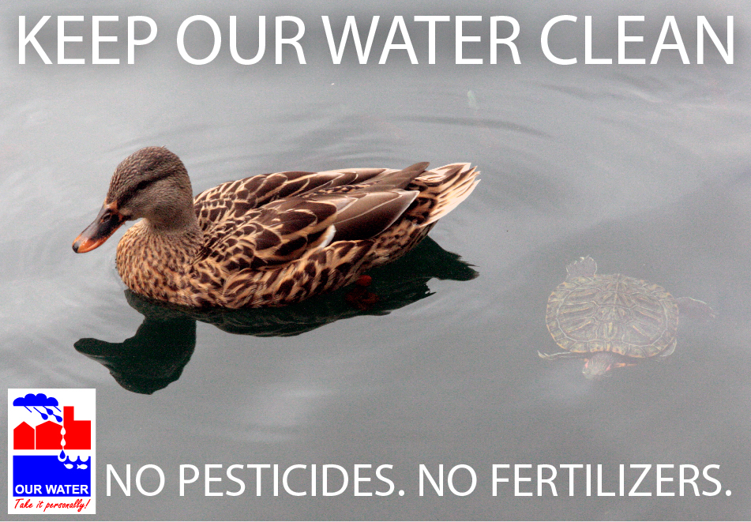  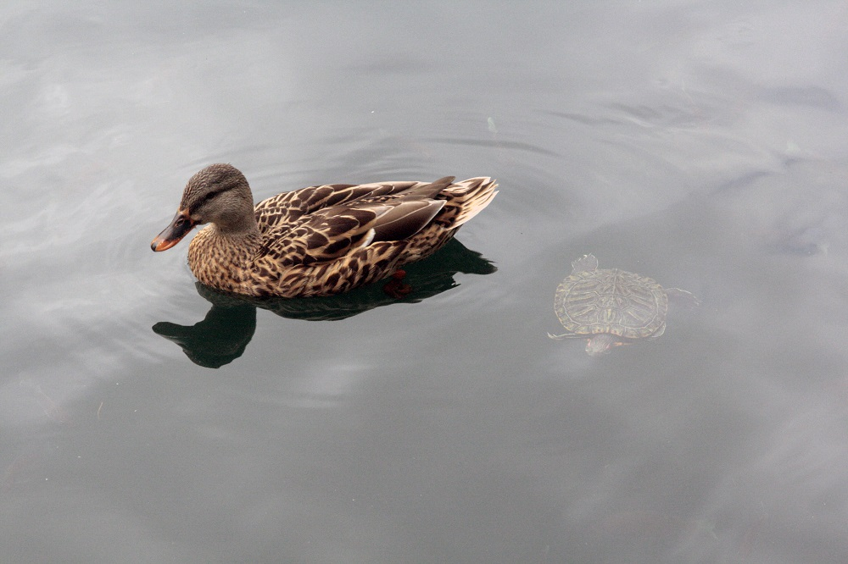 (NCTCOG staff photo)  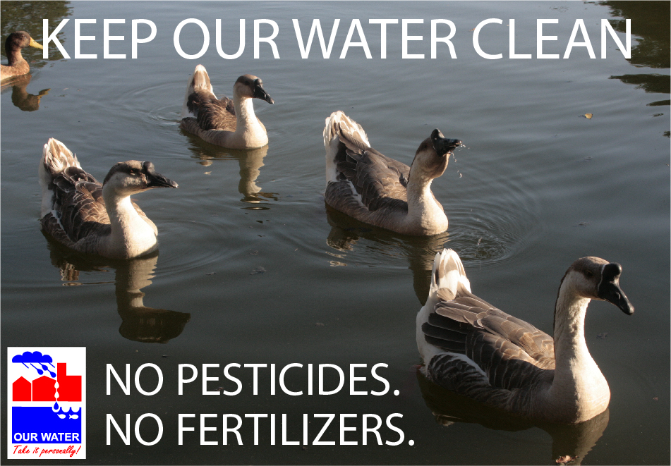  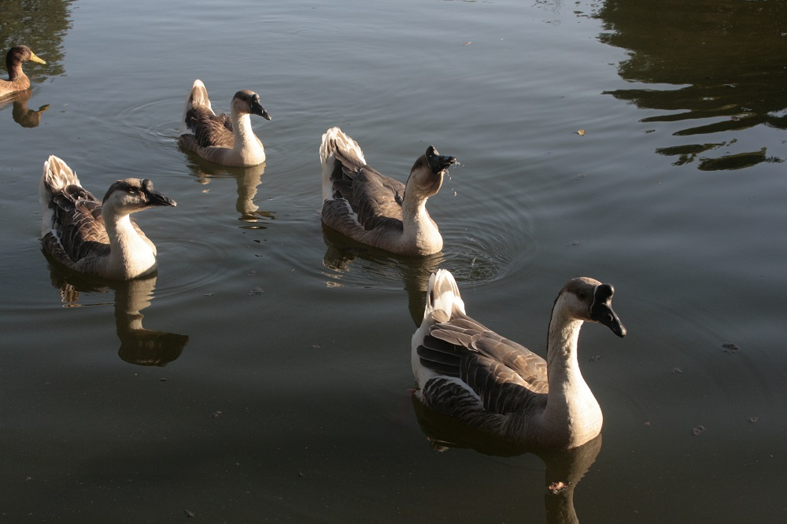 (NCTCOG staff photo)  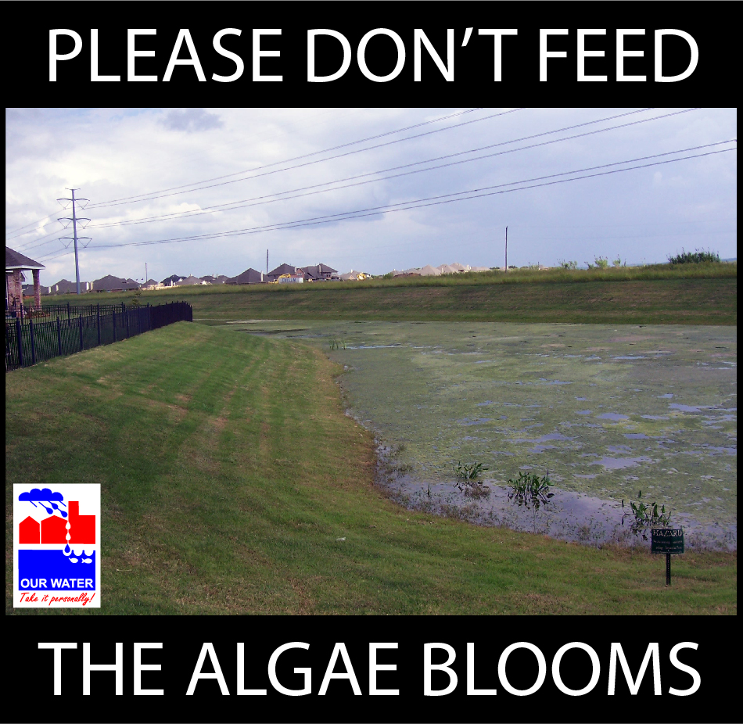  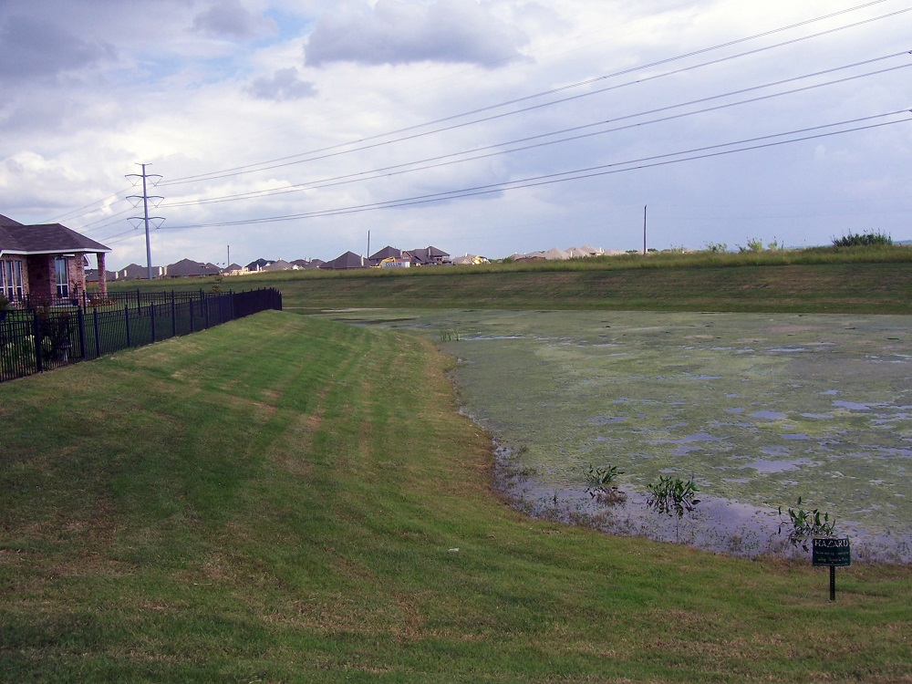(City of Grand Prairie photo)  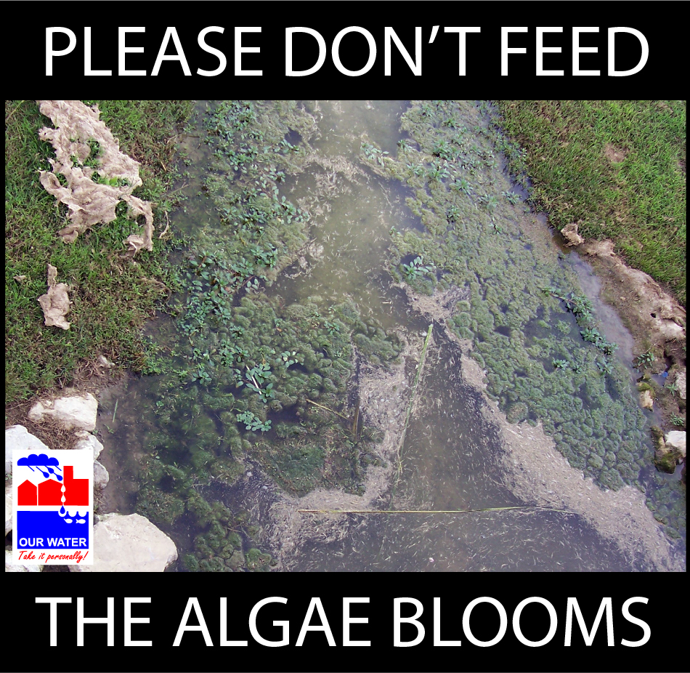  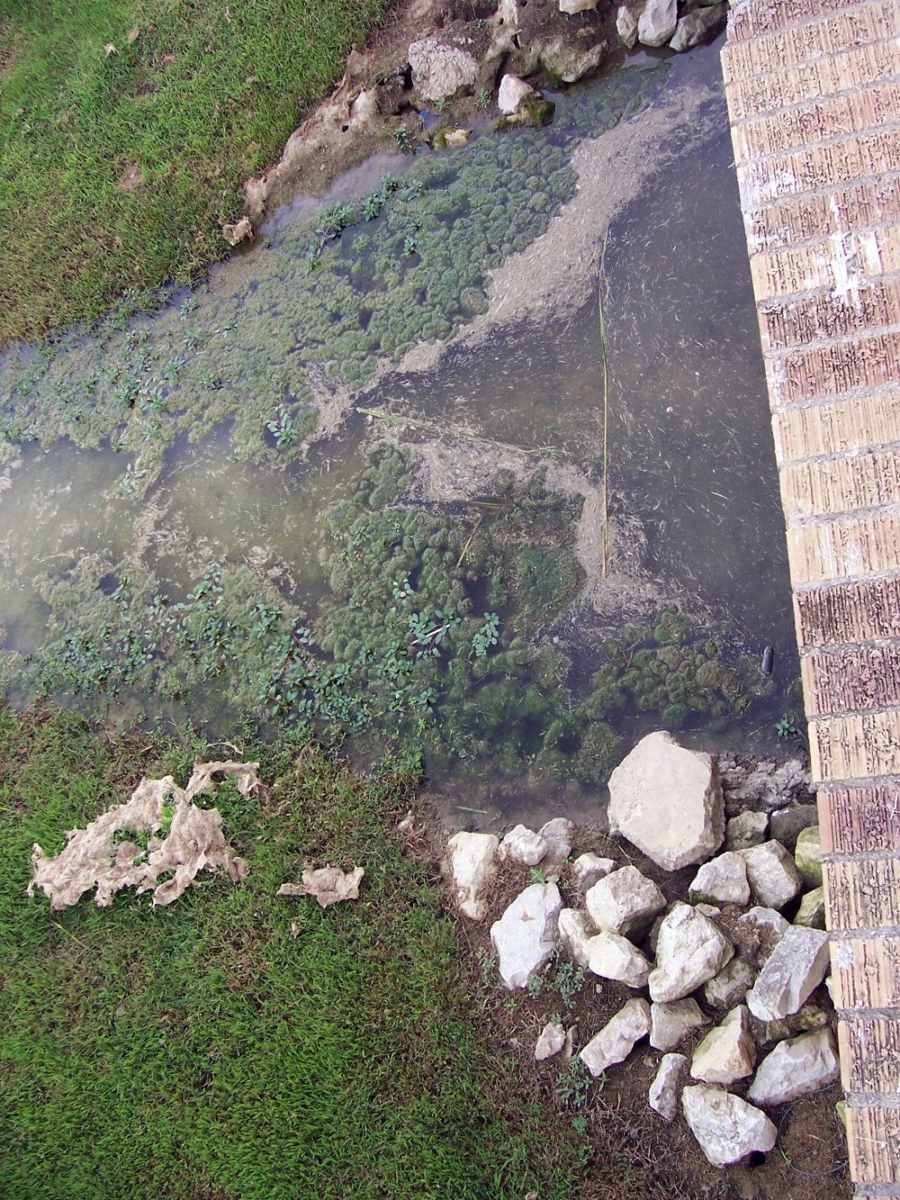 (City of Grand Prairie photo)  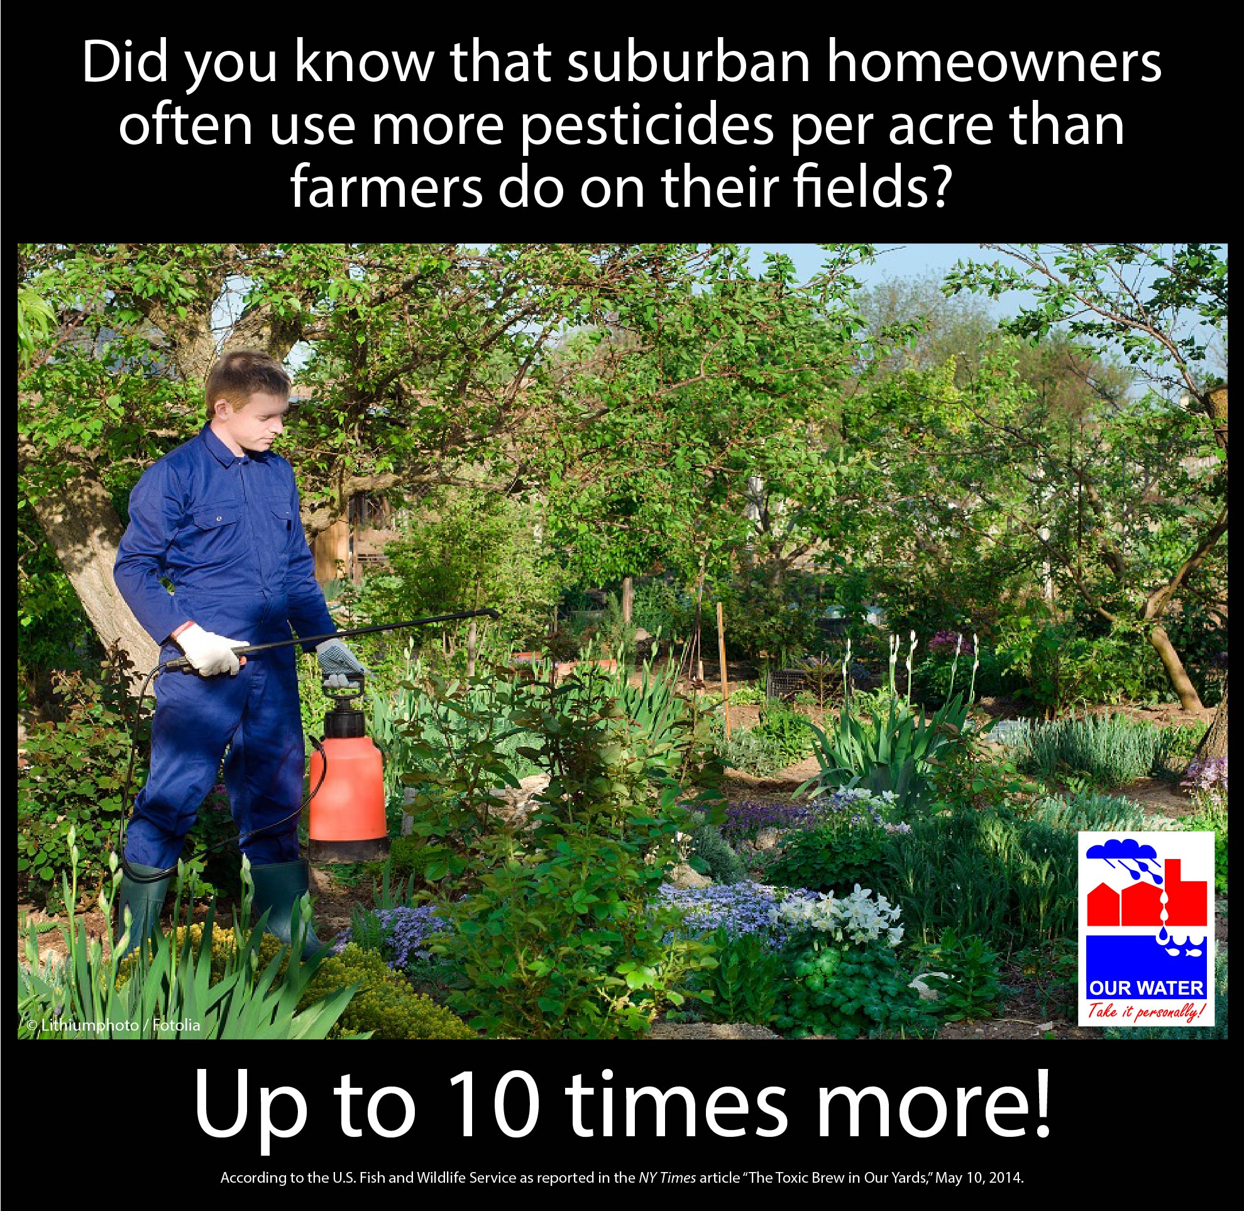

EFFECTIVE PEST CONTROL WITHOUT CHEMICAL PESTICIDES

Time | General, Year-round
Topic | Changing pest control – not depending on chemical pesticides
Source | Arlington Organic Garden Club, “Effective Pest Control Without Chemical Pesticides” http://www.aogc.org/critters/effpest.htm;  Natural Resources Defense Council “Trouble on the Farm” http://www.nrdc.org/health/kids/farm/chap1.asp;  Texas A&M AgriLife Extension, “What is a pesticide?”, http://citybugs.tamu.edu/factsheets/ipm/ent-6007/
Long version sample (edited from Arlington Organic Garden Club list) | 5 Tips for Controlling Insect Pests Without Chemical Pesticides  Are unwanted insects in your garden driving you buggy? Before you turn to chemical pesticides, consider using some of the following techniques.  1. Plant native. (Or adapted and resistant.)  Plants that grow well in California or Wisconsin may not grow well in North Texas. Plants native and adapted to this region require less water and fertilizer to thrive in our intense summer heat, and are less likely to succumb to disease and pests. The Texas SmartScape plant database provides plenty of suggestions for native and adapted landscape plants to look for at your local garden store. Stocking up on vegetable plants or seeds? Look for disease-resistant plants by reading the seed packet or nursery tag. On a nursery tag, disease resistance will usually be marked by capital letters following the plant name. For example, if a tomato tag has “VFN” after the name, it’s resistant to verticillium wilt, fusarium wilt, and nematodes.  2. Provide companions for your plants.  Your garden may benefit from companion plants that repel “bad” bugs and attract “good” ones. For example, petunias may repel asparagus beetles, leafhoppers, aphids, and tomato worms. Encourage pest predators such as ladybugs, green lacewings, praying mantis, and wasps by creating an inviting habitat for them. Butterfly Weed, Dwarf Goldenrod, Mexican Marigold, and Sunflower produce lots of nectar and pollen to attract beneficial insects. (But be aware that not all plants work well together—contact your local Master Gardener [link to your local master gardener here] for advice on your specific situation.)  You may also want to lure pests away from prized plants. For example, beetles love radishes and Harlequin bugs adore mustard, so you could lure them away from one area of your yard by stocking their favorite snacks in another area.  3. Patrol your garden for pests.  While predators such as ladybugs are keeping an eye out for pests, you should too. Carry a bucket of soapy water and drop in larger pests that you can remove by hand. Spray pests like aphids with a strong stream of water to knock them off sturdy plants—but be careful to not shred your plants. You may also want to inspect the underside of leaves for egg masses. Identify the egg masses before deciding to get rid of them, as they could be eggs for beneficial insects like lady bugs. If they belong to a pest, depending on how many eggs there are, you could simply rub them off with a tissue, cut off the infested portion of the leaf, or remove entire leaves. Drop these leaves into your bucket of soapy water instead of on the ground, as the eggs might otherwise hatch and start the cycle again.  4. Rotate your crops in your vegetable garden.  In a vegetable garden, crop rotation is crucial in fighting pests such as knot root nematodes. Rotating plants that are not related botanically is also a good practice for reducing pathogens.  5. Clean up your garden.  Many insects love leaf litter and dead plant material. Don’t give them safe haven! When your annuals have finished producing and gone to seed, pull them up and add them to your compost pile. If your plants have been attacked by a bad infestation, the best solution may be to bag the entire plant—seeds and all—and throw them in the trash. [Adjust this last sentence as necessary. Some cities in the area have ordinances that prohibit plant biomass from entering the solid waste stream. If your local municipal programs gets compost hot enough that pathogens and infestations are killed off, you may want to note that instead. From Frisco’s newsletter, for those who participate in the same program: This material can be composted through our partnership with Texas Pure Products, where the heat generated from the composting process is enough to destroy any viable seeds.]  If you do plan to use pesticides, make sure that you use the right pesticide for your target pest. Avoid broad-spectrum pesticides so you don’t inadvertently target beneficial insects. It’s also important to read the product label to learn about its safety and proper use. Pesticides vary greatly in the hazards they pose to people and the environment. Learn more at the National Pesticide Information Center’s website.  This list is modified from one created by the Arlington Organic Garden Club.
FB sample | Check out these 5 tips for controlling insect pests without pesticides. Have more ideas? Let us know what works for you! [link to article] | Safely eliminate unwanted pests in your garden with these all-natural solutions.  [link to article] | This year, don’t lose your garden to pests. But before turning to pesticides, consider these alternative techniques to keep your yard pest-free. [link to article]
Memes/  Graphics/ Images | 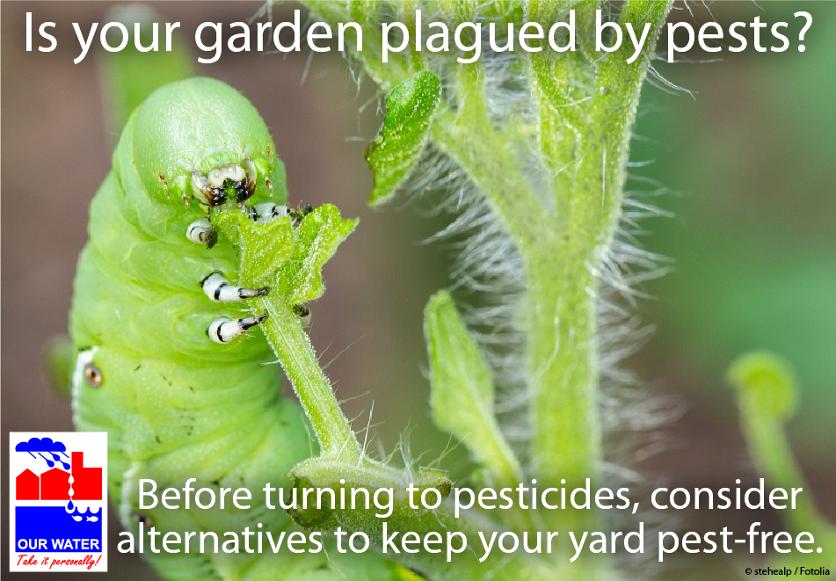

Time | Spring
Topic | General: Education about healthy landscapes (reducing pesticides and herbicides)
Source | Frisco WaterWise newsletter, “Weed Out Landscape Pests Naturally,” http://us4.campaign-archive2.com/?u=33cd614c011fb86a5e16e4f59&id=2ff5cfbb22;  http://organiclifestyles.tamu.edu/;  Cycle-Soak AgriLife video https://www.youtube.com/watch?v=Vmr9YbHTjL0, http://aggie-horticulture.tamu.edu/earthkind/publications/#pest;  Texas A&M AgriLife Research & Extension Center at Dallas, “Cycle and Soak Method of Lawn Irrigation,”  http://agrilifeextension.tamu.edu/blog/2015/08/06/cycle-soak-method-of-lawn-irrigation
Long version sample | Want a healthy landscape this summer? Give your lawn and plants some spring TLC.  Spring is in the air, and nature’s beauty is emerging all around us. Ah, the birds, the bees...the weeds and aphids?  The arrival of warmer temperatures brings both desirable and less desirable creatures. However, this doesn’t mean an endless cycle of herbicides and insecticides! Healthy lawns and plants are less susceptible to insect pests and weeds—so give your yard a little spring TLC to avoid future problems.  - Apply compost early in the season to give plants and turf a healthy boost (and also reduce your fertilizer needs).  - Fight weeds by preventing them in the first place. Add a 2- to 4-inch layer of mulch in your flowerbeds and containers to keep weeds from popping up.  - Water your lawn only when needed during the spring. Overwatering can lead to stressed turf and disease. One method of watering deeply and efficiently is called “cycle and soak.” [You may want to provide a link for more details, such as http://agrilifeextension.tamu.edu/blog/2015/08/06/cycle-soak-method-of-lawn-irrigation/.] If you have an irrigation system, consider using a smart irrigation control system or manually set the controller on an as-needed basis. This trains grass roots to grow deeply, helping to ensure a healthy lawn through the summer dry season. [If your municipality or water district provides watering recommendations via WaterMyYard or something like Frisco’s WaterWise enewsletter or free irrigation audits or soil moisture sensors, etc., add more information here letting them know what you can offer.]  How can you help prevent pest infestations in your garden?  - Plant native and adapted plants.  - Select plants that pests don’t like, or employ companion plants to help repel insects. (Check out the Galveston County Master Gardener April/May 2014 issue for companion plant recommendations for both vegetable gardens and landscapes.)  - Make sure to not overwater or apply too much fertilizer.  - Clean up yard debris, which acts as havens for pests.  - Make sure that your yard doesn’t have areas of standing water or poor drainage. (This is especially important for reducing mosquito populations.)  - Keep an eye out for pests. You can catch the first generation of insects before they have a chance to multiply (and multiply, and multiply). Some insects and larvae can simply be washed off with a strong stream of water, or picked off by hand and dropped into a bucket of soapy water.  Before applying insecticide, find out whether the insect you’re looking at is beneficial or harmful. Many insecticides are indiscriminate in their targets. Without careful species identification, you may be eliminating important natural helpers from your garden. If you know you have a troublemaker, choose a control method as specific to the target as possible, and consider natural methods such as beneficial predators like ladybugs or mechanical control.
FB sample | It’s spring again! Want a healthy landscape this summer? Start now! [link to article] | Employ companion plants like marigolds. Eliminate areas with poor drainage. Clean up your yard debris. These are some easy, ecofriendly steps you can take to help prevent pest infestations in your garden. Have more suggestions? Share in the comments!
Memes/  Graphics/ Images | 

TIPS RELATED TO FLEAS AND TICKS, MOSQUITOES, COMMON TEXAS YARD PESTS
Time | Summer
Topic | Tips on controlling fleas and ticks in yards
Source | Frisco WaterWise newsletter, “Ticked off about fleas and ticks in your yard?” http://us4.campaign-archive2.com/?u=33cd614c011fb86a5e16e4f59&id=001f69575d;  Additional resources:  http://citybugs.tamu.edu/factsheets/biting-stinging/others/ent-3001/
Long version sample | Four Natural Methods for Controlling Fleas and Ticks in Your Yard  In addition to being a nuisance, fleas and ticks can transmit disease to pets and their humans.  Fleas are tiny, wingless insects with long legs that love to jump. Their bites are a common source for allergic reactions, causing small, red, itchy bumps. In the yard, fleas tend to congregate in places of high humidity that are protected from bright sunlight. If given an opportunity, they may want to move in with you.  Texas is home to 11 common tick species. They are typically found resting on the tips of grasses and shrubs, often with their first pair of legs outstretched, just waiting for a host (such as you, your family, or your pets) to brush into them. Once aboard, ticks attach themselves for feeding.  Protecting your dog or cat from fleas and ticks is important, but it’s not easy—especially when the fleas and ticks are in your yard. (Consult your veterinarian about the best way to protect your pets from fleas and ticks and whether pesticides are needed.)  What are some natural ways to make your yard less appealing?  1. To reduce your yard’s appeal, avoid overwatering. Both fleas and ticks prefer moist, shady areas.  2. Keep yard debris, such as lumber or bricks, to a minimum. (This also reduces hiding spaces for rodents.) Make sure pots and other garden items are stored when not in use.  3. Cedar mulch has been reported to repel most fleas and ticks. Spread cedar mulch around shaded areas of your yard. (Cedar mulch may help push the fleas into sunny areas of your yard, killing them without chemicals.)  4. If fleas and ticks are already a problem in your yard, consider applying chemical-free treatments such as food-grade diatomaceous earth and beneficial nematodes.  - Food-grade diatomaceous earth can be purchased at most garden supply stores and some pet stores. This natural abrasive is made from the ground-up bodies of tiny marine organisms, and kills fleas by drying out their bodies. Food-grade diatomaceous earth is most effective in dry conditions, so apply this treatment well before or after you water your yard.  - Beneficial nematodes are insect parasites that attack the larval stages of soil-dwelling pests, leaving plants alone. (They’re not the pest nematodes that attack plants.) Nematodes are typically applied as a spread or with a sprayer, and are available for purchase at most home improvement stores.
FB sample | Are fleas and ticks lying in wait in your yard? Check out these 4 natural control methods. [Link to your article.]
Memes/  Graphics/ Images | 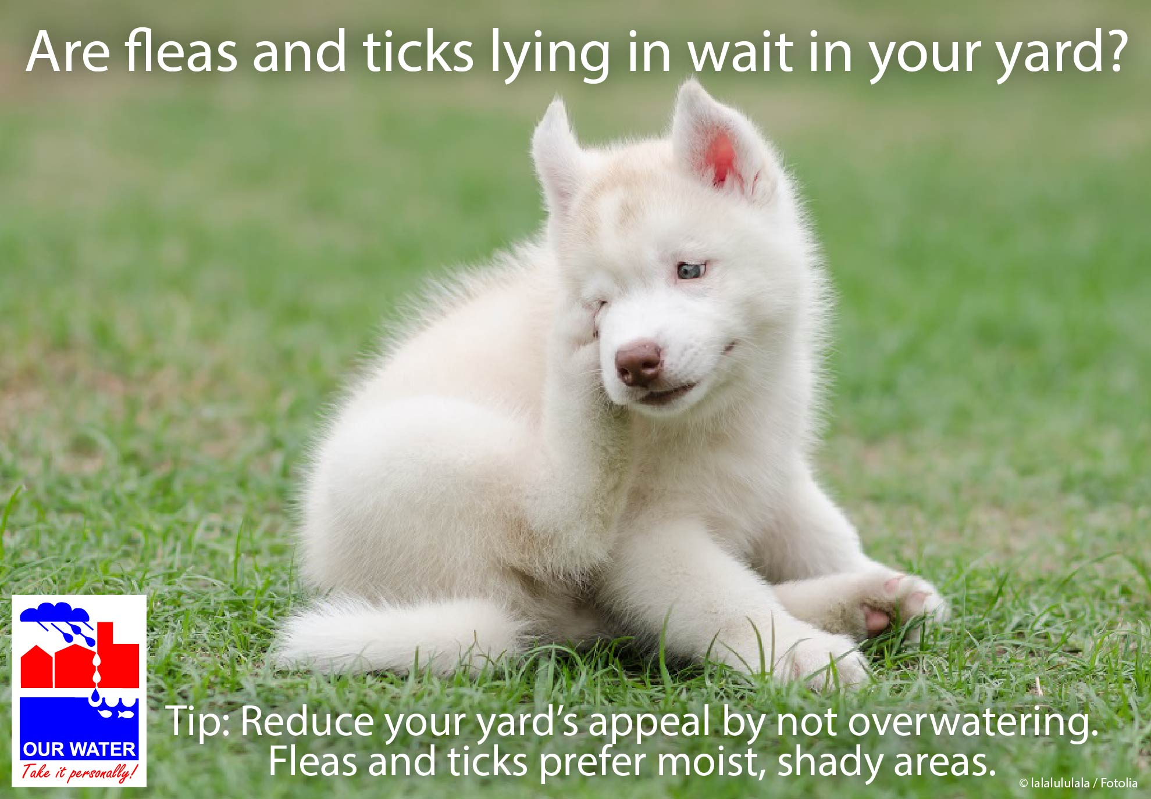

Time | Year round, especially spring through fall
Topic | Mosquitoes (make sure not overwatering, drain standing water, check containers, etc.)
Sources | AgriLife “The Best Way to Control Mosquitoes”  http://brazoria.agrilife.org/files/2015/06/The-Best-Way-to-Control-Mosquitoes.pdf;  AgriLife, “Mosquito-Proof Your Yard” http://citybugs.tamu.edu/2012/08/08/mosquito-proof-your-yard/;  Take Care of Texas handout, “Managing 10 Common Texas Yard Pests” http://www.tceq.state.tx.us/publications/gi/gi-405.html/view
Long version sample | Mosquito-Proof Your Yard  Mosquitoes are an obvious nuisance, leaving their victims bumpy and itchy. Mosquitoes that carry diseases such as West Nile Virus can even pose serious health risks. So how do we keep our local mosquito population down? Based on the high visibility of spraying operations with truck-mounted fogging machines and highly publicized treatment schedules, many people assume that mosquito control is essentially spraying. But spraying is only a small part of an integrated mosquito management program. And there are several good reasons to limit the use of sprays for adult mosquitoes, such as community health concerns, the impact on beneficial insect species, and the risk of increasing insecticide resistance among target mosquito species.  So how can you help reduce the mosquito population in your neighborhood? Walk through your yard looking for potential breeding sites. The first thing that may come to mind when you think mosquito is the delicate winged insect, but mosquito larvae are aquatic. That means they require standing water in order to survive. Standing water is the most obvious breeding site, but all mosquitoes need are a few leaves or small amount of organic material and water.  Locating and eliminating their breeding sites is the most important part of a community mosquito control program.  Mosquito breeding sites are more common in backyards than you may think: at least one site can be found in nearly every backyard during the warm months, and at least 25% of mosquito complaint calls can be traced back to the caller’s property.  Limit mosquitoes’ ability to breed by:  - Dumping and storing buckets, wheelbarrows, cans, tarps, or anything that holds water.  - Keeping the lid closed on your trashcan or dustbin.  - Not overwatering potted plants or lawns.  - Cleaning gutters and downspouts regularly.  - Cleaning bird baths at least once a week.  - Changing the water in kiddie pools regularly.  - Sealing and screening cisterns and rain barrels.  - Drilling holes at the bottom of tire swings, which allows them to drain.  - Filling in sunken areas of your yard with soil or gravel. Several products, such as mosquito dunks, are available for treating standing water that can’t be easily drained or filled. (See below for more information.)  - Repairing leaky faucets and outdoor pipes.  You can also control mosquito larvae through the use of low-impact pesticides that target only mosquitoes. In small bodies of water that are impossible to drain or plant containers that tend to stay damp, some good options are methoprene granules or the bacterial insecticides Bacillus thuringiensis israelensis and Bacillus sphaericus (sold in dunks, granules, or liquids).  If you have a pond, you can practice biological control by releasing Gambusia fish (a.k.a. mosquito fish) or similar minnow species into the water. Mosquito fish are excellent predators and, where established, can quickly reduce mosquito populations.  Of course, adult mosquitoes can fly. A few mosquitoes may wander over from your neighbor’s yard and buzz around (right by your ear, most likely). So screen your windows, and limit outdoor activities during dusk and dawn. Wear long-sleeved, loose-fitting, light-colored clothing if you need to venture out during those times. And use mosquito repellent, carefully following all label directions. You can also light citronella candles to provide short-term relief outside, or check with your local nursery for advice on plants that might help deter mosquitoes. For example, American beautyberry contains compounds in its leaves that have been shown to repel mosquitoes.
FB post | At least 25% of mosquito complaint calls can be traced back to the caller’s property. Learn how to reduce the source by locating and eliminating mosquito breeding sites in your backyard. [link to your article or http://brazoria.agrilife.org/files/2015/06/The-Best-Way-to-Control-Mosquitoes.pdf or http://citybugs.tamu.edu/2012/08/08/mosquito-proof-your-yard/],
FB post | When scouting for mosquito breeding sites in your yard, remember to check your gutters. Mosquitoes breed in moisture, and clogged gutters are a perfect place to find it.
Memes/  Graphics/ Images | 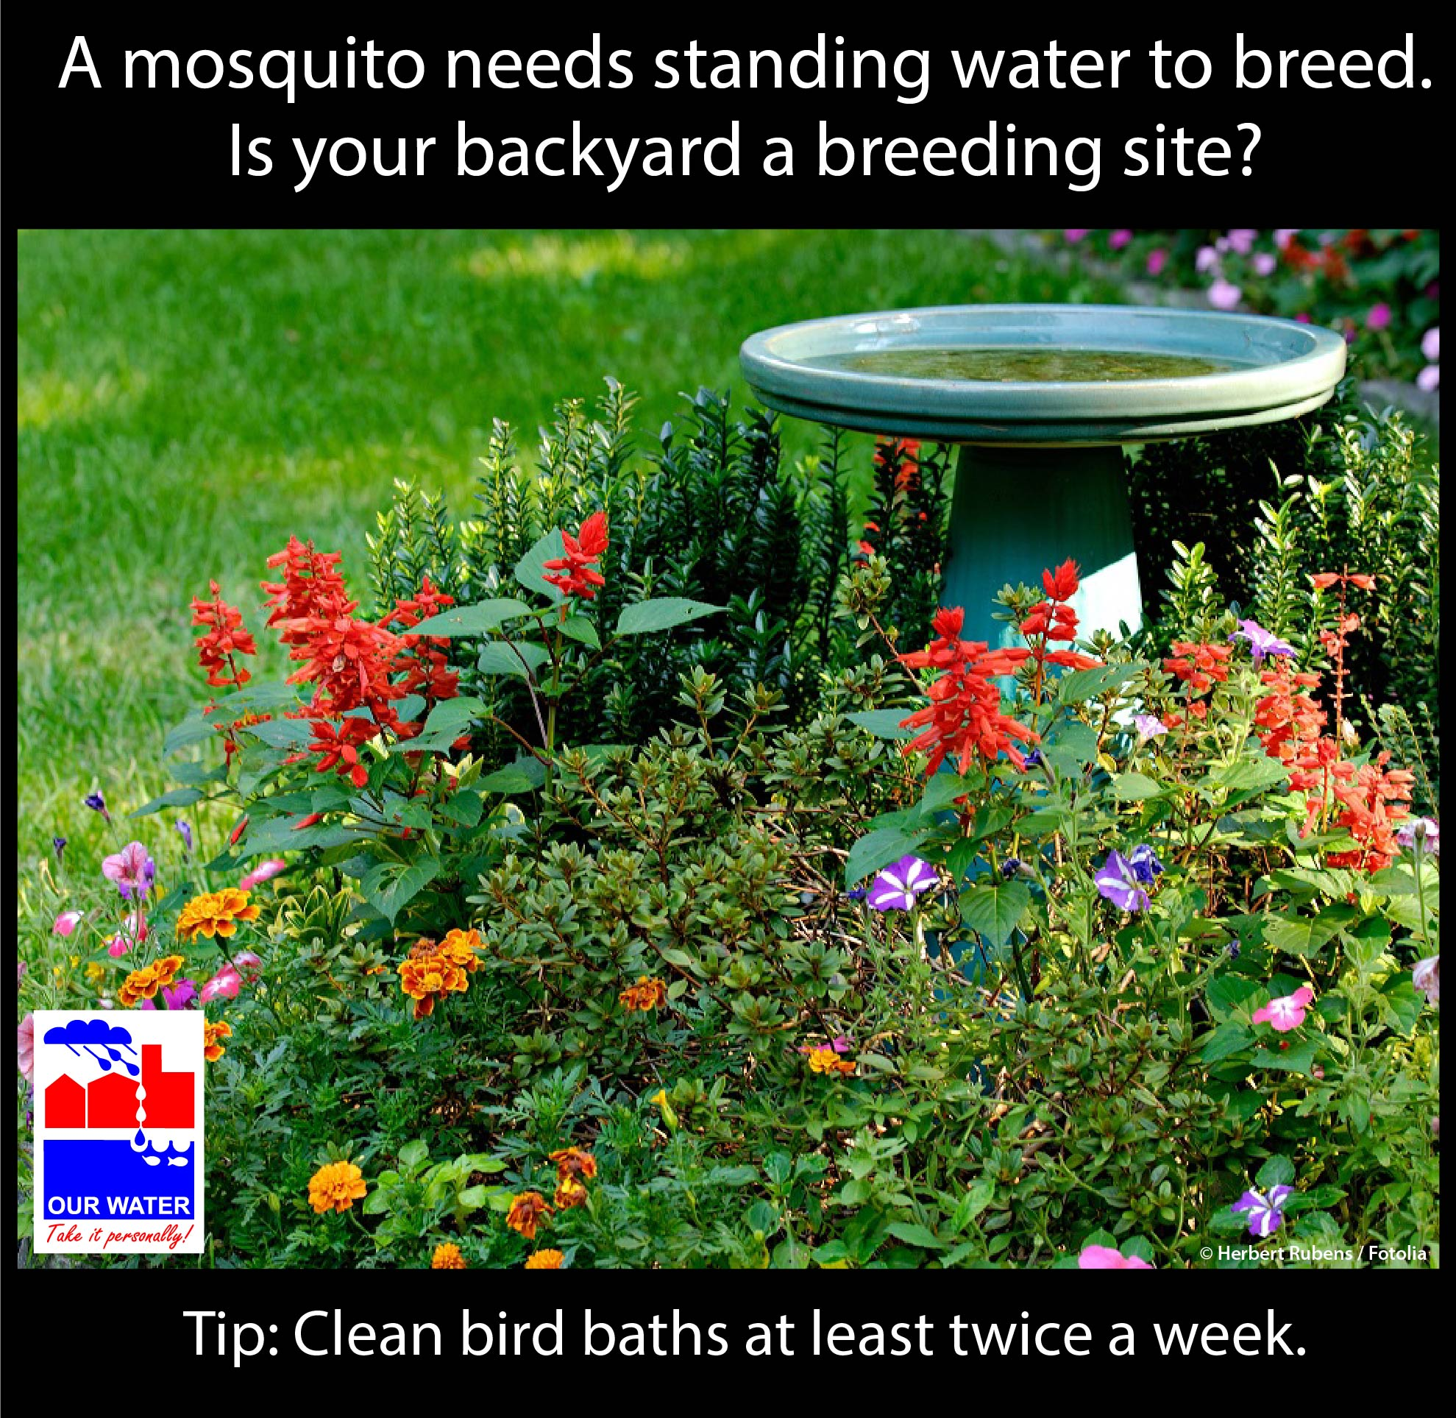  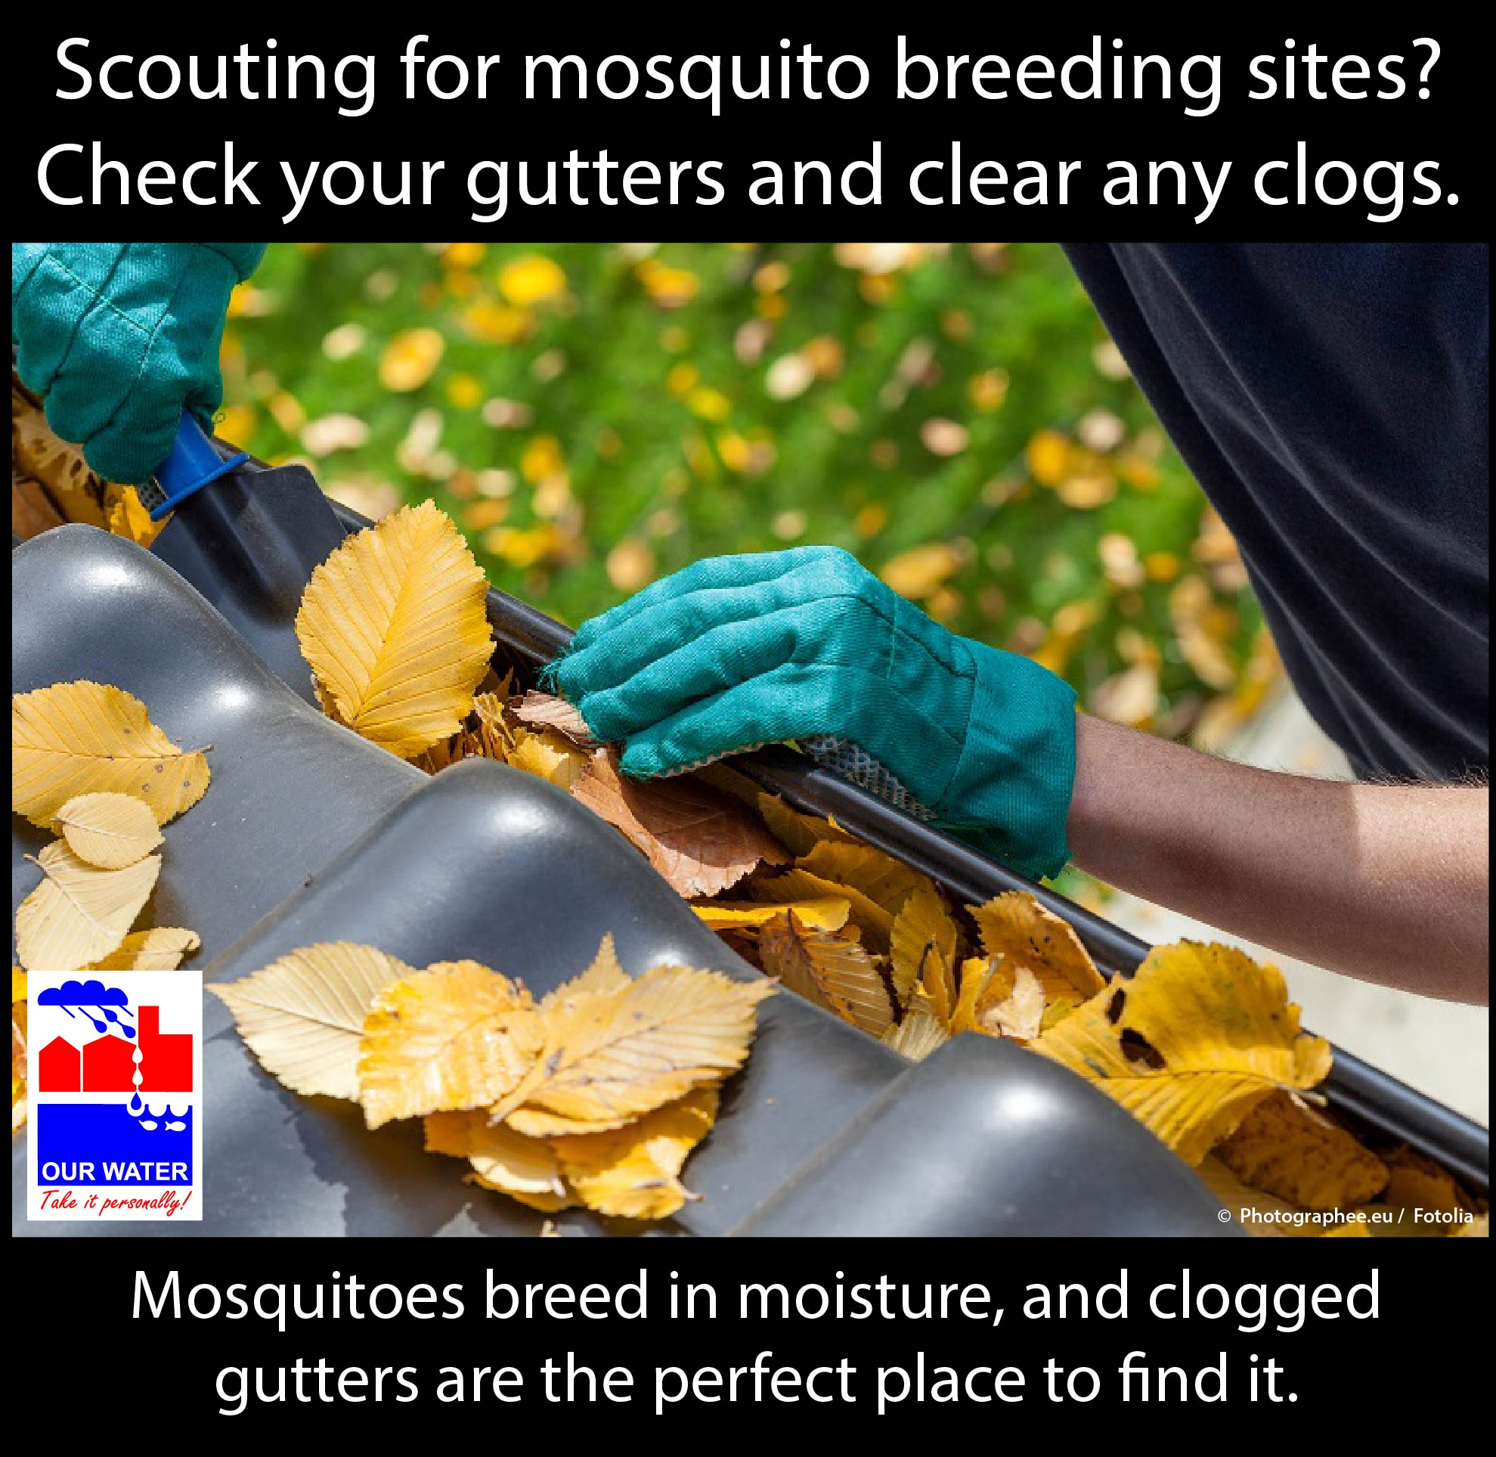  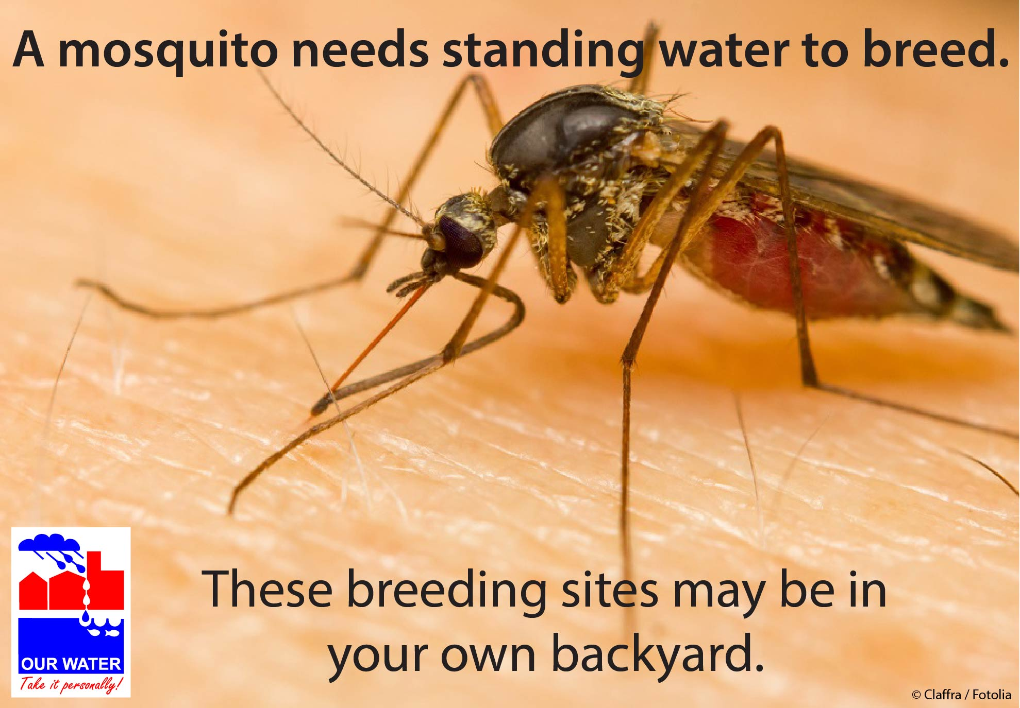  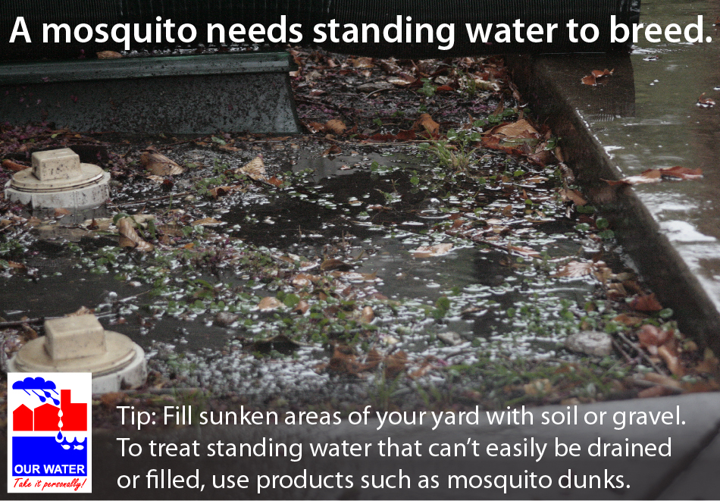  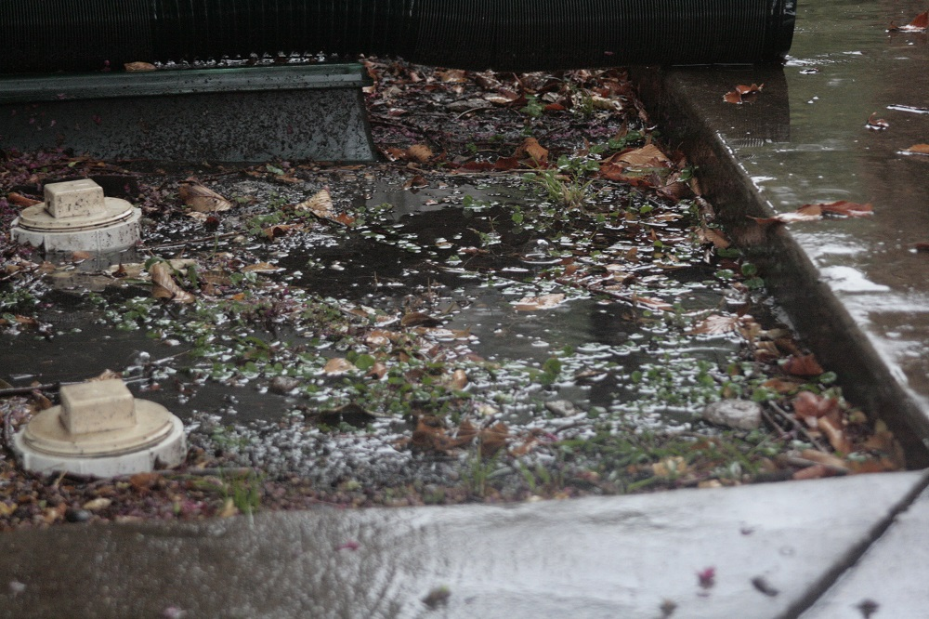 (NCTCOG staff image)

Time | Spring, Summer, Fall
Topic | Managing 10 Common Texas Yard Pests
Source | Take Care of Texas handout, “Managing 10 Common Texas Yard Pests” http://www.tceq.state.tx.us/publications/gi/gi-405.html/view
Long version sample A – general quick tips and pesticide use advice from Take Care of Texas guide | Managing Texas Yard Pests  Insect pests wreaking havoc on your garden? Check out the Take Care of Texas guide “Managing 10 Common Texas Yard Pests,” which provides ecofriendly tips on how to get rid of aphids, caterpillars, fleas, fire ants, chinch bugs, grubs, mosquitoes, spider mites, snails and slugs, and beetles.  General tips:  - Irrigate efficiently. Insects are more likely to infest landscapes that are stressed or diseased from overwatering than healthy turf. Water infrequently but thoroughly—generally 1 inch per week or less during the active growing season (April to October). [If you promote WaterMyYard or the WaterWise watering recommendations, add that information here.] Always comply with your water system’s water-use requirements. And as North Texas clay soils infiltrate water slowly, you may want to use the Cycle and Soak method to allow the water time to penetrate the root zone.  - Use native and adapted plants. Plants native or adapted to our region are often better suited to the local environment and more resistant to pests.  - Don’t scalp your lawn. Insects like a closely shorn lawn. When you mow, remove no more than one-third of the grass blade with each mowing. (Check out this Texas A&M AgriLife turfgrass selection guide for specifics on mowing height and frequency for the type of grass in your yard.)  - Encourage natural predators such as ladybugs, certain beetles, lizards, and birds.  - Monitor for pests often to catch infestations early. Assess whether a control is needed frequently, as natural predators can make treatment unnecessary. Sometimes you can just spray the host plants with a steady stream of water to dislodge the pests.  Advice on pesticide use:  If you feel that pesticide use is necessary, make choices that have less potential environmental impact.  - Avoid applying broad-spectrum pesticides. They kill beneficial insects as well as pests.  - Select the least toxic option and apply it when pollinators are not present. (The Xerces Society for Invertebrate Conservation has a helpful resource specific to bees.)  - Always read the pesticide’s label and follow the instructions.  - Mix pesticides according to their directions and apply only the recommended dosage. Avoid the overuse of chemicals.  - Apply pesticides only to plants specified on the label. Some formulations can injure tender ornamental plants and new growth.  - Don’t apply pesticides when it’s windy or rain is forecast. (Otherwise, the pesticide could inadvertently end up drifting over to your neighbor’s plants or washing down the storm drain.)  - Never throw unused pesticides in the trash—instead, bring them to a household hazardous waste facility for disposal. [Provide information on your local hazardous waste facility or direct them to www.timetorecycle.com to find a location.]
Long version sample B – Management tips for 10 common Texas yard pests from Take Care of Texas | Managing Common Texas Yard Pests  Insect pests wreaking havoc on your garden? Don’t get discouraged! Check out the Take Care of Texas guide “Managing 10 Common Texas Yard Pests” and learn about environmentally friendly ways to deal with pest infestations. Then boot those pests out of your yard!  A few of our favorites are listed below.  Target: Aphid Infestation  Method of attack: Let beneficial insects do the dirty work. Introduce ladybugs, lacewings, and other beneficials to your landscape.  Target: Caterpillar Infestation  Method of attack: Remove egg masses or caterpillars by hand. Carry a bucket of soapy water and drop the caterpillars into the bucket. If necessary, you may decide to prune them out. (This advice is generally for infested trees, but if you are dealing with an especially feisty tomato hornworm, you may decide it’s worth losing a tomato branch.) Inspect the underside of leaves for egg masses. Depending on how many there are, simply rub them off with a tissue, cut off the infected portion of the leaf, or remove entire leaves. Drop these leaves into your bucket, too.  Target: Mosquitoes  Method of attack: Eliminate breeding sites by draining standing water in your yard. Use bacterial larvicide tablets to reduce mosquitoes in permanent bodies of water.
FB sample (first one directly for guide, second for getting the public’s ideas) | Insect pests wreaking havoc on your garden? Don’t get discouraged! This Take Care of Texas guide provides environmentally friendly tips on how to deal with pest infestations.  [Link to  http://www.tceq.state.tx.us/publications/gi/gi-405.html/view] | What’s your favorite ecofriendly method for getting rid of pest infestations in the garden? Releasing ladybugs to get rid of aphids? Using companion plants? Share your tips with us!  [Just a note: The whole PETF could compile everyone’s ideas and create a webpage on the Texas SmartScape site to share, if people are interested.]
Memes/  Graphics/ Images | Might want to use a screenshot of the Take Care of Texas guide.  Could also use hornworm image in Effective Pest Control Without Pesticides section, or one of the Beneficial Insects section images.

BENEFICIAL INSECTS
Time | Spring, Summer, Fall
Topic | Beneficial insects
Source | AgriLife, Earth-Kind “Beneficials in the Garden,” http://aggie-horticulture.tamu.edu/earthkind/files/2010/10/beneficials.pdf;  AgriLife, Landscape IPM: Beneficial Insects, http://landscapeipm.tamu.edu/what-is-ipm/ipm-concepts/pest-identification/good-bug-bad-bug/beneficials/;  Grow Green – Earth-Wise Guide to Beneficial Insects  http://www.ci.austin.tx.us/growgreen/downloads/beneficial.pdf;  Frisco WaterWise newsletter, “It’s a Bug’s Life”, http://www.frisco-online.com/frisco-news/living/around-the-house/6083-it-s-a-bug-s-life;  Planet Natural, Beneficial Insects 101 http://www.planetnatural.com/beneficial-insects-101/
Long version sample – TAMU and Grow Green | Don’t kill your garden’s heroes!  Did you know that 97% of the insects most commonly seen in homes and gardens are not pests? Some are pollinators, some are harmless, and others are predators of pests. So how can you help conserve your garden’s heroes?  - Select disease- and insect-resistant plants to prevent pest infestations.  - Encourage birds, lizards, and frogs as well as beneficial insects in your garden. Include blooming plants throughout the year and provide shelter such as groundcover.  - Monitor your plants regularly so you can catch problems early, but resist the urge to spray when you first spot plant damage. Plants can withstand some damage, and will provide a food source for beneficial insect predator populations.  - Properly identify problem pests and choose your treatment accordingly.  - Consider treating the pest with a nonpesticide application such as spraying with water or handpicking.  - When pesticide application is deemed necessary, select the narrowest spectrum product possible. Broad-spectrum products don’t discriminate—they kill both pests and beneficial insects. In addition, choose a product that won’t harm birds, bats, spiders, and other insect-eating creatures.  - Avoid over-applying pesticides by reading the label carefully. The recommended dosage should eliminate the pest, and overuse can increase the chance of pest resistance.  Check out this helpful resource for more information on beneficial insect identification and a list of least toxic products. Another great resource for pest-management solutions is the Texas A&M AgriLife Extension website “Insects in the City.”
Long version sample – Frisco WaterWise, Planet Natural | A Bug-Eat-Bug World  Many people think fondly of bees, butterflies, and ladybugs, but shrink away from other insects. However, experienced gardeners know that it’s a bug-eat-bug world, and some bugs can be your garden’s best friend.  Using a pest’s natural predators (known as a biological control or biocontrol) is an environmentally friendly alternative to expensive and potentially harmful pesticides.  Ladybugs are one of the most popular insects used as a biocontrol. Ladybugs are a natural enemy of many insect pests. They are particularly fond of aphids, which can do tremendous damage to roses, crepe myrtles, and pecan trees. Unfortunately, they tend to fly off when the food source runs out.  Lacewing larvae have voracious appetites. They’re called “aphid lions” for a reason, as they are especially fond of aphids. They also prey on other soft-bodies insects and mites, including mealybugs, immature whiteflies, and small caterpillars.  Praying mantises are insect-hunting machines, devouring flies, crickets, moths, and mosquitoes—however, they’re also predators of beneficial species (including themselves).  It’s important to avoid using pesticides indiscriminately. Broad-spectrum insecticides are often applied to deal with insect pests in the garden, but they can have a detrimental effect on beneficial insects as well. Pests are also showing resistance to conventional pesticides. Before reaching for that insecticide, check to see whether your problem can be treated with a biocontrol. Many home and garden stores sell insect species that would be happy to make a meal of your pests. And so far, pests haven’t become immune to being eaten.
FB sample | You may not need to battle unwanted pests yourself. Some bugs out there are happy to do the job. [link to article] | What’s a biocontrol, and how can it help you reduce the use of pesticides? Find out! [link to article]
Memes/  Graphics/ Images | 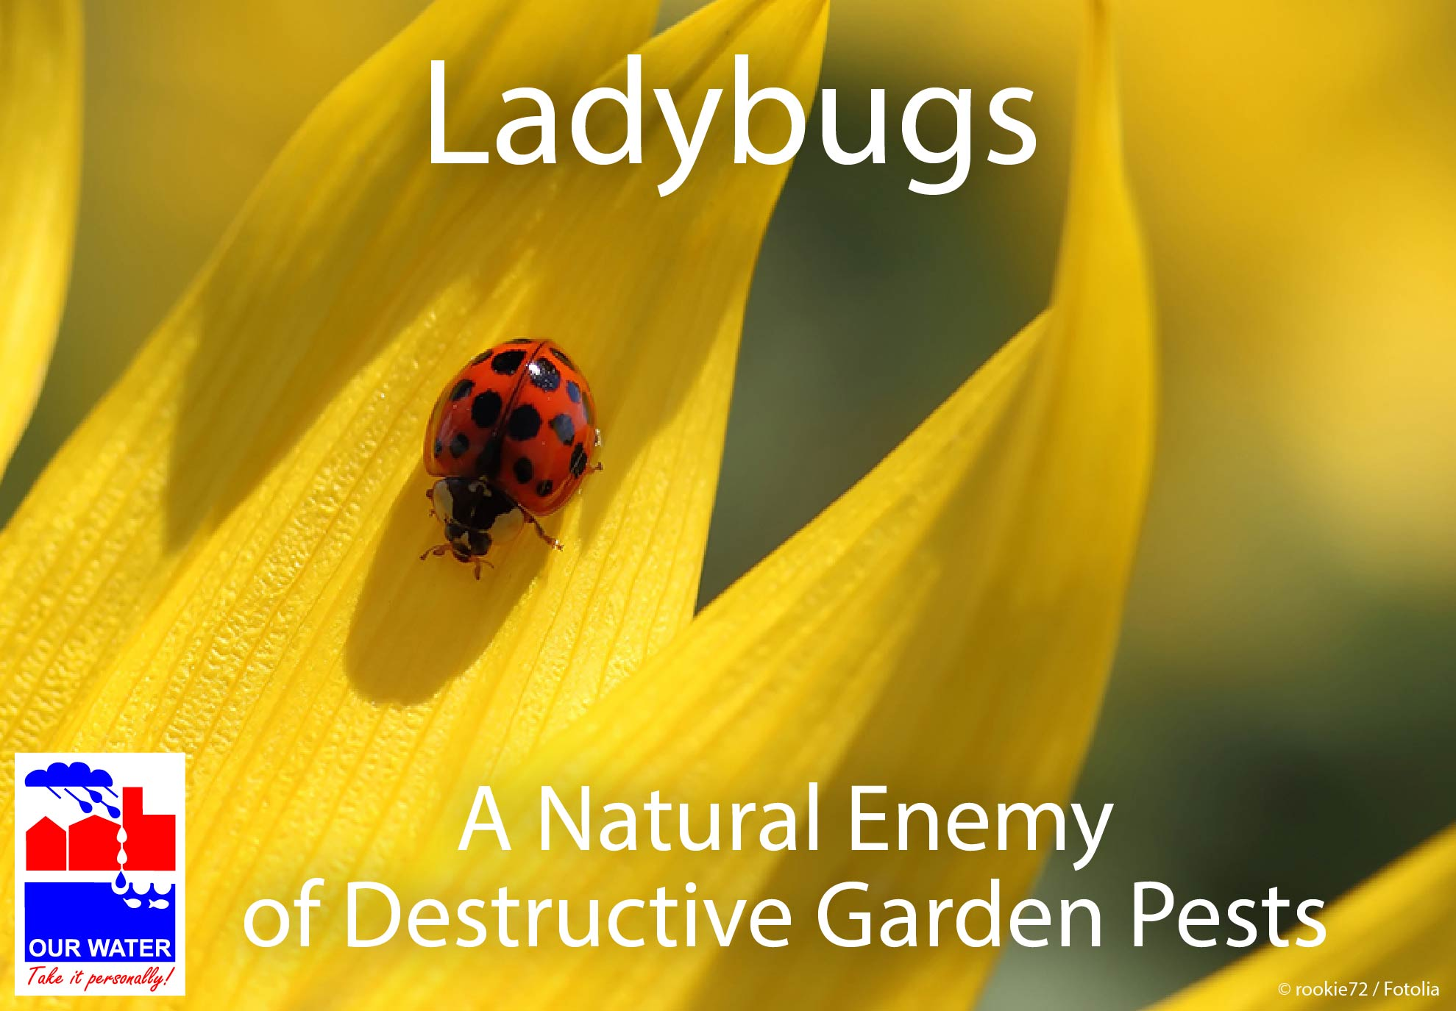  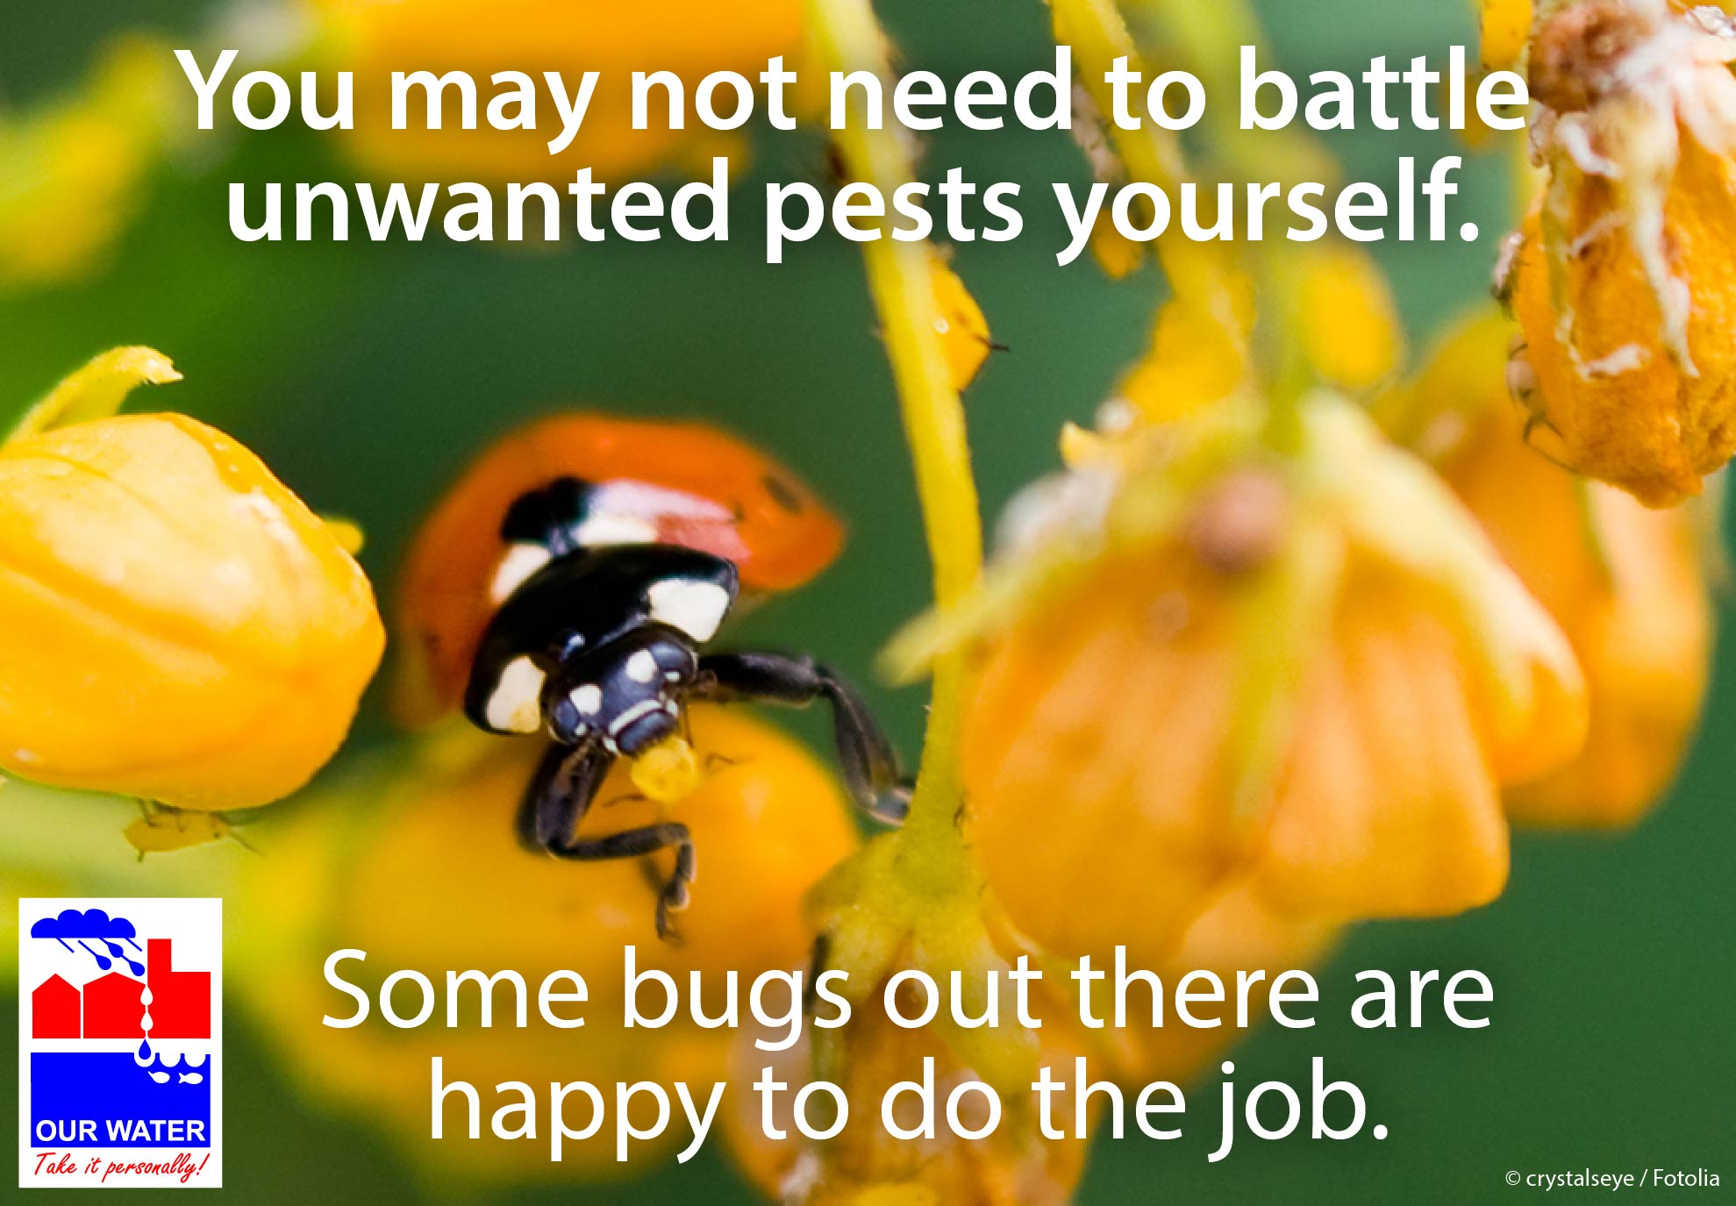  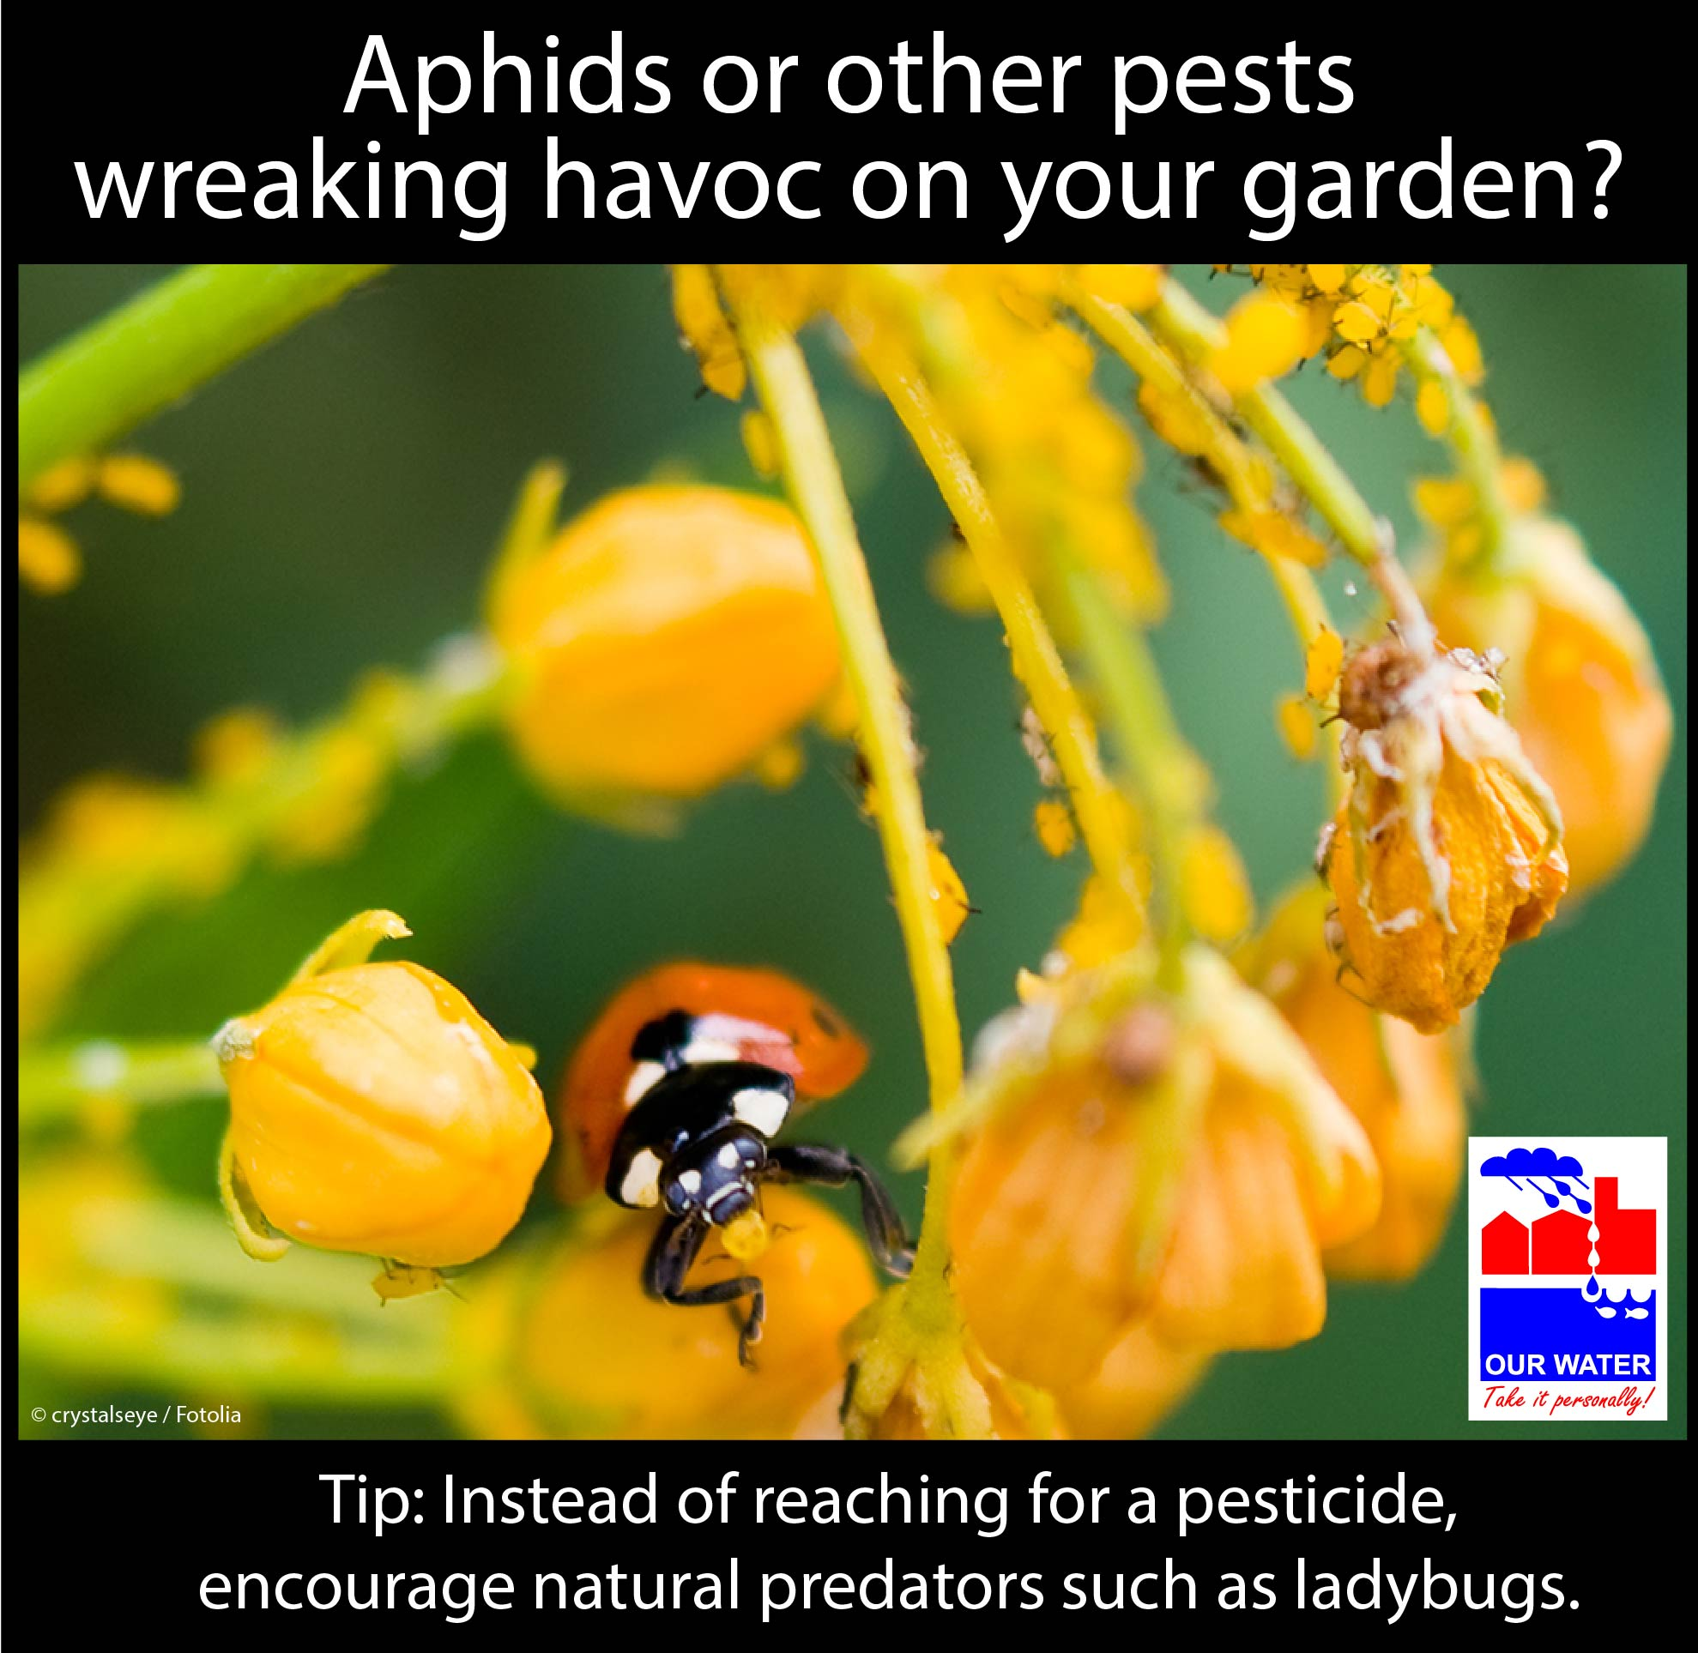

GENERAL LAWNCARE
Time | General, Year-round
Topic | Do’s and Don’ts of General Lawncare
Source | Frisco WaterWise newsletter: http://us4.campaign-archive1.com/?u=33cd614c011fb86a5e16e4f59&id=fa59be5a04;  Texas A&M AgriLife, https://aggieturf.tamu.edu/answers4you/;  http://aggie-horticulture.tamu.edu/travis/wp-content/uploads/2013/06/Simple_Steps_Lawn_Care_2009.pdf
Long version sample A (Do’s vs Don’ts) | Do’s and Don’ts for a Lush Lawn  Maintaining a healthy lawn may seem like a major undertaking with our region’s hot, dry summers and heavy clay soils. But if you follow these simple do’s and don’ts, your lawn may be more than healthy—it may be even lush!  DO’S  - Do water your lawn deeply and infrequently (once or twice a week, if needed). Applying enough water to penetrate the root zone—between four and six inches down, depending on the grass species—encourages the development of deep roots and helps the grass defend itself against drought stress. The Texas A&M University Turfgrass Program’s Irrigation webpage provides more info on deep watering and preventing runoff.  - Do observe your sprinkler system in operation (preferably once in the spring and once in the summer) to look for problems and make adjustments to runtimes. Misaligned, damaged, or clogged sprinklers can waste huge amounts of water and damage your lawn. The City of Plano’s online learning module on irrigation, “Water Water, Everywhere,” provides an overview of a sprinkler system, simple repairs, and cycle/soak watering. [If you have another resource you prefer, adjust this sentence.]  - Do check the backup battery in your sprinkler controller once a year. After a power outage, your controller may revert back to manufacturer settings if your backup battery isn’t working.  - Do scout for pests on a regular basis. Look for discoloration, insect damage, pests, and obvious signs of disease. When you scout regularly, you can tackle a problem before much damage is done.  - Do provide a nutrient-rich environment for your grass, but consider using compost rather than synthetic fertilizers, or reduce the amount of synthetic fertilizer that you apply by supplementing it with compost. Compost can provide much of the nutrients your lawn needs without damaging our aquatic ecosystems, which is a risk associated with over-application of synthetic fertilizers.  - Do sharpen your mower blades. Dull blades shred grass and cause discoloration at the tips.  - Do cut high and let lie. A taller grass in the summer provides shade to surrounding grass blades to reduce water loss and protects it from the hot sun. (Your grass type and species will affect how tall you should let your grass grow. Check out this Texas A&M AgriLife turfgrass selection guide for specifics on mowing height and frequency.) Let your grass clippings lie on the lawn after mowing to cycle their valuable nutrients back into your lawn.  DON’TS  - For your irrigation control, don’t set it and forget it. A plant’s water needs change throughout the year. Watering the same amount throughout the year can lead to water waste in the fall and winter when plants are dormant.  - Don’t apply herbicides unless necessary. Pull your weeds by hand instead. (They may come out easily if you dampen the soil first.)  - Don’t water the lawn with light, frequent watering. You’ll end up with shallow-rooted grass and a lawn much more susceptible to disease, drought, and insect damage.  - Don’t cut wet or wilted grass. When you cut wet grass, clippings clump together and smother your lawn. This leads to ugly brown spots.  - Don’t “winterize” a southern lawn. Warm-season grass does not need fertilizer in order to go dormant.  - Don’t scalp your lawn. Weeds and insects thrive in a lawn with a buzz cut, and the lawn will also require more water. How tall you should let the grass grow varies by type and species. Check out this Texas A&M AgriLife turfgrass selection guide for specifics on mowing height and frequency.  - Don’t pick a day of the week and mow on that schedule regardless of how tall the grass is. If it doesn't need mowing, don't mow it. (See the link above for general guidance on mowing frequency.)
FB sample | Follow these simple do’s and don’ts for a healthy lawn.  [Then link to webpage where you’ve posted the Do’s and Don’ts list]
Memes/  Graphics/ Images | 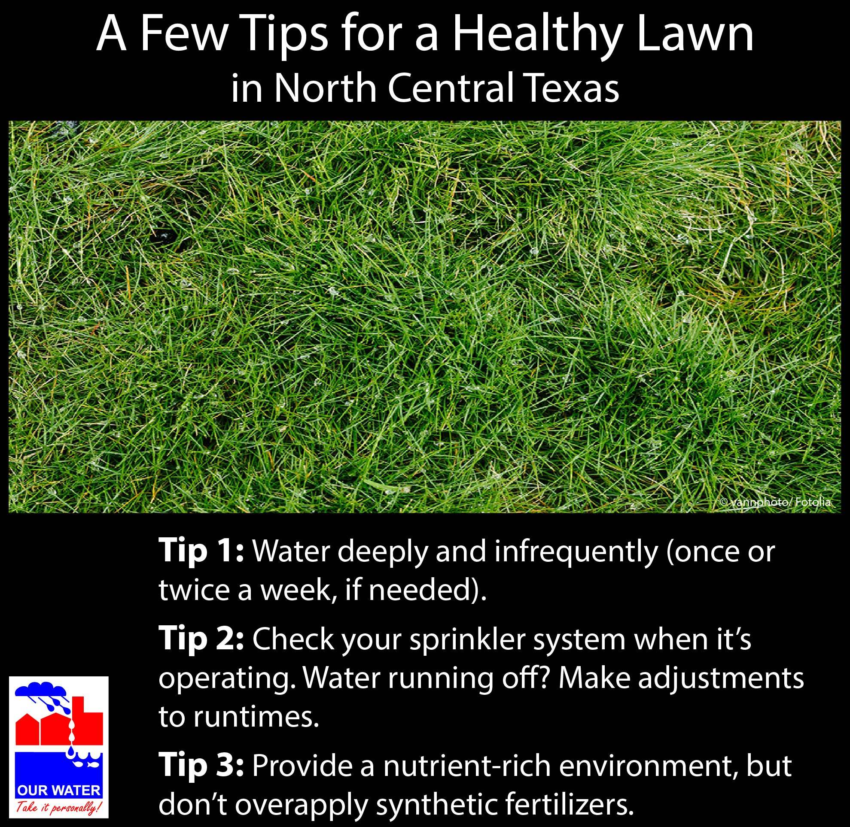

TEXAS SMARTSCAPE PLANTS / NATIVE AND ADAPTED
Time | March or April
Topic | To reduce the amount of pesticides or fertilizers necessary, select native and adapted plants for a thriving garden/landscape.
Source | Texas SmartScape website  Earth Kind Landscaping, http://aggie-horticulture.tamu.edu/earthkind/ and http://aggie-horticulture.tamu.edu/earthkind/files/2010/10/wildscapes.pdf;  Frisco newsletter, “WaterWise Wildflowers” http://www.frisco-online.com/frisco-news/living/around-the-house/6048-waterwise-wildflowers
Long version sample | Plant Native or Adapted  Looking to add a burst of color to your garden? Consider planting native or adapted. The Texas SmartScape program includes a database of grasses, turf, perennials, groundcover, trees, and shrubs native or adapted to North Central Texas. You could spruce up your yard with the shade-tolerant tree Texas Redbud or hardy yet delicate-looking Winecup. Or maybe you want to replace some turf with the flowering groundcover Frog Fruit.  Plants included in the Texas SmartScape database should thrive in the wide range of temperature and moisture conditions typical in North Texas. These hardy plants are rarely plagued by major pest problems, thus reducing or even eliminating the need for pesticides. They are also capable of maintaining healthy, vigorous growth in our region’s soils without the use of much—or any—fertilizer. (Although they might appreciate a nutrient boost once a year or so.)  The elimination or reduction of these chemicals can help reduce potential risks our environment and community. Here are a few issues that stem from the misuse of pesticides and fertilizers:  - Stormwater and irrigation runoff can carry pesticides and fertilizers from residential yards into neighborhood creeks, streams, ponds, lakes, and rivers, contaminating our waters and potentially harming wildlife.  - Fertilizer in our waters feeds algae rather than your plants. Algae blooms can reduce oxygen levels in water, killing fish.  - Broad-spectrum insecticides kill not only the target pest but also pollinators and natural predators.  For more details on the benefits of using native and adapted plants, see the Texas SmartScape’s Benefits webpage.  Interested in purchasing some plants on the Texas SmartScape list? Check out these local nurseries and garden centers. Texas SmartScape plant sales are also held at select times around the Metroplex. [Make more specific as appropriate.]  Happy gardening!
FB sample | Looking for some color to spruce up your garden? Plant native or adapted! Plants on the Texas SmartScape list should thrive in your garden without much (if any) help from fertilizers or pesticides. Learn more at www.txsmartscape.com. Happy gardening! | Looking to spruce up your garden? Plant native or adapted! Plants on the Texas SmartScape list should thrive in your garden without much (if any) help from fertilizers or pesticides. Come to the Texas SmartScape plant sale on [date] at [time]. Master Gardeners will be on hand to answer your questions. Learn more at [provide link that has more info, address]. Look forward to seeing you!
Memes/  Graphics/ Images |  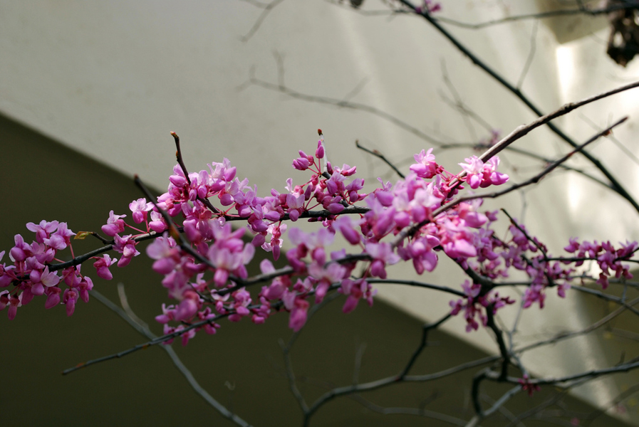redbud 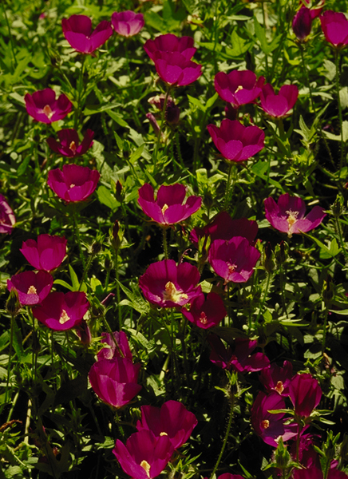 winecup  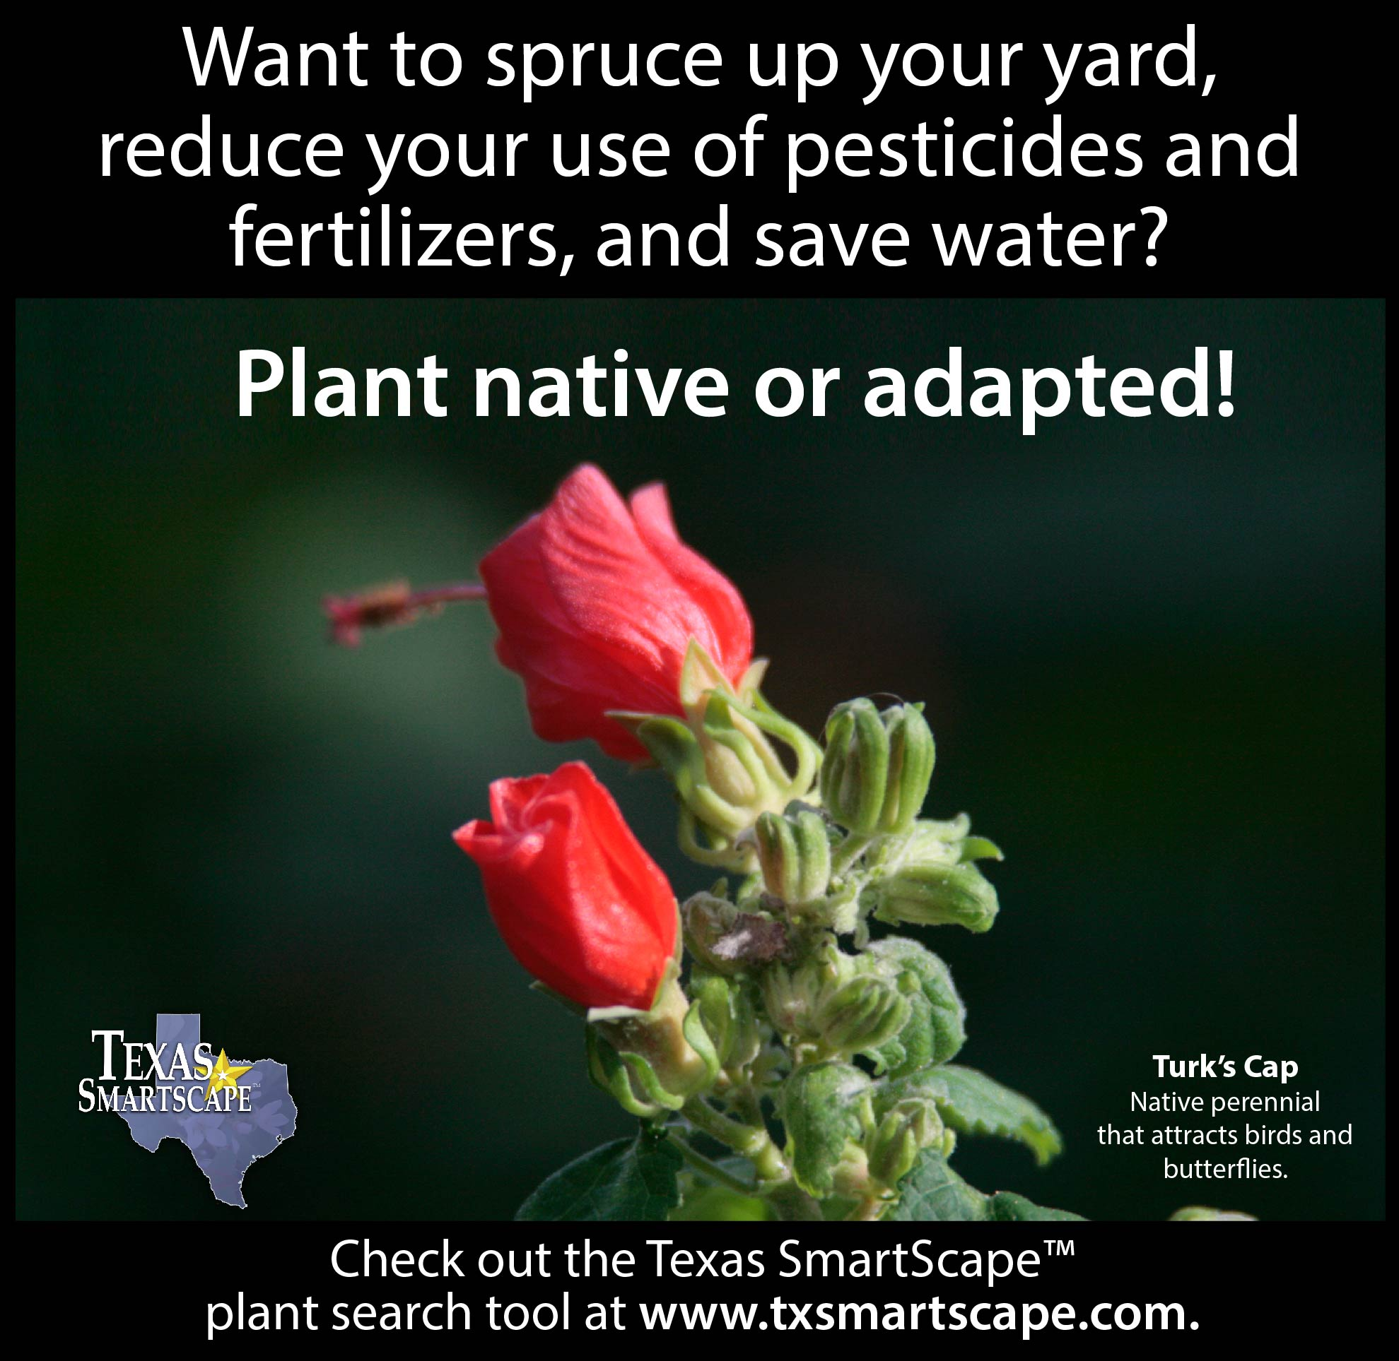  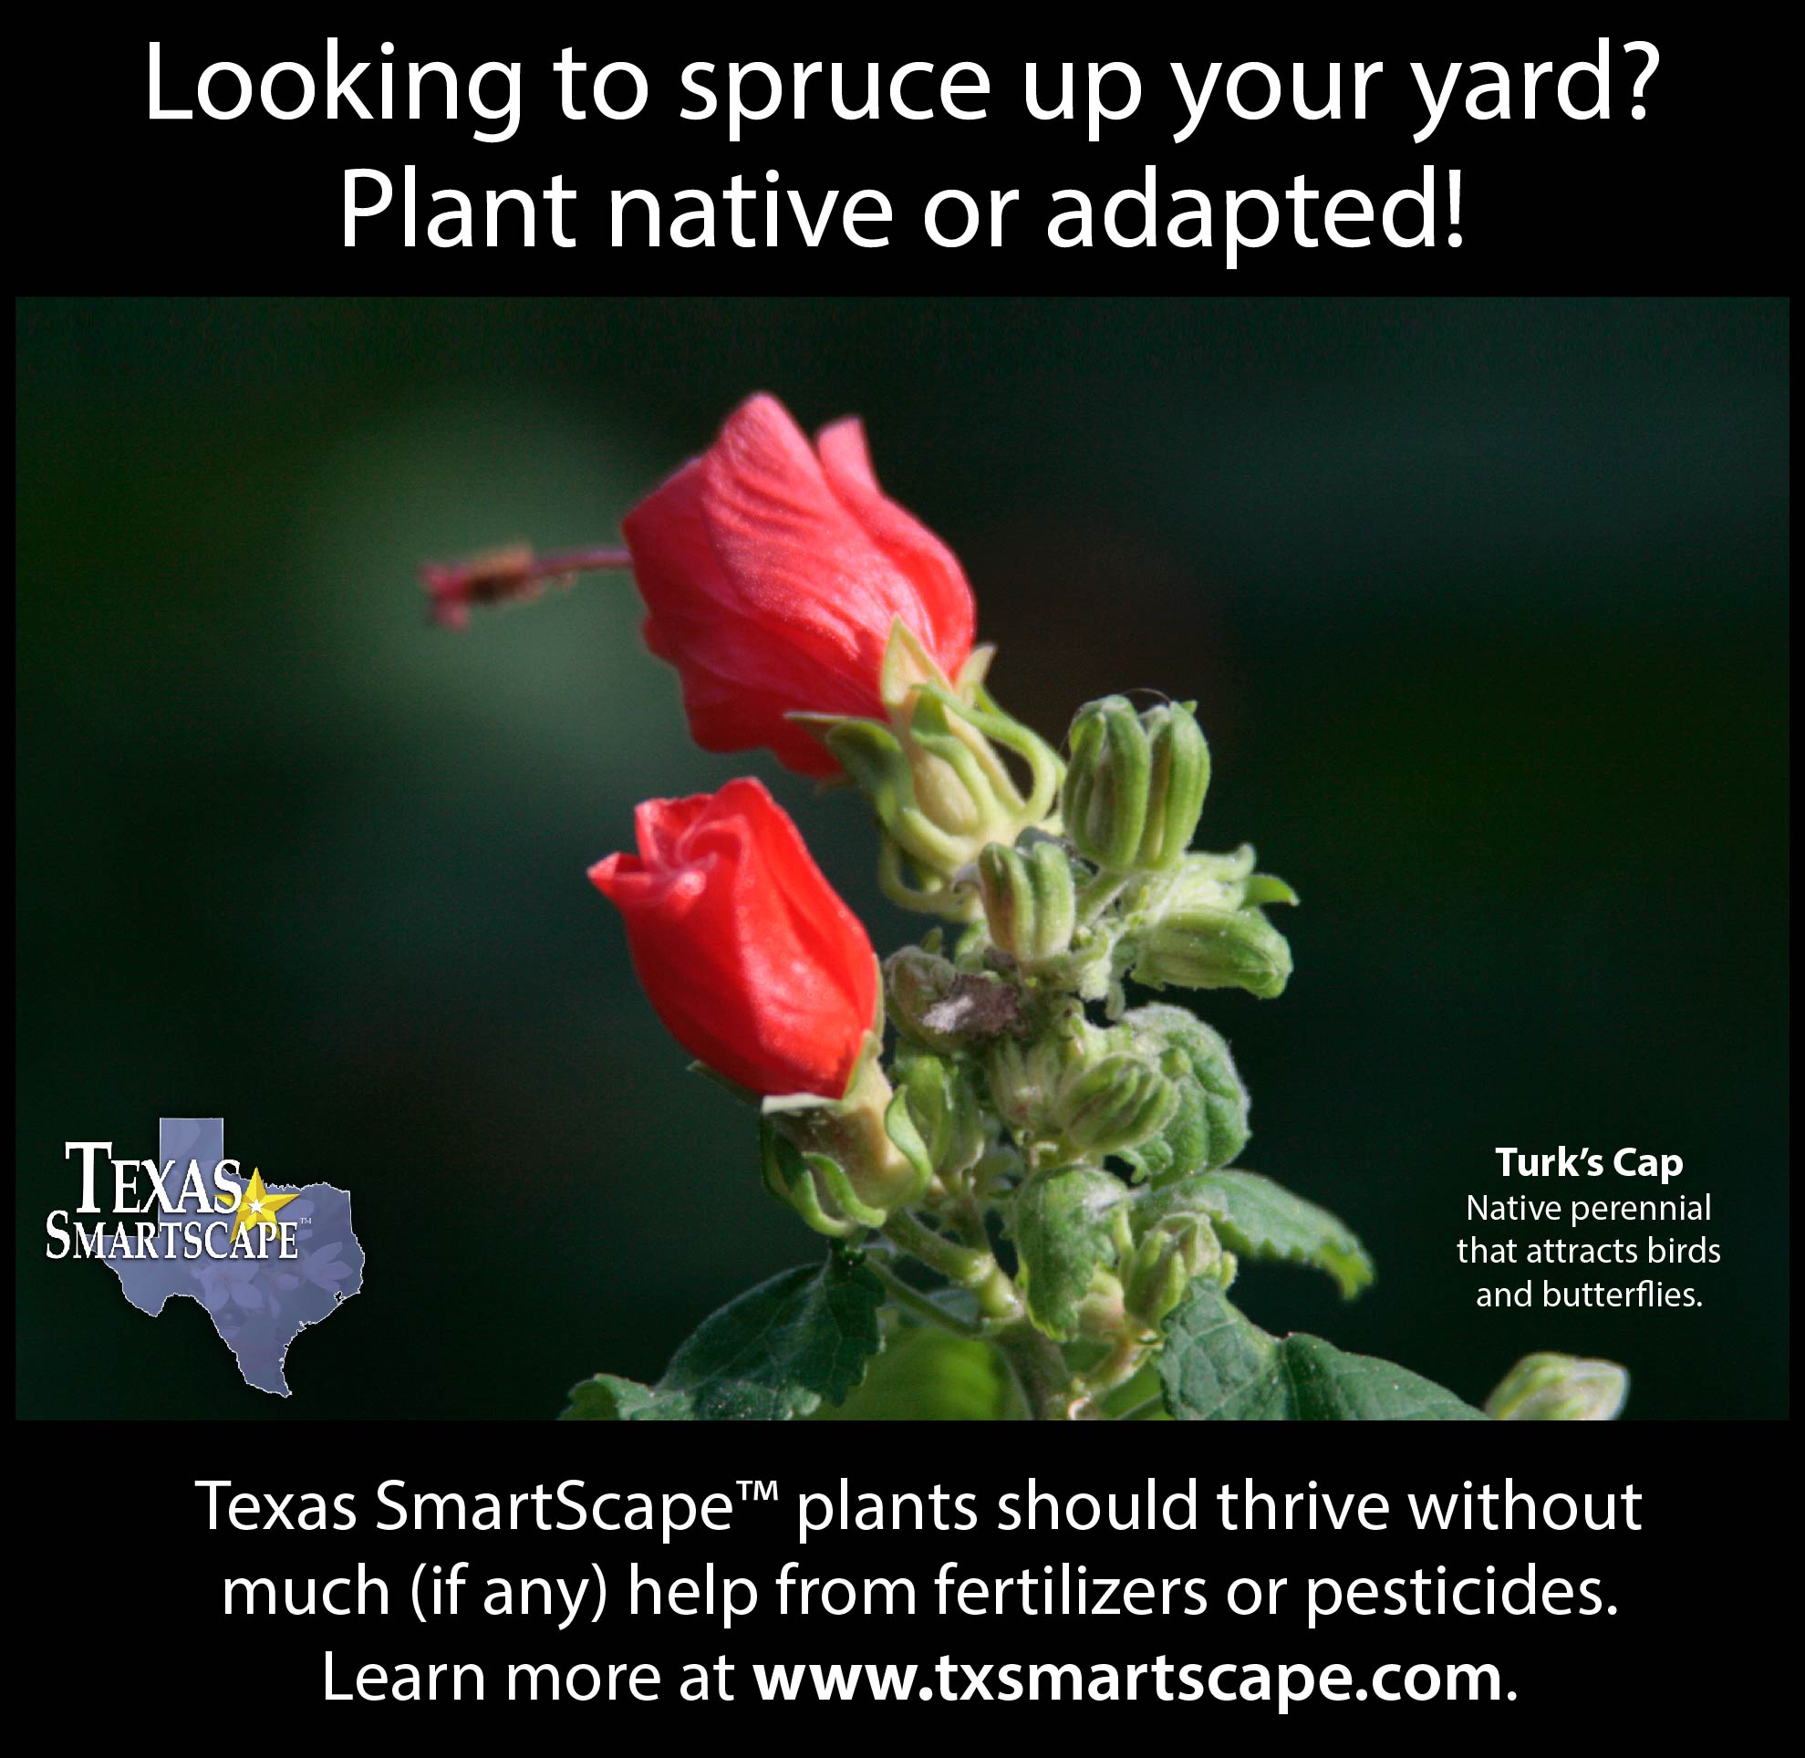  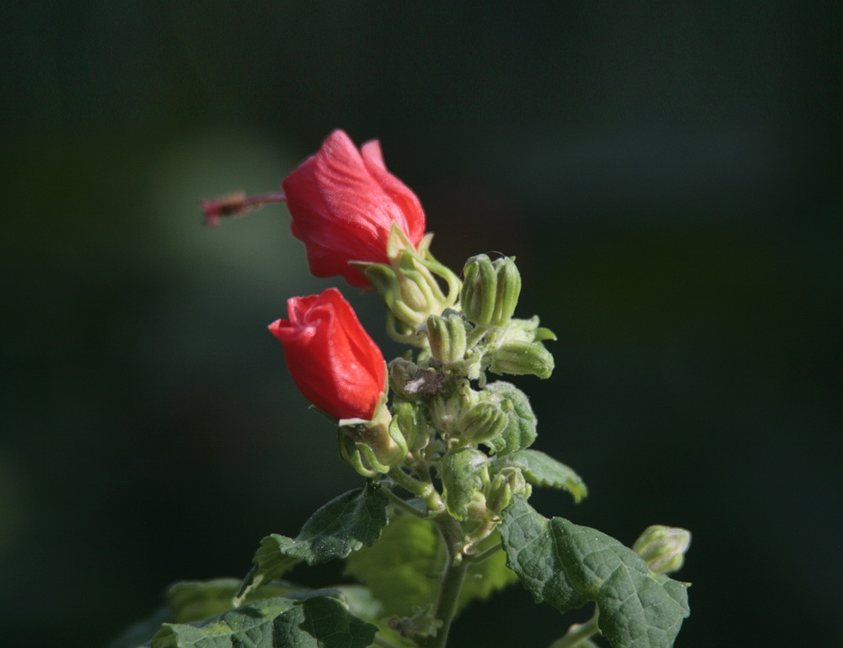 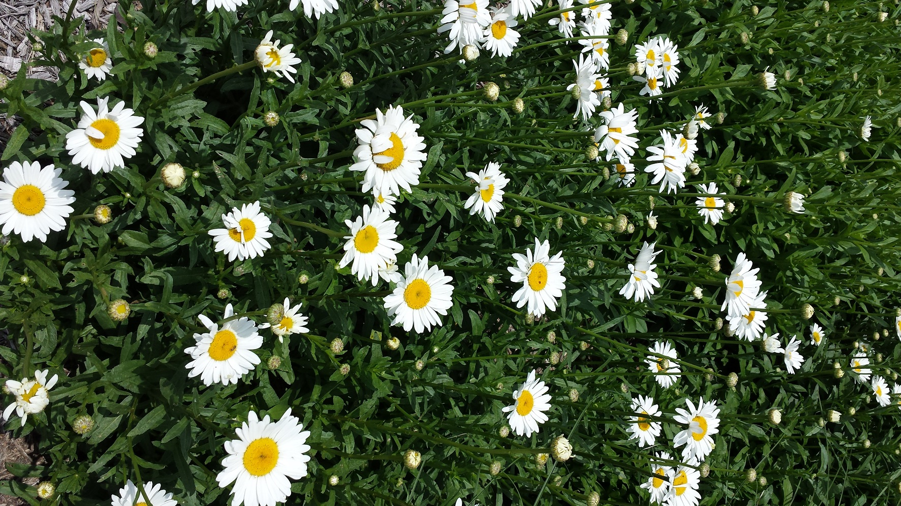  (NCTCOG staff photo of Turk’s Cap) (NCTCOG staff photo of Shasta Daisy)

DEALING WITH INVASIVE PLANTS
Time | Spring, Summer
Topic | Dealing with stubborn invasives
Source | Frisco WaterWise newsletter, “Dealing with Stubborn Invasives,” http://us4.campaign-archive1.com/?u=33cd614c011fb86a5e16e4f59&id=e01f16298e;  Lady Bird Johnson Wildflower Center http://www.wildflower.org/conservation_invasive/
Long version sample | Stop the Spread of Invasives  While a “weed” is simply any plant that pops up where you don’t want it, invasive plant species don’t just crash the party—they move in. They can spread so aggressively that they take over entire landscapes. In our region, invasive species such as Chinese privet, Japanese honeysuckle, Heavenly bamboo, and a noxious weed called Bastard Cabbage or Rapistrum rugosum can often out-compete native species, reducing plant biodiversity and disrupting ecosystems. According to the Lady Bird Johnson Wildflower Center, invasives are a significant threat to almost half of endangered native U.S. species.  The Lady Bird Johnson Wildflower Center maintains the Texas Invasives database to help Texas residents identify invasives that might be growing in their yards or community areas. The site includes a map where you can find your ecoregion’s “dirty dozen” terrestrial invasive threats.  It’s important to note that many invasive species are largely resistant to herbicides, so spraying them is not the best solution. Often, the most effective method is to pull them by hand. If pulled early in the season, many of these species can be removed fairly easily. In addition, if you pull annual species before they go to seed, you’re reducing the number of plants coming up next year.  When removing invasives from any landscape, bag the entire plant—seeds and all—to reduce the risk of further dispersal, then dispose of it. Don’t put it in your backyard compost pile, as the heat generated from the composting process may not be hot enough to destroy its seeds. [From Frisco’s newsletter, for those who participate in the same program: This material can be composted through our partnership with Texas Pure Products, where the heat generated from the composting process is enough to destroy any viable seeds.]
FB sample | Invasive species can out-compete native species, reducing plant biodiversity and disrupting ecosystems. Help stop their spread by learning about the problematic species for our region. Invasives taking over your yard? Pull those interlopers out, bag them, and dispose of them. [Link to Lady Bird Johnson Wildflower Center’s Texas Invasives database.]
Memes/  Graphics/ Images |   Hello, invasive species. Goodbye, Texas natives. Check before you plant at texasinvasives.org.  Image of Rapistrum rogusum, designated a terrestrial noxious-weed seed in the state of Texas. (http://www.texasinvasives.org/plant_database/detail.php?symbol=RARU)  http://www.texasinvasives.org/plant_database/detail.php?symbol=RARU

SOIL
Time | Spring, General
Topic | Improving soil—without using chemical fertilizers
Source | Frisco WaterWise newsletter “Get the Dirt on Dirt” http://wewww.frisco-online.com/frisco-news/living/around-the-house/4604-4604.html;  http://aggie-horticulture.tamu.edu/earthkind/files/2010/10/soilimprovement.pdf;  Texas Almanac – Soils of Texas, http://texasalmanac.com/topics/environment/soils-texas
Long version sample | The Trick to a Great Garden Isn’t Fertilizer … It’s Healthy Soil  Soil is the most important component in a successful garden. Soil is evaluated by its fertility (how much nitrogen, potassium, phosphorus, and other nutrients are available for root growth and foliage) and texture (varying from sandy to clay, which can make a huge difference in how easily plant roots develop and water infiltrates).  Across North Central Texas, we have our work cut out for us when it comes to soil—and our soil types vary across the region. For example, the Blackland Prairie region consists primarily of black clay soils, which is surprisingly rich in nutrients but difficult to amend and break down, while the Eastern Cross Timbers bottomland soils are loams or gray clays, with low fertility.  Do you know which type of soil you have? To get an idea (and also see the wide range of soils you can find in Texas), look at this General Soil Map of Texas from the USDA Natural Resources Conservation Service. (To get detailed information on your soil, check out the USDA’s Web Soil Survey tool. Click the green button that reads “Start WSS,” search by address, draw a box around your area of interest, and click the Soil Map tab for detailed descriptions about the soil types.) However, keep in mind that your soil was likely amended when your plot was developed, so you probably have a mix of soils.  Get your soil tested by Texas A&M AgriLife Extension Service –  Soil Sample Information  Urban Soil Test Form  Improving your soil –  Expanded Shale - A New Possibility for Amending Clay Soils  Don't Bag It™ - Compost It!  How to Compost
FB sample | The trick to a great garden isn’t fertilizer, it’s healthy soil. Do you know if you have good garden soil? If not, consider getting it tested by Texas A&M. [Link to (http://soiltesting.tamu.edu/] | The trick to a great garden isn’t fertilizer, it’s healthy soil. Know that your soil isn’t up to snuff? Amend it with compost. [Link to http://www.tceq.state.tx.us/news/releases/06-22howtocompost] | Healthy plants start with healthy soil. Find out what’s in yours.  [Link to (http://soiltesting.tamu.edu/]
Memes/  Graphics/ Images | 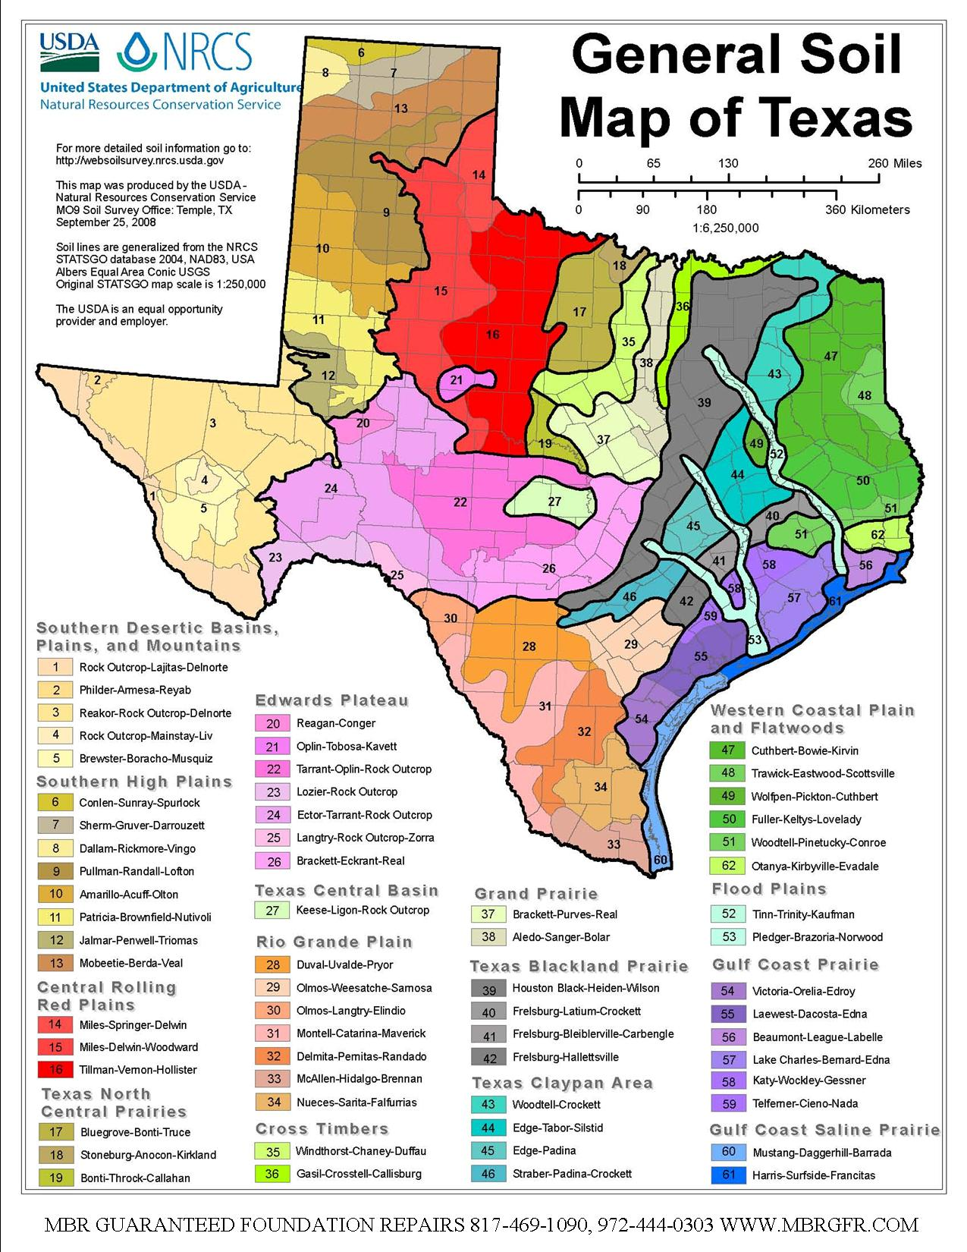  maybe soil map http://www.nrcs.usda.gov/wps/portal/nrcs/main/tx/soils/  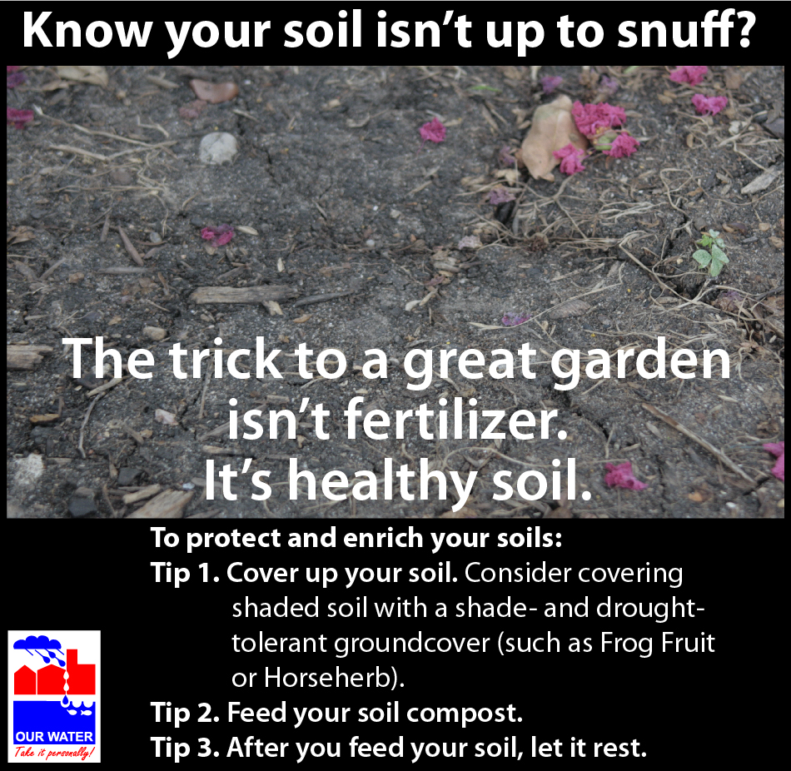  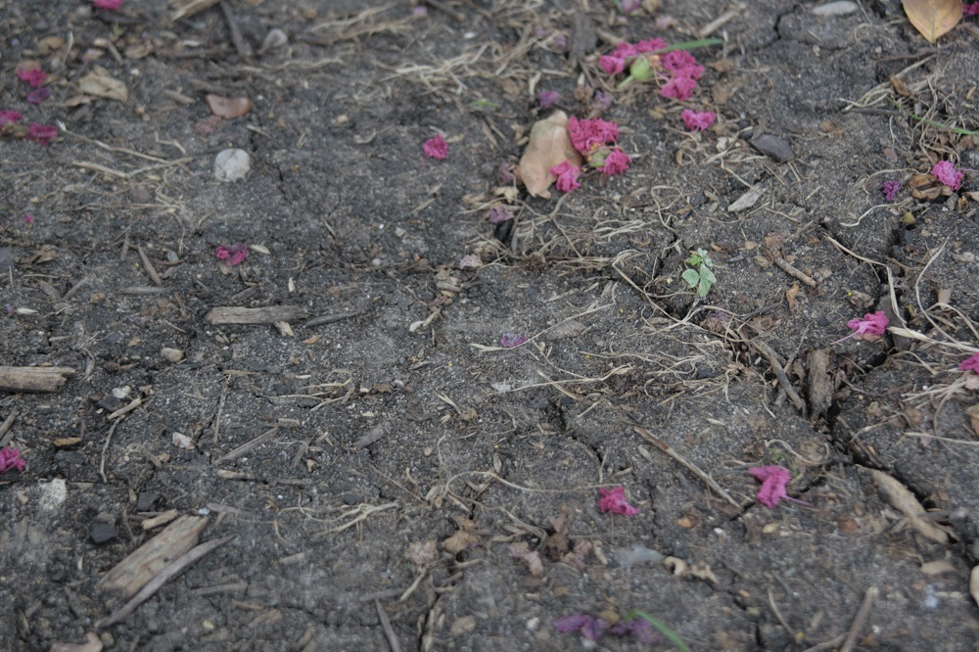 (NCTCOG staff photo)  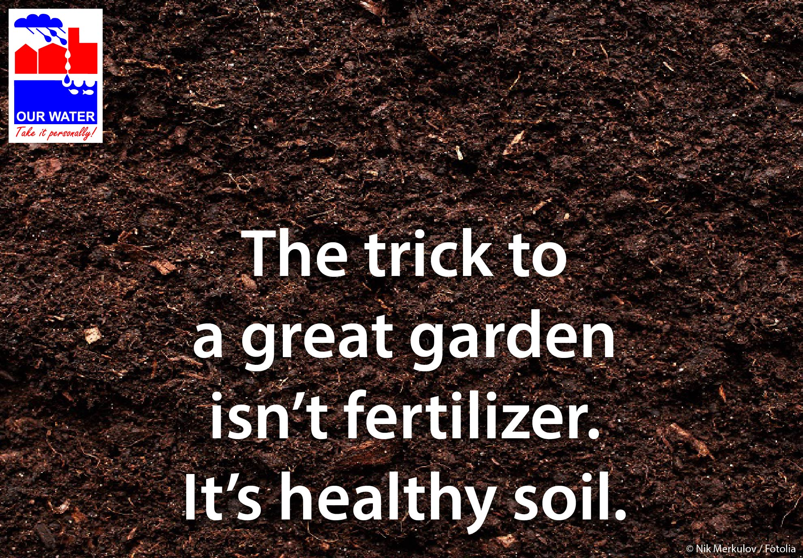

Time | General/Year-round
Topic | Protecting soils (rather than using synthetic fertilizers, etc.)
Source | Frisco WaterWise newsletter http://us4.campaign-archive2.com/?u=33cd614c011fb86a5e16e4f59&id=ec08b2042e;  Texas A&M AgriLife – Mulch http://aggie-horticulture.tamu.edu/earthkind/files/2010/10/mulch.pdf
Long version sample (adapted from Frisco newsletter) | Don’t Treat Your Soil Like Dirt  Soil health is vital to a healthy landscape.  Our soils perform many important ecosystem functions. They absorb water from rain events, sustain beneficial microbes vital to plant health, and provide nutrients so that plants can thrive.  Much of our region consists of black clay soils, which expand as they absorb water and contract as they dry out. As many North Texans know, working with expansive clay soils can be challenging.  Here are a few ways to protect and enrich your soils:  Cover up your soil. Uncovered soils have an increased risk of damage and loss from erosion. If your bare soils are located in a shady area, topping them with sod is not always the best solution. Instead, consider covering shaded soil with a shade- and drought-tolerant groundcover, such as Frog Fruit or Horseherb. (Find other suggestions via the Texas SmartScape plant list database, which can be searched by type, light requirement, and water use.) Another method of covering the soil is to use mulch. Mulch inhibits weed growth, reduces evaporation from the soil surface, moderates soil temperatures in summer and winter, breaks down into nutrients that your plants require for good growth, and keeps soil from eroding and crusting. The soil in planted beds should also be mulched.  Feed your soil compost. Synthetic fertilizers can do more harm than good if applied to unhealthy, compacted soil that has a hard time holding nutrients. Instead of applying fertilizer, amend the soil with compost rich in organic material. Soil amendment helps to expand pore spaces, enabling the soil to hold more water, air, and nutrients.  After you feed your soil, let it rest. In general, the less you disturb soils, the better. Once you have amended your soil, minimize turning over the soil and don’t over-aerate it. This allows beneficial soil microbes and earthworms the time alone that they need to flourish.  USDA Natural Resources Conservation Service videos from the Unlock the Secrets in Soil series -  - Soil health lesson in a minute: discover the cover  - Soil health lesson in a minute: how healthy soil should look  Plant health often starts with soil health. Some soil TLC will create a foundation for a healthy landscape that requires less water and fertilizer to thrive.
FB sample | Our soils work hard. They absorb water from rain events, filter pollutants, sustain beneficial microbes, and provide nutrients so that plants can thrive. Help your soil by protecting it. Keep soil covered with mulch or groundcover, amend with compost rich in organic matter rather than loading it up with synthetic fertilizers, and don’t disturb it any more than necessary. Your soil and plants will thank you!  [Either use alone, or link to article or USDA video] | Our soils work hard. They absorb water from rainstorms, filter pollutants, sustain beneficial microbes, and provide nutrients so that plants can thrive. Lean how you can help protect your soil. [Link to your article]
Memes/  Graphics/ Images | 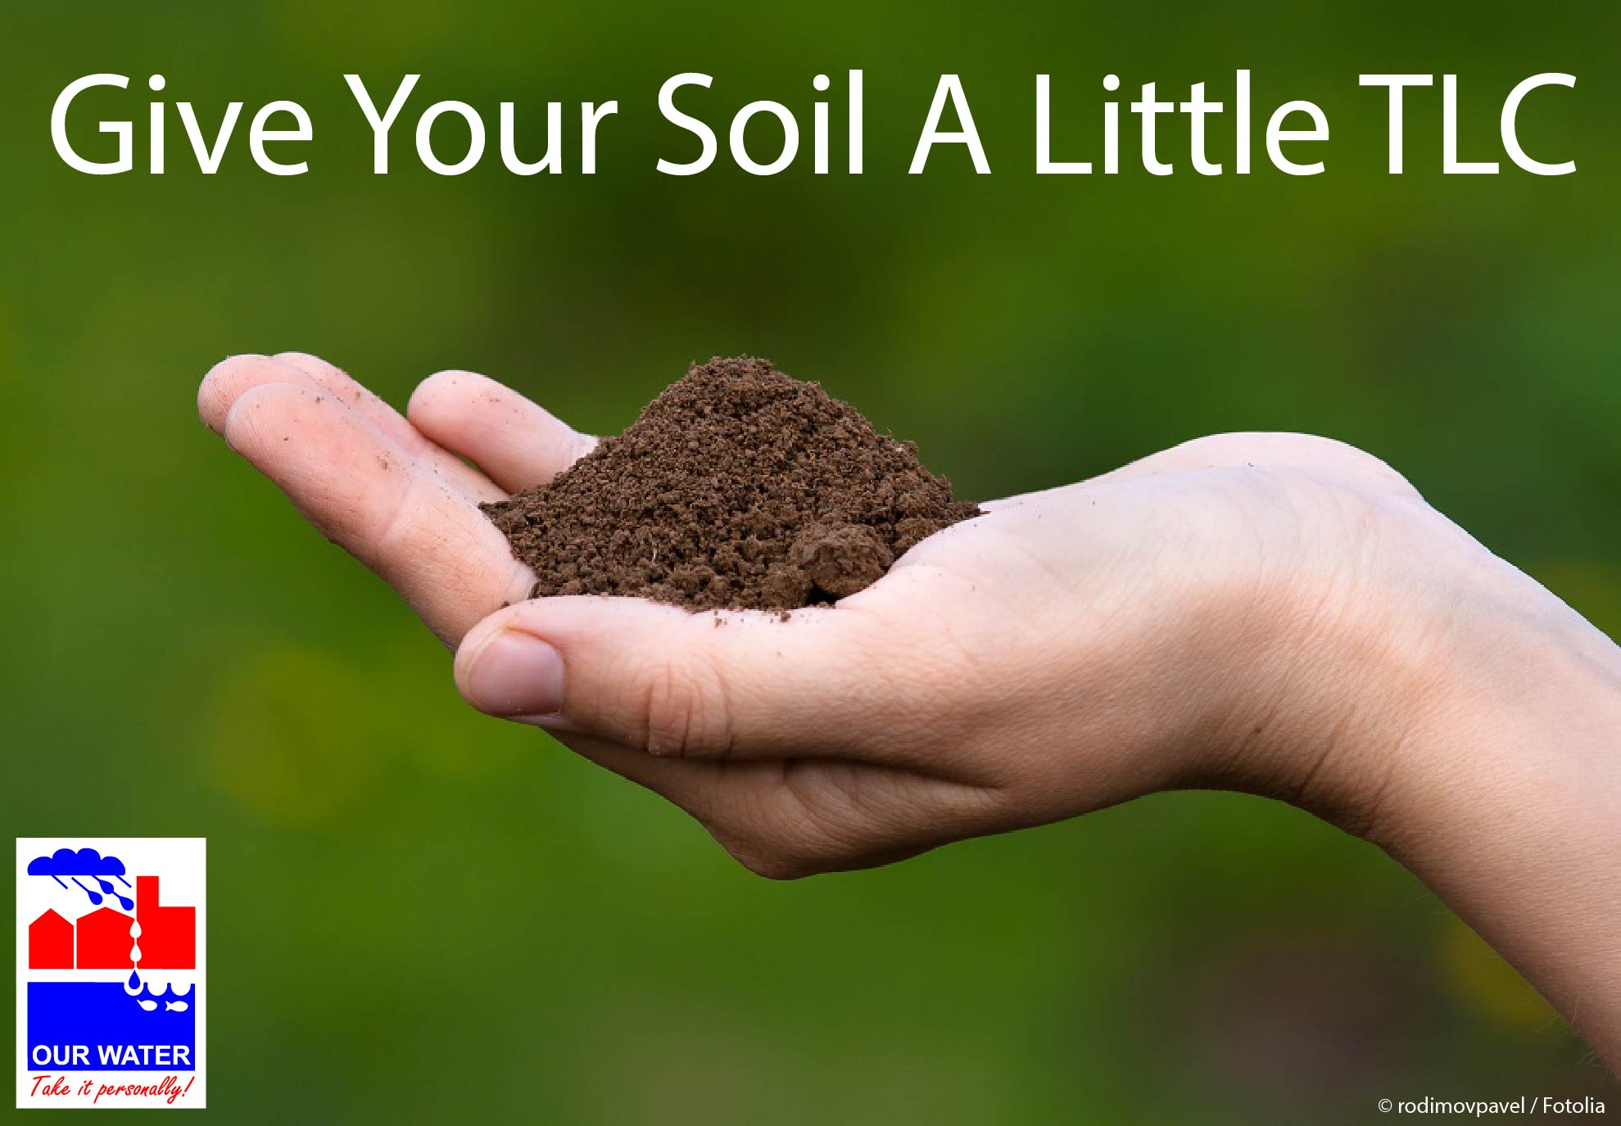

MULCH

Time | General/Year-round
Topic | Mulch – Overview
Source | AgriLife, Earth-Kind publication “Landscape Mulch,” http://aggie-horticulture.tamu.edu/earthkind/files/2010/10/mulch.pdf;  AgriLife, “Easy Gardening – Mulching,” http://aggie-horticulture.tamu.edu/vegetable/files/2010/10/E-512_mulching.pdf;  Frisco webpage “Mulching,” http://www.friscotexas.gov/departments/publicworks/water/lawnGarden/Pages/Mulching.aspx
Long version sample (adapted from Texas AgriLife publication) | Organic mulches such as wood chips and straw can provide your soil and plants with a variety of beneficial services. They can enrich soil, increase plant yields, discourage weed growth, and shield your plants from disease.  Enriching Soil and Increasing Yields  As organic mulches break down, they enrich the soil, improving the environment for plant growth. At the end of the season, organic mulch can be turned under the soil. Turn it under as soon as the gardening season is over. This enables the mulch to break down before you replant the garden next year.  According to Texas A&M, a well-mulched garden can yield 50 percent more vegetables than an unmulched garden. Why? A well-mulched soil is cooler than an unmulched soil, and plant food is more available in cooler soil. Mulched soils also retain more moisture, which can increase plant growth and yields. Your rows of veggies can also be spaced more closely because there is less need to cultivate the soil.  Discouraging Weed Growth  Most mulches help control weeds. While mulch does not prevent weed seeds from sprouting, if the mulch layer is thick enough to exclude light (about 2 to 4 inches deep), it can block the emergence of weed seedlings.  Reducing the Spread of Disease  Mulches prevent raindrops from splashing the soil surface, reducing the spread of soil-borne diseases. Note: For vegetable gardens, never mulch with the same crop material as the crop you’re growing. This increases the potential for disease transmission. For example, don’t use potato vines from the spring crop to mulch fall potatoes.  Seasonal Tips  Depending on the season, you may want to use different-colored mulch. In the spring, dark organic mulch will help soak in those sun rays and warm the soil. In the summer, a light-colored organic mulch about 2 to 4 inches deep will help keep the soil cool. You may need to add more mulch during the season, as mulch settles and begins to break down where it meets the moist soil surface.
Long version sample (adapted from Frisco site) | Got Mulch?  Mulch does your garden good. It blocks out weed seedlings, holds soil in its place, and can beautify your landscape as well as help enrich your soil. Mulch also acts like an insulator, protecting the plant’s roots from both cold winter weather and hot, dry summers. As an insulator, it helps your soil retain moisture, which reduces your need to water. Plus, it’s easy to apply.  Local garden supply and home improvement stores carry many different types of mulch. Which kind should you get? It depends on how you’re using it.  Organic mulch such as cedar and pine bark should be used around plants and trees. Add organic mulch to your flowerbeds when bare ground is visible between plants. If your drip irrigation lines on the bed’s surface are visible, add some mulch over those, too. Mulching around trees holds water near the tree and protects trunks and surface roots from being damaged by lawn maintenance equipment. Mulch can also be used in areas where grass is difficult to establish, preventing soil erosion.  Organic mulches add nutrients to the soil as they break down, which reduces or eliminates the need for synthetic fertilizers. The finer the mulch, the faster the particles enrich the soil. Larger mulch pieces will break down more slowly, but may float away in rainstorms. The shredded variety works well on slopes and paths, as it’s more likely to stay in place during heavy rain.  Inorganic mulch, such as rock or recycled tire particles, can work well along paths or borders. (Inorganic mulch tends to get hot under sunlight, which can then burn plants.)  A layer of about 2 inches of mulch is sufficient for most areas, and more can be added at any time.
FB sample | Got mulch?
Memes/  Graphics/ Images | 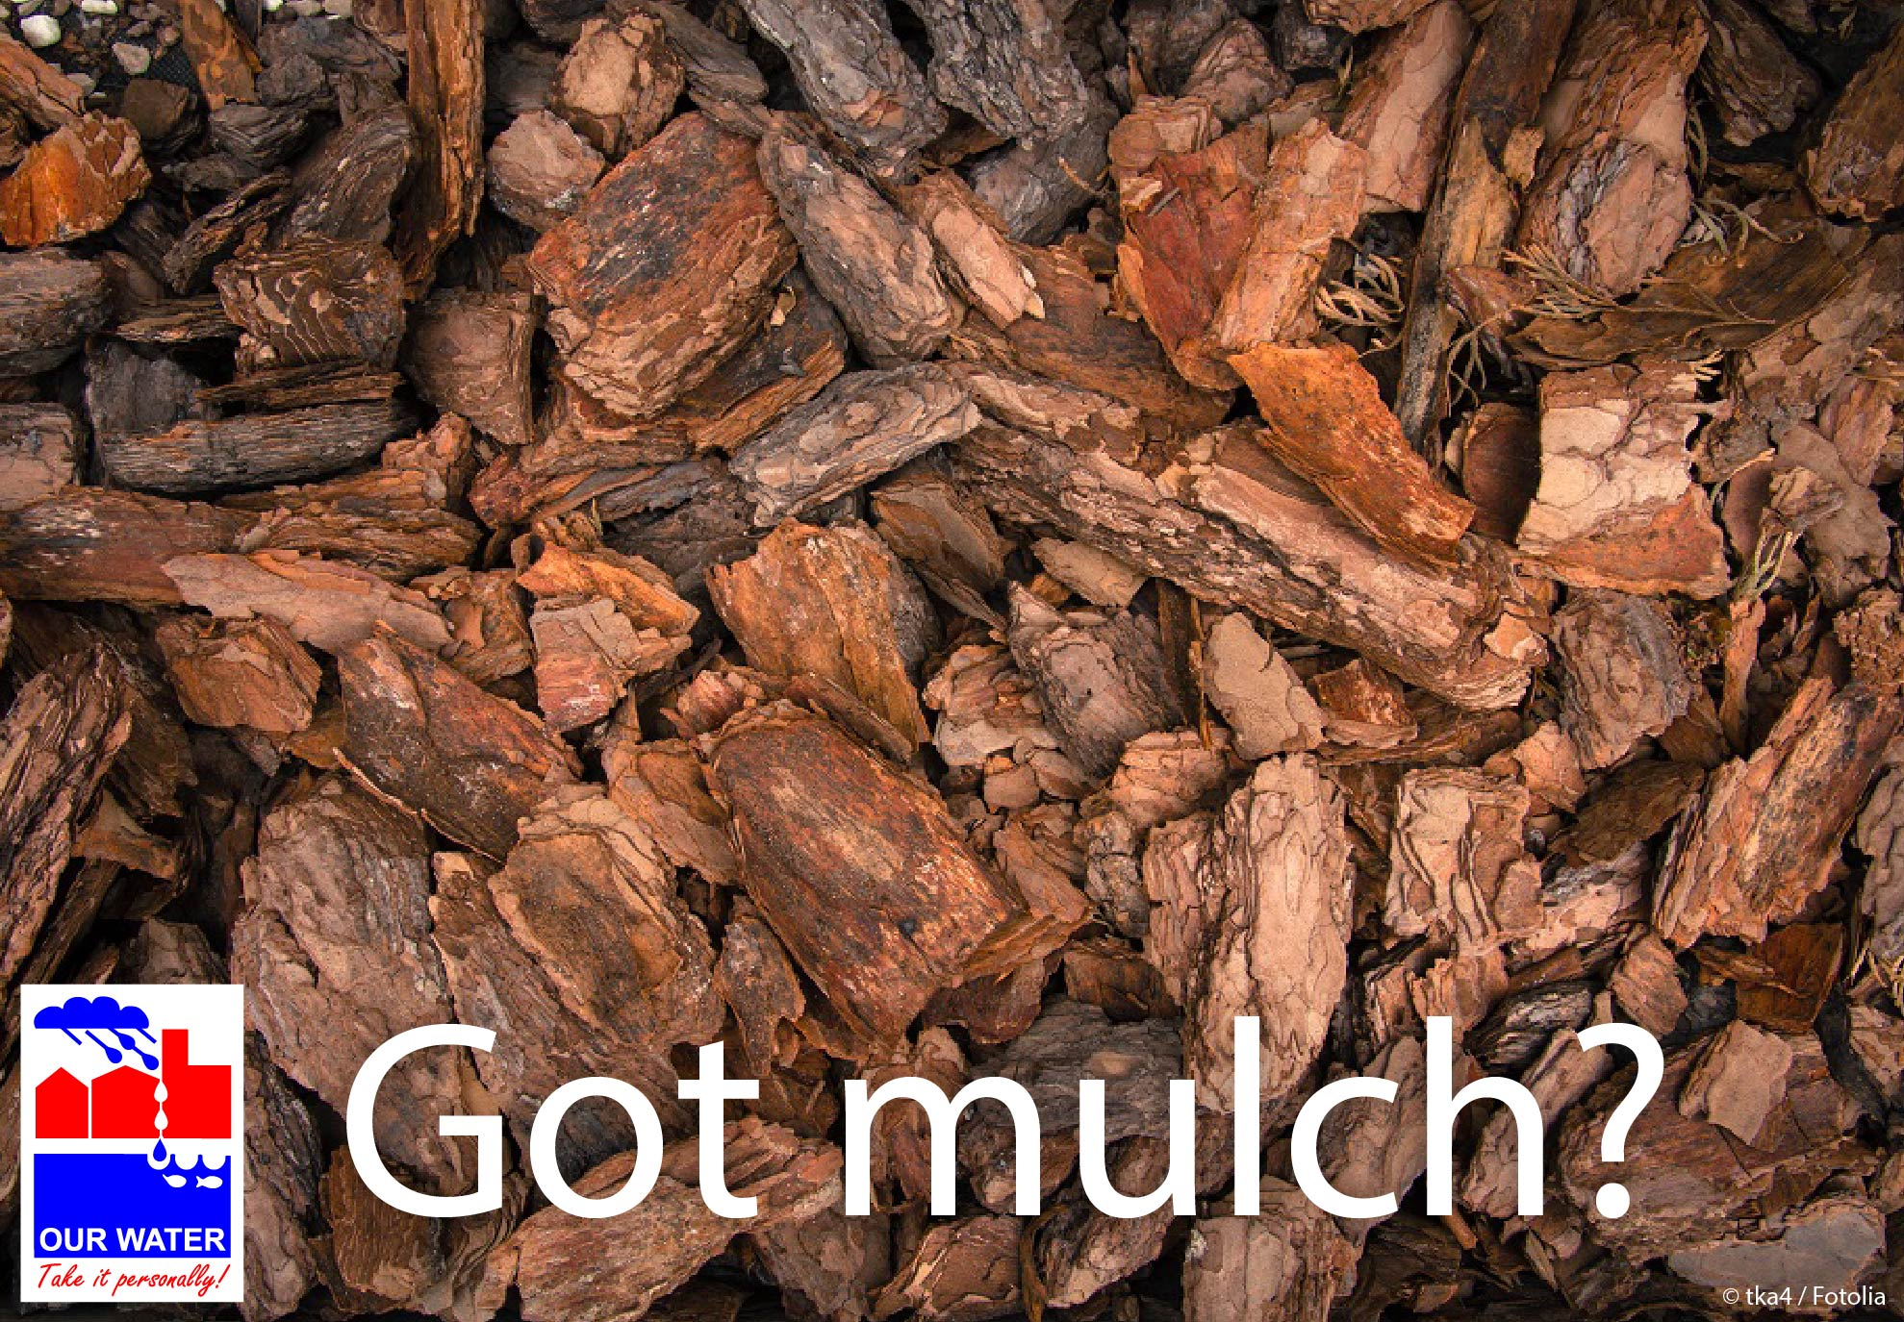  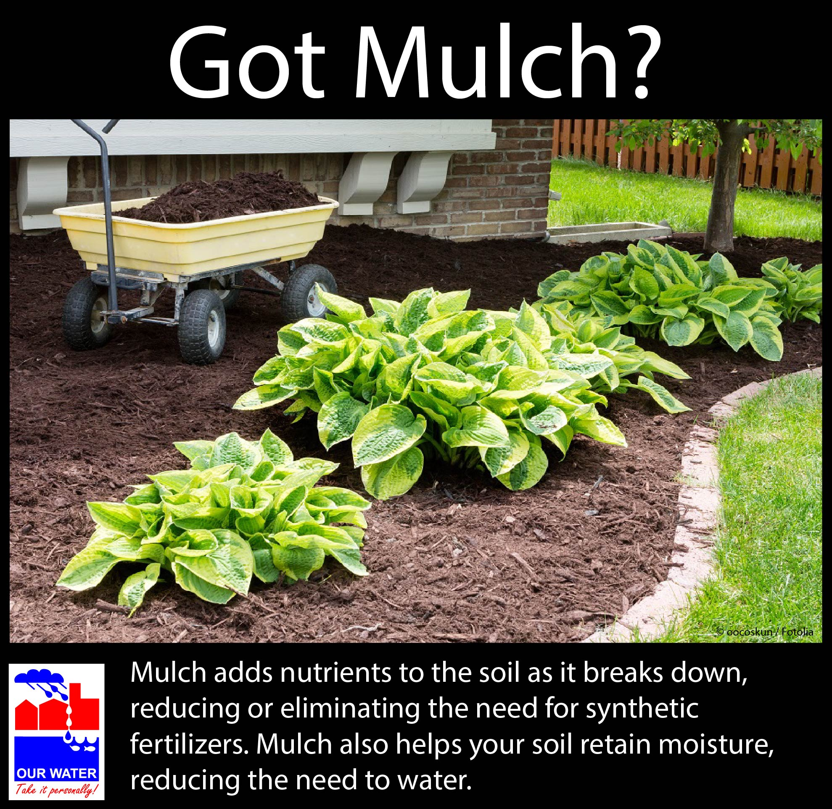  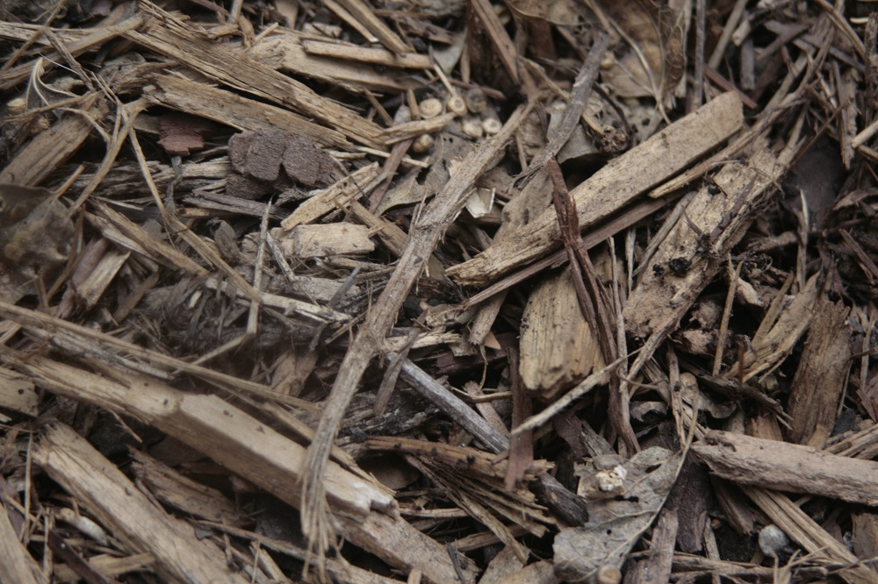 (NCTCOG staff photo)

COMPOST
Time | Spring, Summer, Fall
Topic | Compost (instead of synthetic fertilizer)
Sources | Take Care of Texas, “Mulching and Composting” http://takecareoftexas.org/sites/default/files/publications/gi-036_2.pdf;  EPA, “Backyard Composting: It’s Only Natural” http://www.epa.gov/waste/conserve/tools/greenscapes/pubs/compost-guide.pdf,  EPA, “Municipal Solid Waste,” http://www.epa.gov/wastes/nonhaz/municipal/
Long version sample – mostly from Texas AgriLife and Take Care of Texas (with blurb added on municipal compost) | Compost: A Cure for Many Garden Woes  Compost is a cure for many garden woes. Low soil nutrients? Add compost! Heavy clay soils that won’t drain when it rains? Add compost! Soil can’t seem to hold enough moisture? You guessed it—compost may help!  You can make compost by mixing materials such as leaves, grass clippings, vegetable scraps, and coffee grounds. With a bit of heat (or not, depending on your composting style), the mixture breaks down into a nutrient-rich material that can reduce the need for fertilization and help conserve water in your garden, saving you money. And while you’re creating a terrific soil amendment, conserving water, and saving money, you’re also helping reduce the amount of compostable food and yard waste being sent to our rapidly filling landfills. According to the Environmental Protection Agency, compostable food and yard waste make up 28 percent of what we throw away each year—the largest component of municipal landfills! [If your city turns yard waste into compost, adjust or delete the above sentences.]  If you’re worried about how the compost will look or smell in your yard, use a container or bin. A variety of commercially made bins are available, or you can build your own. An enclosed container keeps out pests and retains the heat and moisture needed to break down the materials. If composting is done correctly, the compost shouldn’t have an offensive odor. If your pile smells, it may have too many “green” materials or be too wet. Luckily, there’s often an easy fix. Simply turn and mix the compost and add “brown” materials such as dry leaves and paper.  Decomposition time depends on a few factors. The smaller the pieces, the faster the materials will decompose. Turning the compost also speeds up the process. In addition, it depends on your compost style! Hotter piles tend to break down faster than cooler piles.  Composting resources  Detailed compost recipes and troubleshooting: Take Care of Texas guide “Mulching and Composting”  City of Plano’s online learning modules on backyard composting and composting food waste  Dallas News, “Composting 101: Everything you need to know for the perfect, organic plant feed”  [If you want to promote classes] Interested in learning more, or just want to share your composting troubles or triumphs with composting comrades? Come to one of our composting classes! [Provide date, time, location, url for information/how to register. If you don’t hold classes, you may want to see if AgriLife has one coming up—see http://dallas.tamu.edu/courses/]  [You might want to use this below paragraph if you are part of a program that provides compost/curbside recycling. Revise so it has information for your area. If you have compost available at your drop-off stations, incorporate that information instead.]  Overwhelmed by the idea of backyard composting but have lots of yard waste? The [City/Town of XYZ] is a member of the North Texas Municipal Water District (NTMWD) regional composting program. Yard trimmings collected from our residential curbside recycling program are not sent to a landfill—we compost them instead. The finished material is marketed as TexasPure, and a limited supply of bagged product is available at no charge to residents at [your pick-up location.] Pick up is limited to [bag limit per month] on [pickup day/time]. Compost is available on a first-come, first-serve basis while supplies last. Additional product can be purchased at Shades of Green Nursery, 8801 Coit Road, Frisco, 972-335-9095, or the NTMWD Custer Road Transfer Station, 9901 Custer Road, Frisco, 214-495-7389.
Long sample – from EPA and AgriLife | Backyard Composting: An Easy and Earth-Friendly Way to Build Healthy Soil  With a small investment in time, you can improve the health and appearance of your yard, save money on fertilizers and mulch, preserve natural resources, and protect the health of your family.  Why compost?  - Your yard will love you for it. Compost increases the soil’s ability to hold water and air (both crucial to plant health), improves soil fertility, and stimulates healthy development of plant roots.  - It’s earth-friendly. Yard waste and compostable food scraps make up approximately 28% of the waste stream, according to the Environmental Protection Agency—the largest component of municipal landfills. When you compost these materials, you’re keeping them out of landfills, where they would otherwise take up precious space and release methane, a greenhouse gas 25 times more potent than carbon dioxide emissions. And because compost creates healthier soil that holds more water, you can reduce the amount of chemical fertilizers applied and reduce your watering, too! [If your city composts yard waste, adjust the first part of this bullet as necessary.]  - You can save money. Adding compost to your garden can reduce or eliminate the need to buy chemical fertilizers or compost. If you pay for the amount of trash hauled, composting can also cut down on your trash costs.  - It’s easy. Start with some yard waste. If you have an enclosed bin, add food scraps like vegetable and fruit peels, coffee grounds, and tea bags.  What you need  Bin or pile? Some people start with a pile then move to a bin when they feel ready. A pile works great for just leaves and grass clippings, but when you want to incorporate food waste, it’s time to move to an enclosed bin with solid sides and a lid to avoid rodents visiting your pile. Enclosed bin options include turning units, stacking bins, and bins with flip-tops. [If you offer free or discounted bins to residents, add a sentence here, such as “The City/Town of XYZ even provides free bins to residents. To request one, …” and let them know where to request one/who to contact.] Bins can also be purchased from retail or mail order businesses. Make sure to consider your options and select a bin that fit your needs.  A good spot. Select a spot in your yard that doesn’t interfere with other uses. Ideally, the compost area should be at least three feet wide by three feet deep by three feet tall (one cubic yard). This area provides enough food and insulation to keep the organisms breaking down your compost nourished and cozy. However, if a pile is managed well, it can be larger or smaller and work just fine. You may want to make sure it’s within reach of a hose so you can easily moisten your compost pile when necessary.  Browns, greens, air, and water. “Brown” materials such as dry yard waste (dry leaves, twigs, etc.) and cardboard provide carbon for your compost. “Green” materials such as wet yard waste (fresh grass clippings, green leaves) and food scraps like vegetable and fruit peels, tea, and coffee grounds provide nitrogen. (Check out EPA’s “Backyard Composting: It’s Only Natural” guide on what to add and what not to add.) Using two-thirds brown materials and one-third green materials is a good rule of thumb to achieve light, fluffy compost. Your compost pile will also need a bit of turning to provide its organisms with some air. You may need to add a bit of water once in a while, too. Your pile should be about as damp as a wrung-out sponge.  A covered plastic container for your kitchen scraps. You don’t want to have to run out to the garden every time you have compostable food waste. Keep a compost pail or a covered plastic container in the kitchen to store those vegetable scraps, fruit peels, coffee grounds, and other compostables. To reduce odor, you may want to purchase a container with carbon filters.  For more information on how to make compost, troubleshooting, and vermicomposting, check out EPA’s “Backyard Composting: It’s Only Natural.”  [If you want to promote classes] Interested in learning more, or just want to share your composting troubles or triumphs with composting comrades? Come to one of our composting classes! [Provide date, time, location, url for information/how to register. If you don’t hold classes, you may want to see if AgriLife has one coming up—see http://dallas.tamu.edu/courses/]
FB sample – for Take Care of Texas version | Want to make your garden happy? Give it a treat: compost. [Link to http://takecareoftexas.org/sites/default/files/publications/gi-036_2.pdf]
FB sample – for EPA version | Today’s a good day to start composting. Why, you ask? It benefits your yard and it can save you money. With this guide’s helpful tips, it’s a piece of (compostable) cake.  [Link to http://www.epa.gov/waste/conserve/tools/greenscapes/pubs/compost-guide.pdf]
FB samples – other | Don’t have the time or space to compost? Don’t worry—the [City/Town of XYZ] hasn’t been throwing your yard waste in the landfill—we’ve been composting it for you. It’s all ready for you to pick up at [address].
Memes/  Graphics/ Images | 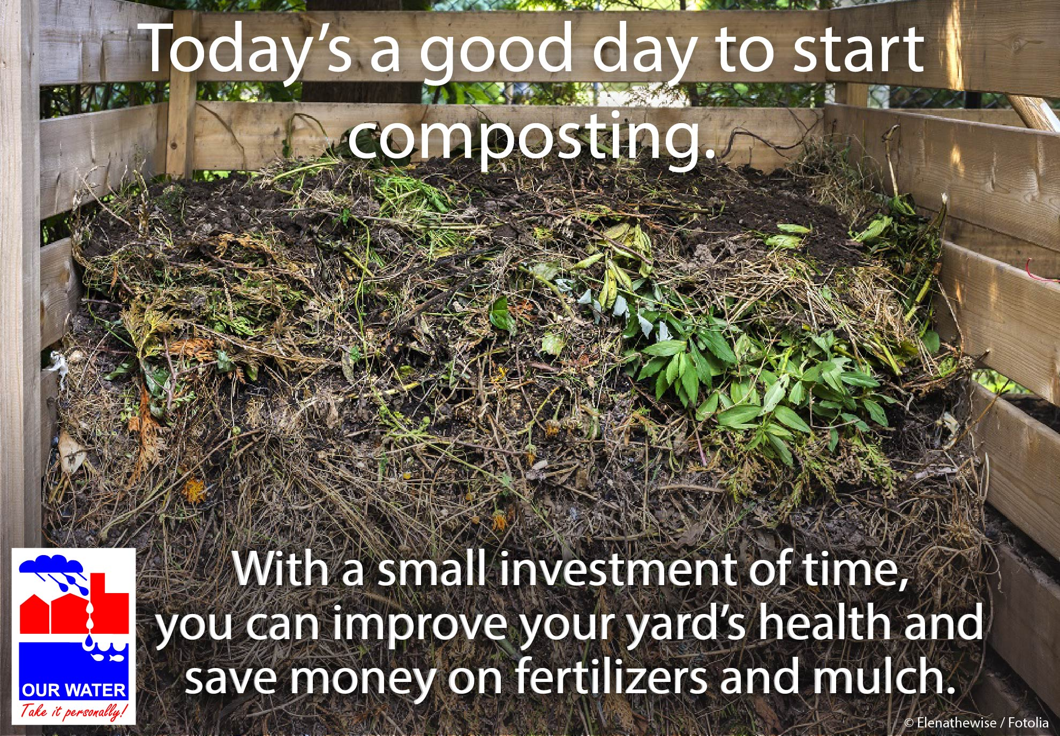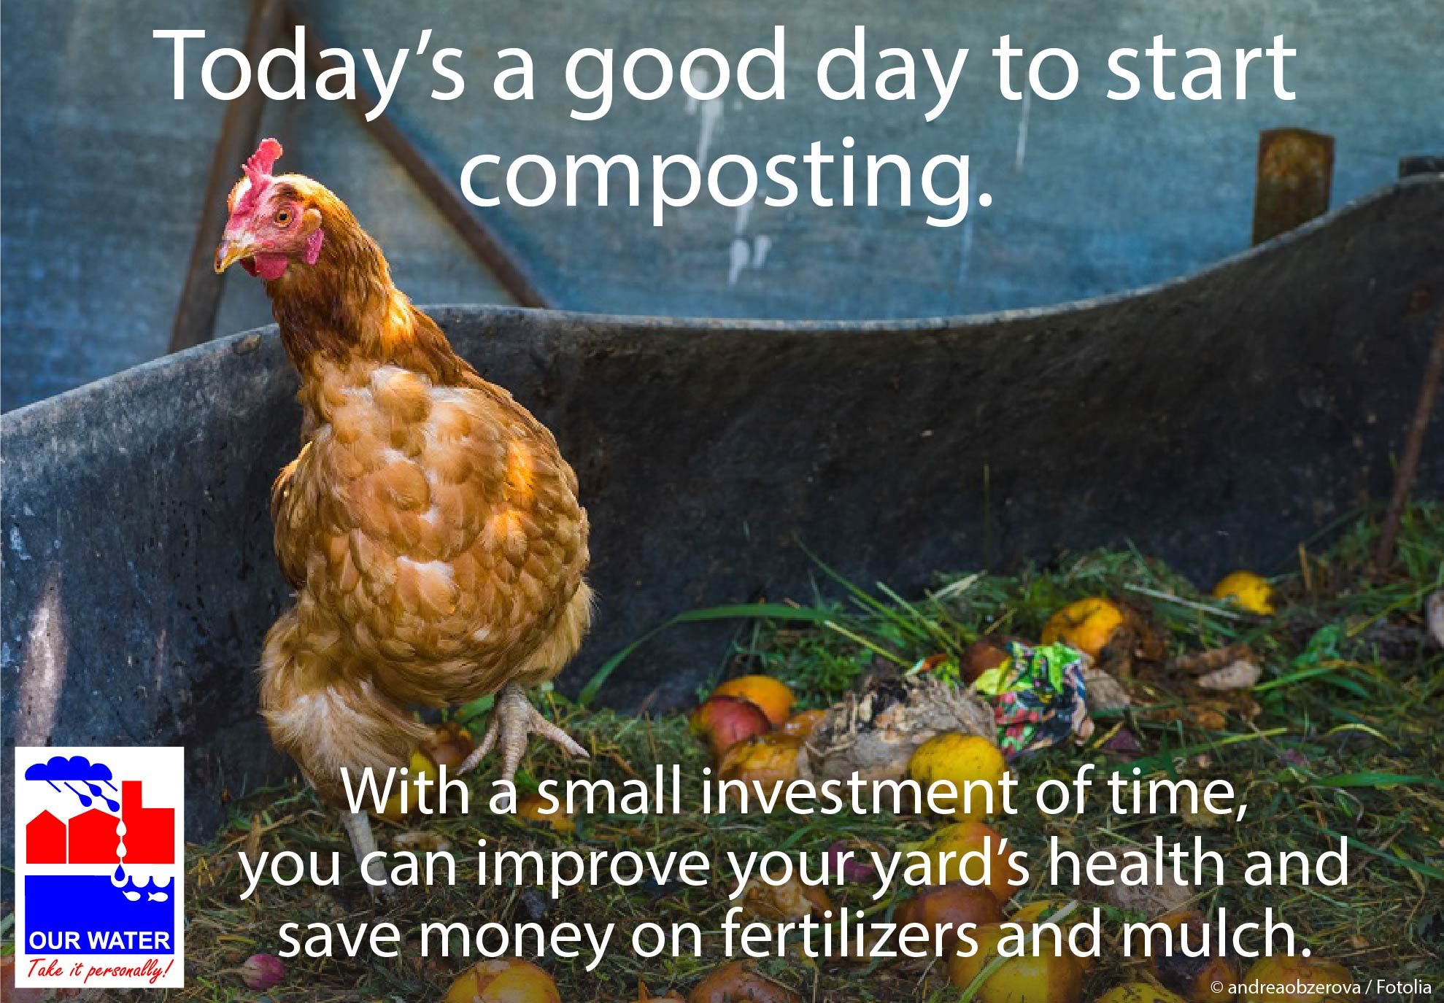  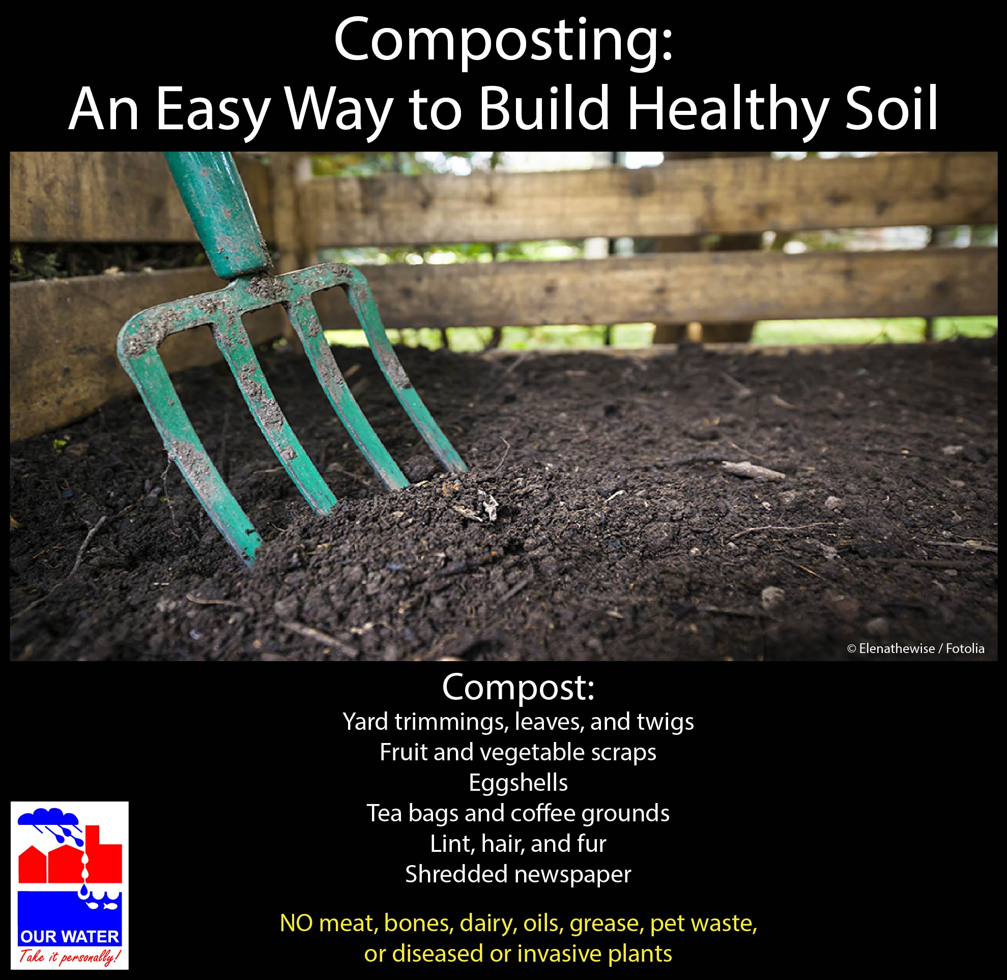  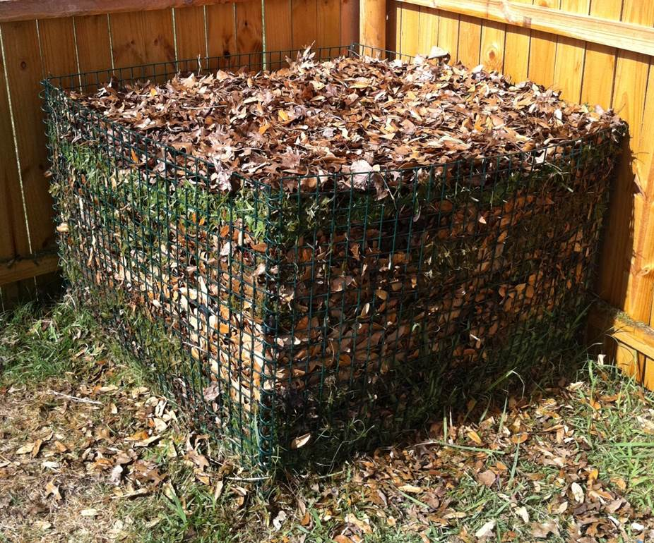 (City of Grand Prairie photo)  For cities that do not compost their yard waste:  http://www.epa.gov/wastes/nonhaz/municipal/infographic/index.htm    http://www.epa.gov/wastes/nonhaz/municipal/images/2012_totl_msw_gen_fig4_lg.png  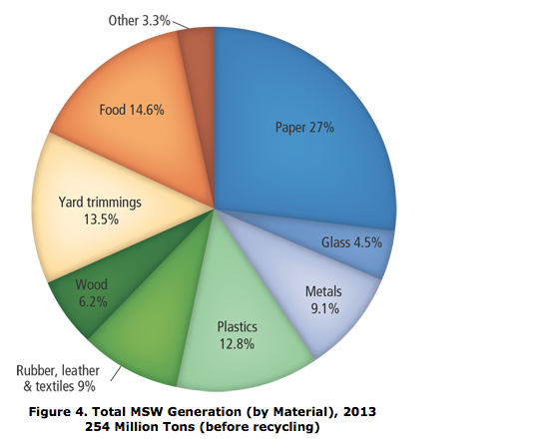

Time | Fall
Topic | Using leaves as compost/mulch
Source | Frisco WaterWise newsletter “Don’t Bag Those Leaves” http://www.frisco-online.com/frisco-news/living/around-the-house/5742-this-year-instead-of-bagging-those-leaves-that-you-ve-raked-up-in-your-yard-take-advantage-of-this-autumn-offering-by-adding-them-to-a-compost;  EPA’s “Backyard Composting: It’s Only Natural”;  Texas A&M AgriLife, http://aggie-horticulture.tamu.edu/earthkind/files/2010/10/compost.pdf
Long version sample | Planning on raking your yard this weekend? Don’t bag those leaves for the city to take away—add them to your compost pile! Don’t have a compost pile yet but thinking about starting one? This may be the perfect opportunity.  Composting allows leaves to break down naturally, providing minerals and nutrients that you can then recycle back into your landscape. Not only will your landscape thank you, so will your wallet. Composting can save you money by reducing or eliminating the need to buy chemical fertilizers or compost, and if you pay to get your trash hauled, composting can also reduce your trash costs.  You might want to get a bin for your compost—especially if you plan to add food waste. The key to successful composting is maintaining a balance of “brown” (carbon) and “green” (nitrogen) materials in your bin. Brown materials such as dry leaves and straw are bulkier and tend to be less dense than green materials such as grass clippings, vegetable scraps, and coffee grounds. Using two-thirds brown materials and one-third green materials is a good rule of thumb to achieve light, fluffy compost.  While backyard compost tends to have plenty of green materials available throughout the year from kitchen scraps and grass clippings, brown materials are often in shorter supply. Dried deciduous leaves are a valuable compost material as they will break down quickly for easy incorporation into your compost pile.  You may want to keep a small layer of leaves under your shade trees to dry and compost naturally. Running a lawnmower over them first—avoiding the tree’s roots—will help the leaves break down and make it a less attractive habitat for all but the smallest garden creatures. You can add these leaves to your compost pile later when you need more “brown,” or keep them where they are and reduce the need to purchase mulch in the coming spring.  While deciduous leaves are a great addition to a compost pile, avoid adding a lot of pine needles or evergreen leaves such as laurel, holly, or conifers. These plants contain compounds that can slow the composting process.
FB sample | Have a date with your yard to rake up leaves? Don’t leave them curbside for the city to take away—add them to your compost pile!
Memes/  Graphics/ Images | 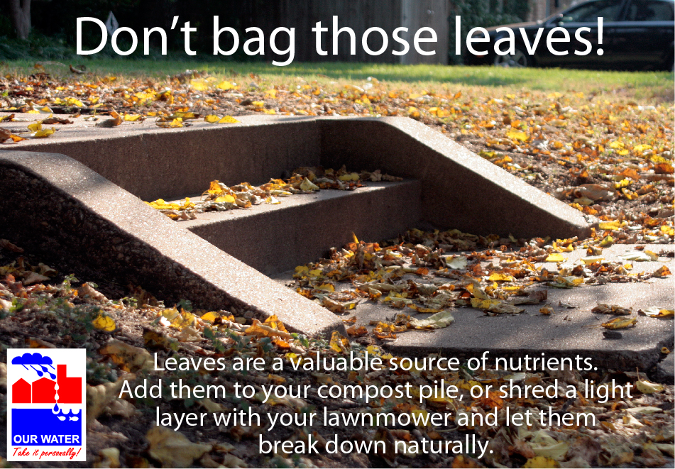  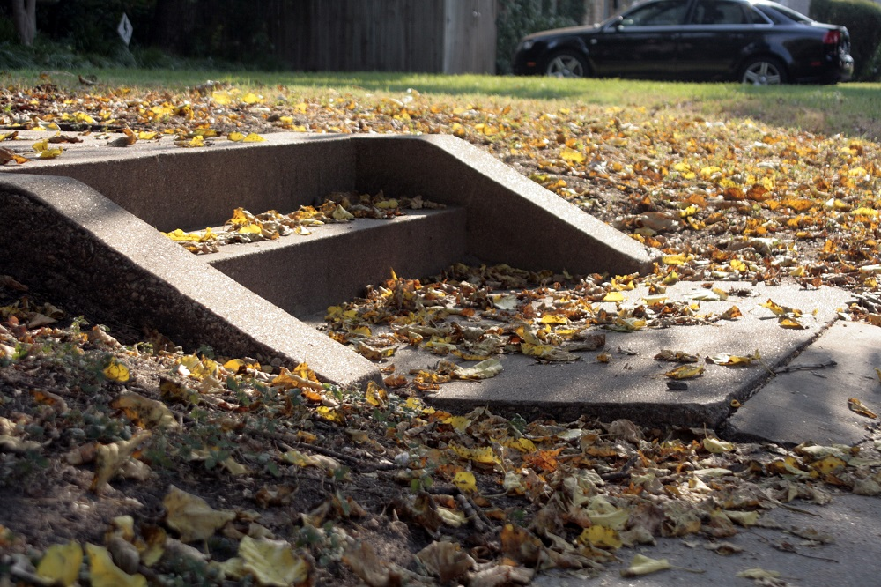 (all NCTCOG staff photos)  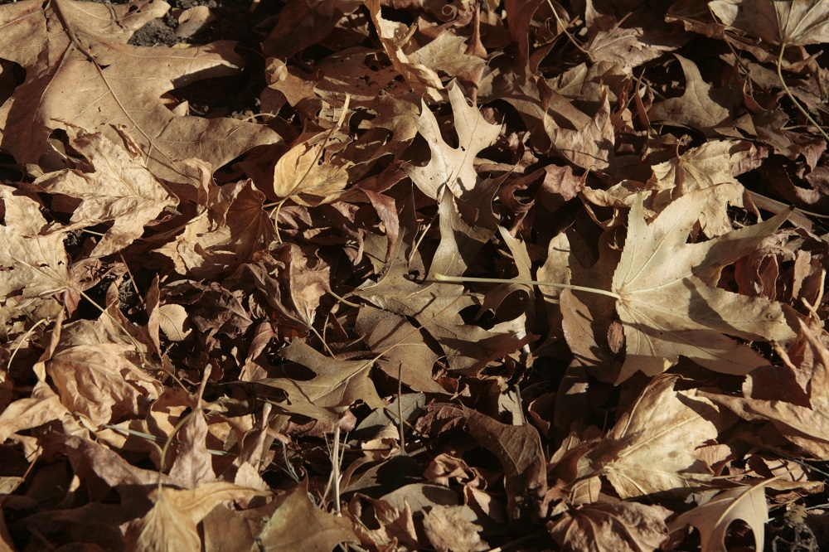 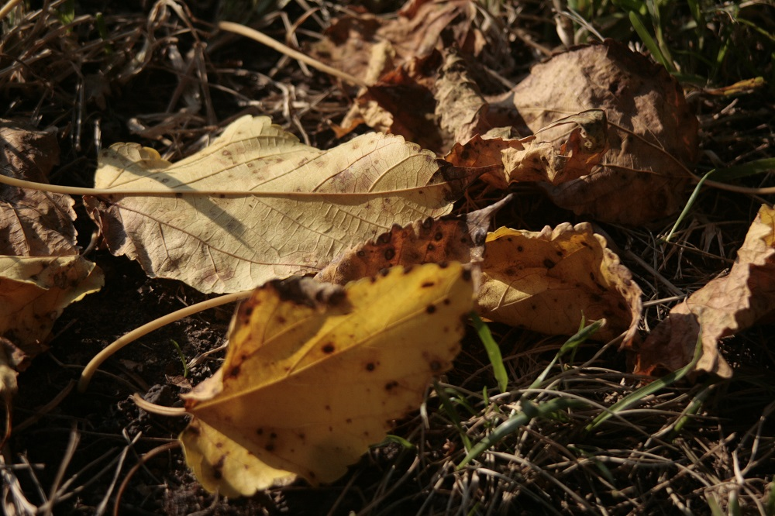

VERMICOMPOSTING, EARTHWORMS

Time | Spring, Summer, Fall
Topic | Vermicomposting, Earthworms
Source | Frisco WaterWise newsletter, “The Benefits of Earthworms” http://www.frisco-online.com/frisco-news/living/around-the-house/5500-the-benefits-of-earthworms;  Galveston County Master Gardeners: Beneficials in the Garden, http://aggie-horticulture.tamu.edu/galveston/beneficials/beneficial-38_earthworms.htm;  EPA’s “Types of Composting” http://www.epa.gov/waste/conserve/tools/greenscapes/pubs/compost-guide.pdf (Note: some of the vermicomposting information is incorrect) and http://www.epa.gov/composting/types.htm (
Long version sample – Frisco plus more info on soil compaction | Earthworms: Soil Superheroes  Lucky for us, earthworms are a dominant presence in most soils, with a square yard of grassland potentially harboring 100 to 500 earthworms beneath its surface. These natural composters are hard at work improving our soil and play a vital role in a healthy garden.  As they dig tunnels, earthworms loosen and turn the soil, transporting nutrients and organic matter closer to the surface where plant roots can access them. The tunneling also aerates the soil, allowing oxygen to penetrate deeper, which benefits helpful soil bacteria. In addition, looser soils also can hold more water than tightly compacted soils.  To help earthworms thrive in your yard (and to prevent them from crawling over to your neighbor’s yard), create an inviting home for them in your landscape. Avoid using pesticides when possible, as they can have the unintended effect of killing these soil superheroes. These little decomposers love organic matter, so consider spreading compost over your landscape liberally. When digging in your garden, avoid over-excavating and disturbing earthworm burrows.  While we may not always see them, earthworms are an integral component of most soil systems. Providing an inviting habitat will not only help the earthworms, but also everything else living in your garden.  Vermicomposting  Vermicomposting is a method of composting that uses earthworms. One pound of red wrigglers can consume up to half of a pound of organic matter every day. In general, it takes three to four months for the worms to produce harvestable castings, which can be used as potting soil. They also produce “worm tea,” a high-quality liquid fertilizer for house plants or gardens. Because red wrigglers are such efficient composters, vermicomposting requires less space than other composting methods, and can be ideal for classrooms, apartments, and high-density urban areas. Typically, vermicomposting is done in a covered container with a bedding of dirt, newspaper, or leaves. Feed the wrigglers fruit and vegetable kitchen scraps, which they break down into a high-value compost. Worm bins are easy to construct and are also commercially available.  Vermicomposting Resources  EPA – “Types of Composting”  AgriLife – “Worm Composting”  City of Plano – Food Waste Composting module
FB sample | Earthworm: Soil Superhero  [link to article] | Earthworms are hard at work below our soil surface, turning the soil, breaking down nutrients. They can also be superstar composters. [link to article.]
Memes/  Graphics/ Images | 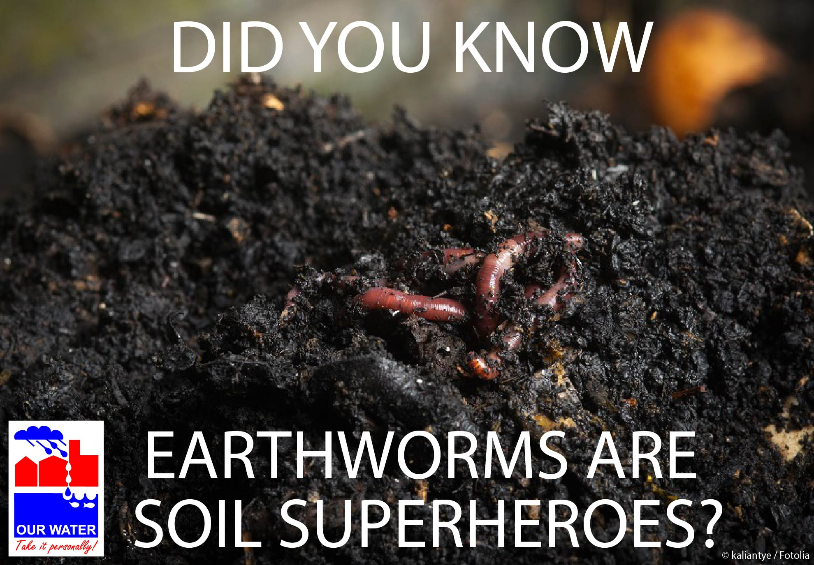

SOIL AERATION
Time | Spring (for reminder to avoid tromping on wet soil),  fall (for repair)
Topic | Repairing and preventing soil compaction
Source | Frisco WaterWise newsletter, “Repairing Soil Compaction” http://us4.campaign-archive1.com/?u=33cd614c011fb86a5e16e4f59&id=0244251df6
Long version sample | Repairing Soil Compaction  Soil compaction occurs when individual soil particles are pressed together, reducing the pore space between them. Machinery (vehicles or lawn mowers), foot traffic, or even heavy rain events can result in compacted soils. Overwatered soils are also “squishier” and more vulnerable than drier soils. North Texas clay soils are particularly vulnerable to soil compaction due to their small particle size.  The smaller pore spaces between particles of compacted soils mean less room for water and air in the soil. This leads to less available oxygen to plant roots, and more runoff and water waste during irrigation. Plant roots also struggle to grow in compacted soils—resulting in shorter, shallower root systems that are at increased risk for damage in extreme temperatures both in the summer and the winter.  Minor soil compaction can often be addressed by introducing organic matter. Mixing compost material into the soil increases pore space and permeability, which also increases available soil moisture. For more severely compacted soils, aeration may be necessary. If aeration is needed, make sure to mark your sprinkler heads with flags beforehand. DO NOT aerate soils in areas where you have drip irrigation installed.  Fall is a good time of year to address soil compaction problems, before freezing temperatures put plant roots at risk. In most cases, however, prevention is the best medicine. Prevent future compaction by avoiding work in your garden while soils are wet, and by minimizing foot traffic in sensitive areas.
FB sample | North Texas clay soils are particularly vulnerable to soil compaction. If your soils are compacted, do you know what to do? [link to article]
Memes/  Graphics/ Images | 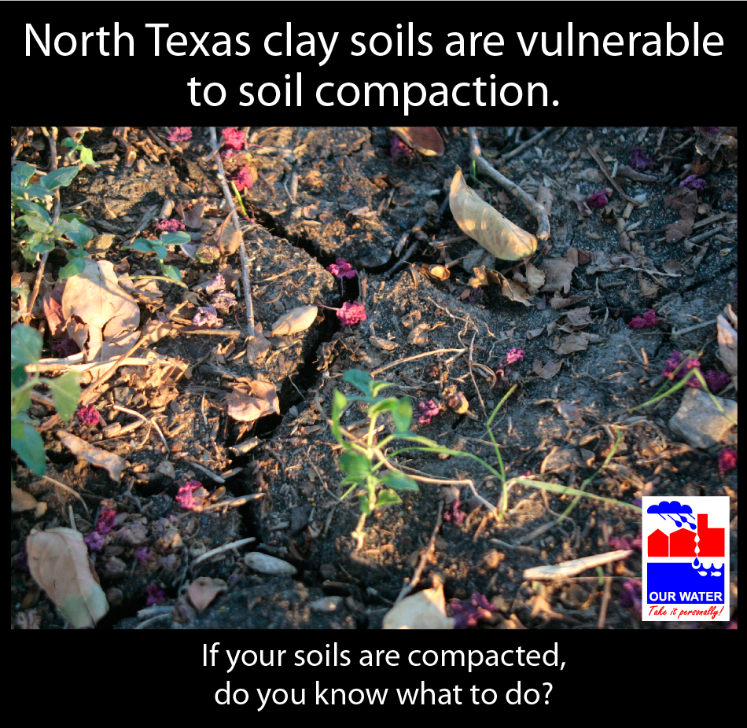  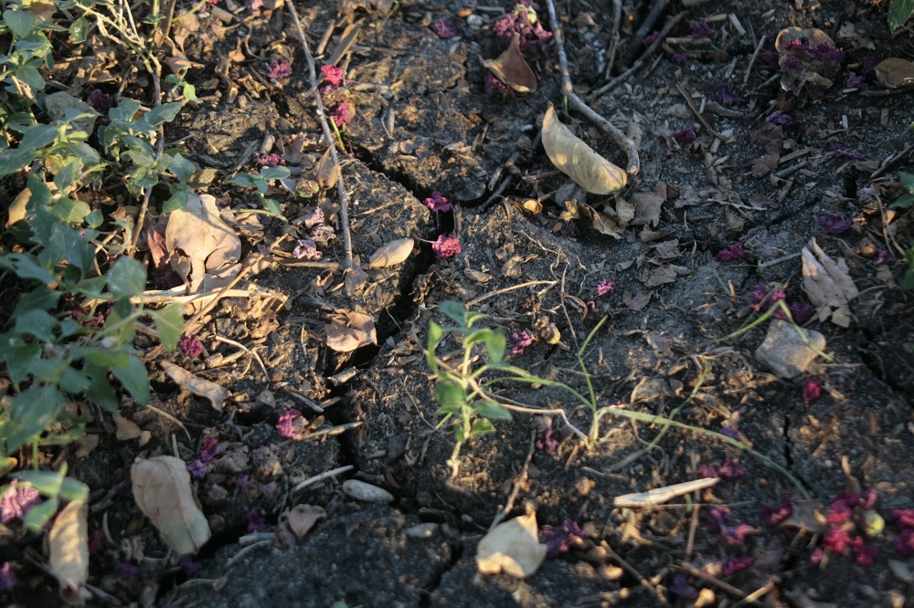 (NCTCOG staff photo)

Time | Spring or fall
Topic | Aeration
Source | Frisco webpage “Aerating” www.friscotexas.gov/departments/publicworks/water/lawnGarden/Pages/Aerating.aspx
Long version sample | Help Maintain a Beautiful Lawn by Making Sure Your Lawn Can Breathe  Aeration is an important step in maintaining a beautiful lawn. Compacted soil is very stressful for plant roots and makes grass less able compete with weeds. Aeration allows for proper water absorption and reduces runoff, and also helps nutrients to reach the roots of your grass.  Spring and fall are generally good times to aerate. Aeration should be done when the soil is slightly damp, not dry or saturated.  To get an idea of whether your lawn needs to be aerated, perform this simple test:  - When the soil is slightly damp, take a screwdriver and push it into the ground.  - If the screwdriver is difficult to push, your lawn may need to be aerated.  - If the screwdriver penetrates the ground easily, your lawn most likely does not need to be aerated.  If you need to aerate, you can either hire a professional or do it yourself. Different methods of aerating can be found at local garden stores or home improvement stores. Machines are also available for rent. These are usually about the size of a lawn mower and can easily be transported by two people.  Before aerating, mark your sprinkler heads with flags and know where your drip irrigation is located. DO NOT aerate in areas where you have drip irrigation installed.
FB sample | Aeration is an important step in maintaining a beautiful lawn. Compacted soil is very stressful for plant roots and makes grass less able compete with weeds. Does your lawn need to be aerated? If so, [fall/spring] is a good time to do it.  [Link to article]
Memes/  Graphics/ Images | 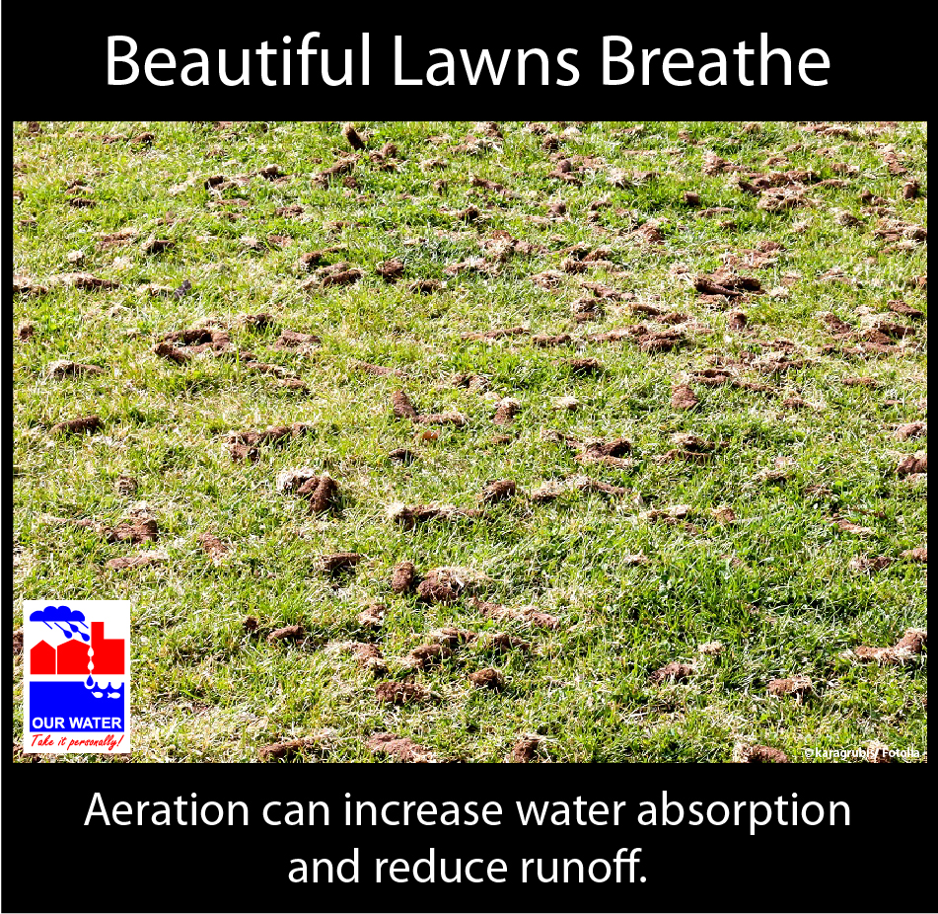

GENERAL FALL TIPS
Time | Fall/When it begins to cool down (October?)
Topic | Less watering required due to cooler temperatures, shorter days, plants going dormant. Also using leaves for compost/mulch, aerating if necessary.
Sources | US IPM http://www.ipm.ucdavis.edu/PMG/PESTNOTES/pn7497.html ,  Frisco webpage “Aerating” www.friscotexas.gov/departments/publicworks/water/lawnGarden/Pages/Aerating.aspx  Frisco WaterWise newsletter, “Less Watering For Cooler Temperatures,” http://us4.campaign-archive2.com/?u=33cd614c011fb86a5e16e4f59&id=17de08f5a1
Long version sample | Cooler weather is finally on the way! That also means it’s time to switch gears in the garden and start preparing for winter.  It’s time to reduce your watering. In the fall and winter, grass like Bermuda and St. Augustine naturally goes dormant, and their green color will fade. While plants haven’t reached their dormant season just yet, reduced evaporation and shorter days mean that less water is needed to keep plants healthy. In fact, if you give your lawn too much water, the soil can become waterlogged and poorly aerated, which restricts root growth, fosters diseases, and allows algae and moss to thrive.  It may be time to aerate your lawn. Aeration is an important step in maintaining a beautiful lawn. Compacted soil stresses plant roots and makes grass less able compete with weeds. Aeration allows for proper water absorption and reduces runoff, and also helps nutrients reach your grass’s roots. Aeration should be done when the soil is slightly damp, not dry or saturated.  To get an idea of whether your lawn needs to be aerated, perform this simple test:  - When the soil is slightly damp, take a screwdriver and push it into the ground.  - If the screwdriver is difficult to push, your lawn may need to be aerated.  - If the screwdriver penetrates the ground easily, your lawn most likely does not need to be aerated.  This is also the perfect time to take advantage of your falling leaves. Compost fallen leaves into fertile, rich soil for springtime planting. Don’t compost or don’t need any more brown material in your pile? Mow the fallen leaves into your lawn for nutrient-rich organic matter for your lawn. Or rake the leaves around your flowerbeds or under your trees. When the leaves break down, they’ll produce leaf mold, a rich, natural compost that seals in moisture. (For fire safety, make sure to not pile up dry leaves against your house or other flammable structure.)
FB sample | A little groundwork in the fall is essential to keep your landscape water-wise and looking great next spring. Here’s our list of tips.  [Graphic with tips—see below]  Do you have any ecofriendly tips for putting your garden to bed? Share them with us!
Memes/  Graphics/ Images | 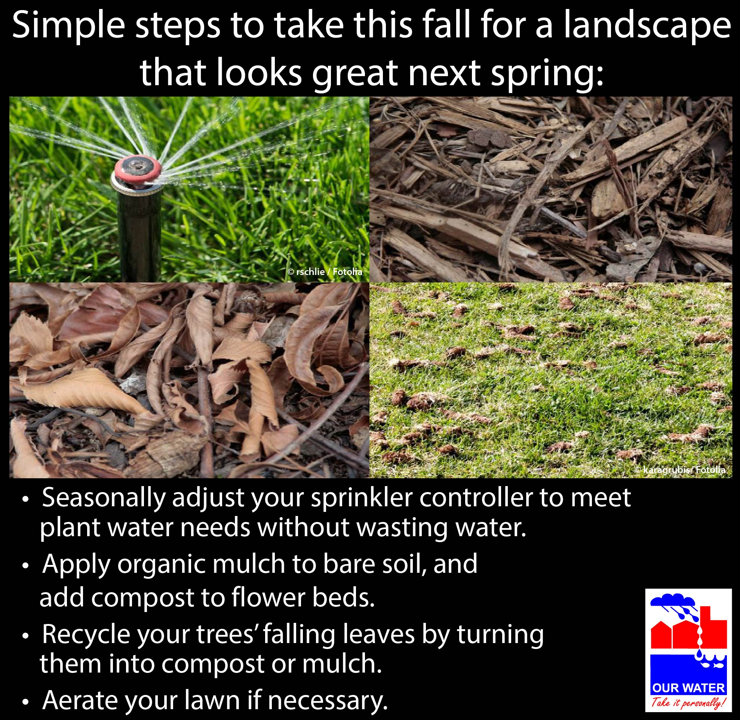  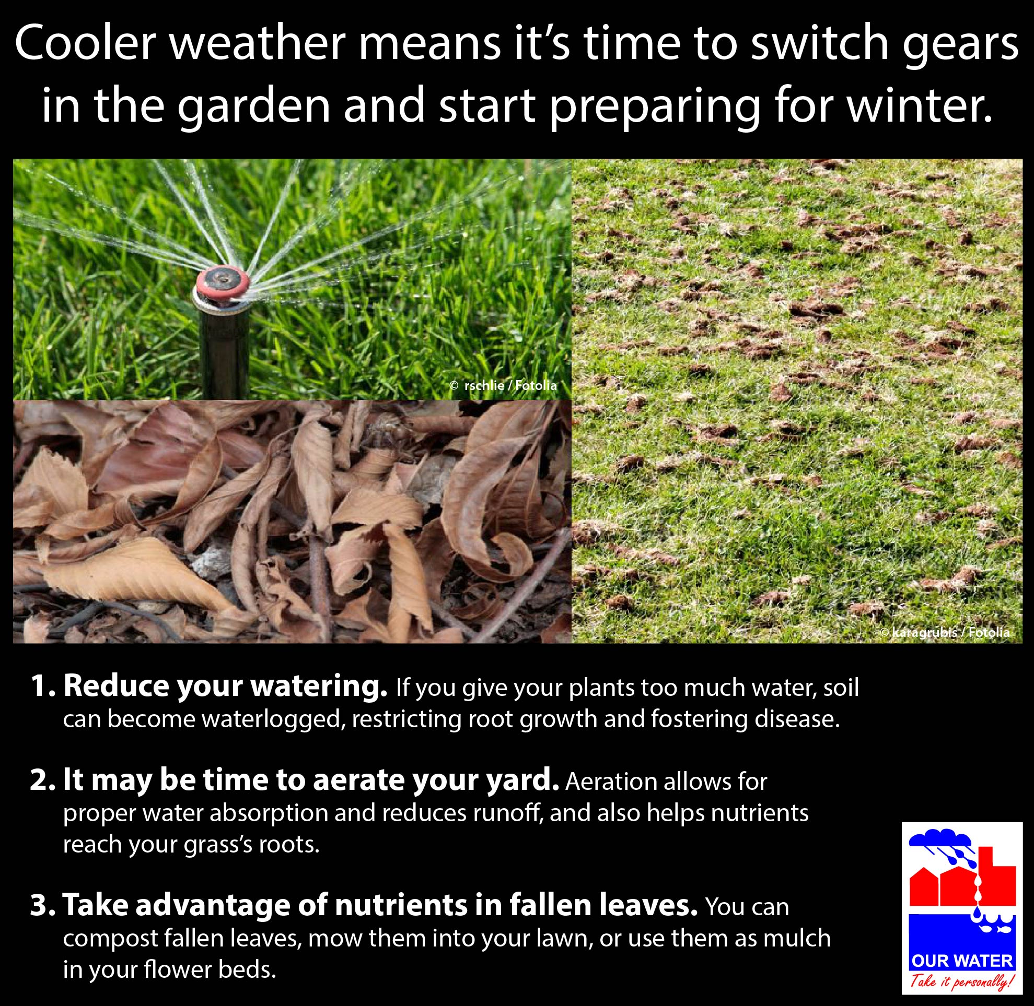

GENERAL WINTER TIPS
Time | January or February
Topic | Planning – converting turf, irrigation changes, researching SmartScape plants, applying soil amendments, mulch
Source | Frisco WaterWise newsletter, “A Gardener’s Guide to Winter,” http://us4.campaign-archive1.com/?u=33cd614c011fb86a5e16e4f59&id=6797761868  Texas A&M AgriLife Fall Practices, http://aggie-horticulture.tamu.edu/earthkind/files/2010/10/fallpractices.pdf
Long version sample | Winter: The Perfect Time to Prepare for Spring  Winter is the perfect time to plan for this year’s garden. Why not try some different native and adapted plants? The Texas SmartScape database of perennials, grasses, shrubs, and trees can be searched by a variety of criteria, so you can look for plants with purple flowers that do well in partial shade, trees with low water requirements, or whatever you and your garden desire.  This is also a great time to apply soil amendments to prep for spring—and applying mulch or compost now will also help to insulate winter crops from freezing temperatures.  You might want to consider conversions, too. Do you have areas of turf that you want to convert to hardscape or SmartScape groundcover? Do you have sprinklers that you’re thinking of converting to drip irrigation? The dormant growing season is a prime time for drawing up plans for infrastructure changes to help increase your garden’s water efficiency. [If your city/town provides irrigation audits, you might want to add information about that here.]  Spring will be here shortly. Tired of twiddling those green thumbs? Now is a great time to get ready!
FB sample | Gardeners: Time for spring dreaming! There’s nothing like a new year to inspire fresh ideas and projects for your garden. [link to article]
Memes/  Graphics/ Images | 

ROSE ROSETTE DISEASE

Time | Spring, Summer
Topic | Rose Rosette Disease: Be aware of this threat, and make sure it doesn’t spread to other plants
Source | Frisco WaterWise newsletter “Rose Rosette Disease” http://us4.campaign-archive2.com/?u=33cd614c011fb86a5e16e4f59&id=2294562b40  Rose Rosette Disease webpage, Collin County AgriLife, http://ccmgatx.org/rrd  NBCDFW article “North Texas Roses Dying from Viral Disease”  www.nbcdfw.com/news/local/North-Texas-Roses-Dying-from-Viral-Disease-307461191.html, http://fortworthtexas.gov/news/2015/06/rose-rosette/
Long version sample | Keep an Eye Out for Rose Rosette  A virus carried by mites called Rose Rosette Disease (RRD) is killing rose bushes across the Metroplex. While there is currently no known cure for the disease, you should know the infection symptoms so you can act as soon as possible in order to prevent its spread.  Once infected, rose canes will display “witches’ broom” symptoms, such as abnormal curled reddish-purplish leaf growth, excessive thorniness and shoot growth, and death of the plant within a few years. Unfortunately, these symptoms can also be linked to other sources, such as herbicide damage, normal reddening of new leaves, or excessive branching caused by heavy pruning. However, while lab testing is the only way to confirm whether your plant has the disease, multiple symptoms suggest that infection is likely.  RRD is believed to be transmitted by a tiny mite, invisible to the human eye, which drift on the wind to feed on rose canes. The mite can’t fly or crawl very far, but the wind can carry the mite for miles, which puts other roses at risk when infected bushes aren’t removed promptly.  To prevent the spread of RRD, make sure to use clean pruning shears on rosebushes—even rosebushes that appear healthy. To avoid inadvertently transporting mites between plants, clean the shears before pruning each bush. If you see signs of RRD on a plant, the best option is usually to remove the plant entirely and destroy it. Pruning the diseased branches will not save the infected rose bush, and keeping it will only perpetuate the disease in the region. Prior to digging up the rose bush, place a bag over it to trap the mites, then remove the entire plant, including the roots, and dispose of it. Do not put infected roses in your compost pile. Avoid planting rose species in the same area for at least a year.  If you have a question about the disease, contact our Texas A&M AgriLife Extension county office at [Phone number]. [Supply them with the appropriate contact information.] More information is available on the American Hort website. [You may want to also point your readers to this video of Greg Church, Collin County horticulture agent for Texas A&M AgriLife, for an in-depth presentation on the topic, http://allentx.swagit.com/play/02112015-1086, or other videos listed on the Collin County Master Gardeners webpage: http://www.ccmgatx.org/gardening-resources/videos/rose-rosette-disease.aspx]
FB sample | Rose Rosette Disease is spreading across the Dallas/Fort Worth area. While this disease may be transmitted by a mite, your best course of action for an infected plant is not miticide—it’s removing the plant entirely and destroying it. [Link to Rose Rosette Disease PDF or other resource]
Memes/  Graphics/ Images | Rose with Rose Rosette Disease  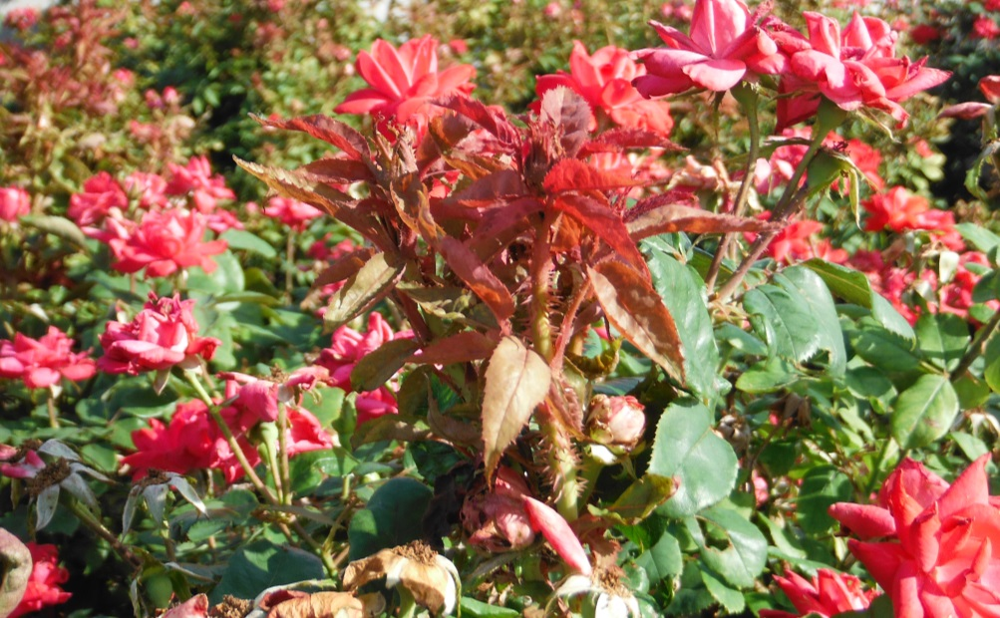 (City of Allen photo)

